WISHING
YOU A VERY
MERRY CHRISTMAS!
DECEMBER FOOD BANK
NEWSLETTER
CALL NUMBER 663-6301
Do You Get 30 Minutes of

Moderate Physical Activity
EVERY Day ? ? ?
IT IS EASY & SIMPLE!!!

EXAMPLES OF MODERATE
AMOUNTS OF PHYSICAL ACTIVITY
Washing &Waxing a Car(45 minutes)
Washing Windows or Floors (45-60 minutes)
Gardening (30-45 minutes)
Raking Leaves (30 minutes)
Walking (15 minutes/mile)
Shoveling Snow (15 minutes)
Stairwalking (15 minutes)
Playing Volleyball (45 minutes)
Playing Touch Football (30-45 minutes)
Basketball (Shooting Baskets) (30 minutes)
Bicycling (5 miles/30 minutes)
Dancing Fast (Social) (30 minutes)
Water Aerobics (30 minutes)
Swimming Laps (20 minutes)
Running (10 minutes/mile)

Making Holiday Foods Healthier
Food preparation techniques that reduce calories, fat, and sodium go a long way to keeping you healthy during the holidays. Lighten up your favorite holiday foods and create new recipes with these 15 tips:
1. Mash white potatoes with low-sodium, fat-free chicken broth instead of milk, butter, and salt.
2. Roast vegetables, such as sweet potatoes, green beans, squash, and carrots to bring out their natural flavor.
3. Mash cooked sweet potatoes with orange juice instead of butter.
4. Skip one of the crusts on fruit pies; prepare a fruit crisp instead of pie.
5. Use a gravy separator to skim the fat when making gravy.
6. Make a low-fat cheese sauce for casseroles.
7. Substitute heart-healthy canola oil for butter and margarine.
8. Consider lean pork tenderloin for holiday meals instead of fattier or saltier meats.
9. Use part-skim or fat-free cheeses to make dishes such as cheesecake or lasagna.
10. Prepare bread pudding with fat-free egg nog instead of full-fat milk for extra flavor; add raisins or dried fruit for more fiber.
11. Prepare just one striking dessert and offer fruit, such as chocolate-dipped whole strawberries, instead of cookies and candy.
12. For a festive appetizer, mix equal amounts of fat-free salsa and low-fat cottage cheese; serve with homemade whole-wheat pita chips or cut-up vegetables.
13. Make a black bean dip flavored with lime juice and cilantro instead of salt.
14. Let your guests nibble on homemade trail mix made with whole-grain cereal, dry roasted peanuts, and dried cranberries instead of fatty chips or other high-fat appetizers.

Easy Scalloped Potatoes with Cheese

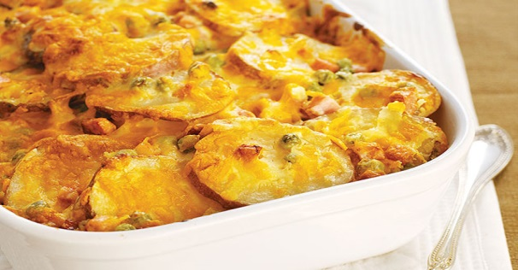
1 pkg. (8 oz.) PHILADELPHIA Cream Cheese, softened
1/2 cup BREAKSTONE'S or KNUDSEN Sour Cream
1 cup fat-free reduced-sodium chicken broth
3 lb. red potatoes (about 9), thinly sliced
1 pkg. (6 oz.) OSCAR MAYER Smoked Ham, chopped
1 pkg. (8 oz.) KRAFT Shredded Cheddar Cheese, divided

Naughty and Nice Holiday Foods
Avoid holiday weight gain, and still enjoy the feast.

'Good for You' Holiday Foods
You know that lower-fat foods are the wisest choices no matter what time of year. But the benefits of holiday fare don't end with fruit, vegetables, and whole grains.
"Many holiday foods that people think they should avoid are actually healthy in small amounts.
As long as you mind your portions, these perennial favorites are wise choices. For fewer calories, prepare them with an artificial sweetener used in cooking, such as Splenda. Here's what they have to offer, besides calories:
Applesauce and Apples
Heart-healthy fiber does indeed keep the doctor away. Look for unsweetened applesauce to get the fiber without the sugar. Bake apples with the skin to get a potent flavonoid called quercitin, which helps prevent heart disease.
Cheese
You get the most bone-building calcium and protein from hard cheeses.
Cranberry Sauce (Unsweetened)
Cranberries spell trouble for bacteria that cause most urinary tract infections. If you like sweet cranberries, add a minimal amount of sugar, or artificial sweetener.
Dark Chocolate
Seventy percent dark chocolate contains the most flavonols -- helpful plant substances that help Nuts
decrease cholesterol.
Green Beans
Naturally low in calories, string beans are loaded with vitamin K, which helps protect your bones. Also, a good source of vitamin C and vitamin A. But skip heavy sauces with this veggie. Try beans lightly tossed with olive oil and lemon.
Nuts
Nuts are chock-full of heart-healthy unsaturated fat, vitamins, minerals, and phytonutrients.
Pumpkin Pie
This rich orange vegetable contains carotenoids for making vitamin A in the body and fighting free radicals. Pumpkin is also a good source of potassium and fiber. Beware: most pies are loaded with sugar. Use artificial sweetener instead of sugar for a lower calorie dessert.
Yams/Sweet Potatoes
Yams offer carotenoids, potassium, vitamin C, and fiber. Candied yams are high in sugar. Bake with a bit of brown sugar, or with artificial sweetener, for the taste without the calories.

Make Nice With Naughty Holiday Foods
Sure, they taste great and they tempt you to eat too much, but it rarely pays to avoid favorite holiday foods, no matter how caloric.
"Depriving yourself of a holiday treat can backfire and make you crave the food even more, leading to overeating. Choose wisely.
"Pick what to splurge on rather than mindlessly nibbling on any party food that comes your way," she says.
Knowing the calorie counts of holiday foods may stop you from reaching for another ladle of gravy, a second piece of cheesecake, or another cup of egg nog.

Food | Calories
Egg nog with alcohol, 1 cup | 360
Gravy, 1/4 cup | 47
Pecan pie, 1/8 of 9-inch pie | 503
Pumpkin pie, 1/8 of 9-inch pie | 204
Cheesecake, 1/6 of cake | 257
Cheddar cheese, 1 ounce | 114
Snack chips, 1 ounce | 138
Sugar cookies, 2 small | 132
Hershey Kisses, 9 pieces | 230
Fudge, 1 ounce | 140
Potato latke, 1 medium | 257
Stuffing, 1/2 cup | 179
Mixed nuts, 1 ounce | 175
Mashed potatoes (made with  milk and butter), 1 cup | 238

The buffet table is groaning under the weight of holiday goodies, but food is not alone in packing on the pounds. Alternate alcoholic beverages with calorie-free drinks, such as water or diet soda, at parties or family gatherings. You'll feel better the next day, and take in far fewer calories.

Don't Let Holiday Foods Get the Best of You
Curb calories from so-called naughty foods by taking tiny portions. The first few bites of any food provide the most pleasure. Once you've finished your treat, fight the urge for more.
Excuse yourself from the dinner table when done eating.
Keep your mouth busy by talking with friends and family.
Chew gum or suck on a sugarless breath mint to prevent picking.
If you're able, brush your teeth; the taste of toothpaste dulls taste buds.

Gift Ideas on a Budget

A collection of nice hot chocolate mixes, plus a mug and marshmallows
As apple cider is to fall, hot chocolate is to winter—regular, steaming mugs of that chocolate-y goodness can propel you through the short days and oh-so-long nights of January and February. Grab a few packets of your favorite brand (and don’t forget you can get different varieties, like mint or Mexican chocolate) and put them in a festive mug for your recipient’s pleasure. Add in a little pouch of mini-marshmallows (cinched with a jaunty little ribbon), and you’re good to go.
Homemade cookies
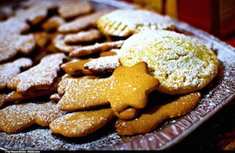
COOKIES! Everyone LOVES homemade cookies!!!!
Puzzle book (crosswords, Sudoku )
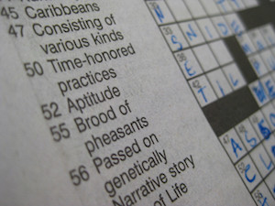
Whether they’re crazy for crosswords or mad about Sudoku, puzzle enthusiasts can almost never get enough. Load them up with head scratchers to keep them busy until the spring thaw.
A nice vase or jar filled with candy
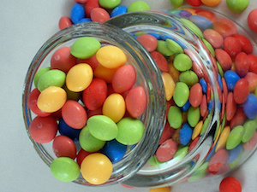
Food, honestly, is never a bad gift. People need to eat, and they’d prefer to eat something delicious. Similarly, home décor is often the last thing on somebody’s mind. So give them a jar or vase full of the delicious food of your choice, and once they’ve scarfed that down, they’ll have a nice receptacle for flowers to go on the dining room table.

This is a basic cheese sauce that you can spruce up with any herbs or spices you may like. I like this sauce with baked potatoes.

Basic Cheese Sauce

Ingredients
Servings 32 Yield 2 cups

1 tablespoon butter
2 tablespoons flour
1 cup milk
¹⁄₂ cup cheese, grated (your choice, mozzarella, cheddar, brie)
¹⁄₄ cup parmesan cheese
salt
pepper

Directions
- Melt butter in heavy saucepan on top of stove.
- Add flour and stir until well mixed and bubbly being careful not to scorch.
- Remove from heat and add milk; stirring until well blended.
- Return sauce to heat and bring to a boil, stirring constantly.
- Reduce heat, add shredded cheese and parmesan and cook until cheese melts and there is no taste of raw starch.
- Add salt and pepper to taste.

