

Hansford County Extension

23 Northwest Court

Basement

Spearman, TX 79081



(806) 659-4130

Fax:

(806) 659-4133

E-Mail:

Hansford-tx@tamu.edu

























Let Every Day Be Christmas

Christmas is forever, not for just one day,  
for loving, sharing, giving, are not to put away  
like bells and lights and tinsel, in some box upon a shelf. The good you do for others is good you do yourself.  
(Written by Norman W. Brooks)

A Special thanks to Delinda McLaughlin, Andrea Woolley, Terrie Harper and Tiffany Earle for helping with the Veteran’s Day program.

**Easy Granola**

**4**cups old-fashioned rolled oats (not quick cooking)

**1**cup sliced almonds

**1/2**cup shredded coconut (preferably unsweetened)

**1/4**cup unsalted pepitas (hulled pumpkin seeds) or shelled sunflower seeds

**1/2**cup pure maple syrup

**2**tablespoons canola oils

**1/2**teaspoon kosher salt

**1**cup dried fruit (such as cherries, cranberries, raisins, or currants)

**DIRECTIONS**

Heat oven to 350° F. On a rimmed baking sheet, toss the oats, almonds, coconut, and pepitas with the maple syrup, oil, and salt.

Bake, tossing once, until golden and crisp, 25 to 30 minutes. Add the dried fruit and toss to combine. Let cool.

Keep at room temperature in an airtight container for up to 1 month











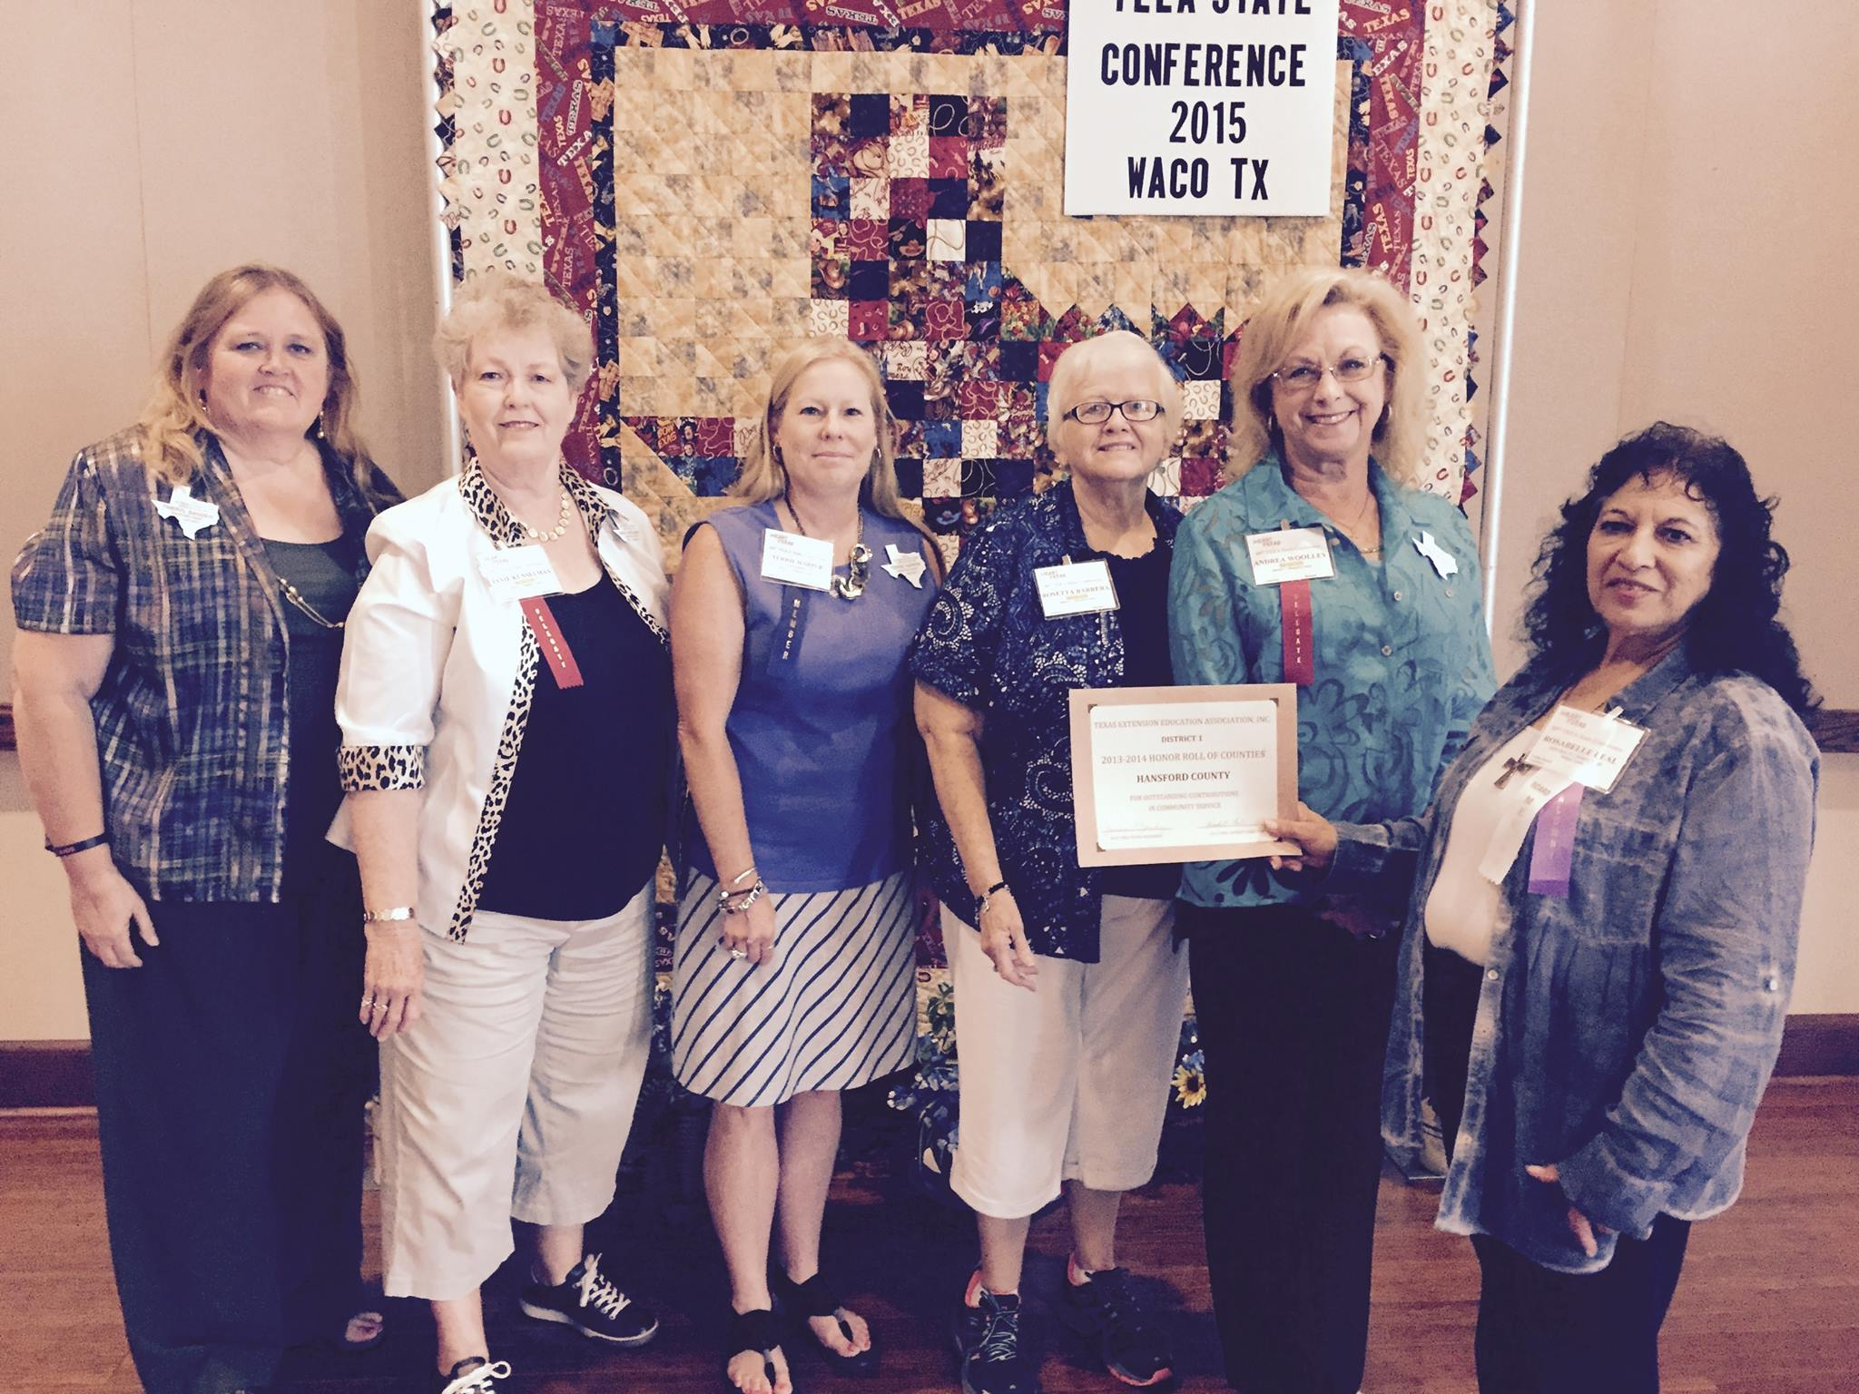







State Conference 2015

Waco, TX

Special events:

Fall Training – Dec. 3rd

Christmas Parties – Dec. 8th

Elect Delegates for Spring District Meeting – April 14

Elect Delegates for District Conference

Happy holidays from our family to yours!

TEEA Newsletter







Type the Page Title here

Page 2 of 3

Caption describing picture or graphic.

Caption describing picture or graphic.

Updating the page numbers in this template

The page numbers in this template are located at the top of the leftmost column on each page.

To update a page number, select the page number, right click on it, and then click **Update Field**.

To add page numbers to additional pages, copy the text box that contains the page number on this page, paste the text box on the additional pages, and then update the page number field.

Adding pictures to your newsletter

Pictures of your family trips, special events, and every day life will bring your newsletter stories to life. Once you have chosen a picture, place it close to the story. Be sure to place the caption of the image near the image.

If you want to use clip art in your newsletter, you can find thousands of clip art images on Office Online that you can download and insert into your newsletter.

To change the pictures in this newsletter to your own, click the image you want to change. On the **Insert** menu, click **Picture**, and then click **Clip Art** or **From File**. Locate the image you want and double-click it. The new image will be inserted into the existing text box for easy positioning.

**Tip:** Text boxes that contain images or text often do not have borders showing, so it may not be apparent that an item is placed within a text box.

To see the text boxes that contain the pictures in this template, click **Options** on the **Tools** menu, click the **View** tab, and then select the **Text boundaries** check box under **Print and Web Layout options**.

Working with linked text boxes

The text boxes in this newsletter are linked, so text from one column flows into the other column and you can easily include more than one story on a page.

When you are working with linked text boxes, you should turn on the **Text** **Box** toolbar. To do this, on the **View** menu, point to **Toolbar**s, and then click **Text Box**.

When you start writing your story, we recommend that you do most of your writing and editing before you copy the text into the empty linked text boxes. To move among linked text boxes in a story, select a text box that is part of a story. On the **Text Box** toolbar, click **Next Text Box** or **Previous Text Box**.

To copy or move linked text boxes, select the first text box in the story. Hold down SHIFT and select each additional text box you want to copy or move. On the **Edit** menu, click **Copy** or **Cut**. Click where you want to copy or move the text boxes. On the **Edit** menu, click **Paste**.

You can also break a link between any two linked text boxes in a story. To do this, select the text box. On the **Text** **Box** toolbar, click **Break Forward Link**.

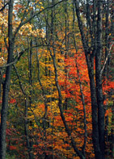



Our kids’ favorite Christmas joke:

What do you call a person who is afraid of Santa Claus?

Claustrophobic!

Page 3 of 3

A favorite family phrase or slogan can go here.

We’re on the Web!

Visit us at:

<http://www.widgets.msn.com/>

Our Family

Address line 1

Address line 2

City, ST ZIP Code

Phone:

(242) 555-0167

Fax:

(242) 555-0168

E-Mail:

someone@example.com

Season’s greetings!

A special message from our family

On the back of your family’s newsletter, you may want to add a simple greeting, a poem, or a child’s drawing. This is the first part of the newsletter that your loved ones will see when they receive your newsletter in the mail, so make sure that it is festive and eye-catching.

You can add your own artwork to the back of a family newsletter by scanning in a drawing or a photograph.

You can also find a wide variety of holiday clip art and photographs on Microsoft Office Online.

A great way to add content to this newsletter is to include a calendar of upcoming events or a special memory that your family shares. You can also transcribe the words of a song or a poem onto the back of your newsletter to set the tone for the rest of your message.

With a little creativity and imagination, creating a holiday newsletter can be a great way to say “Season’s Greetings!”

Friend’s Name

Street Address

City, State Zip Code

Our Family’s Name

Address line 1

Address line 2

City, ST ZIP Code