Seller Name________________________ Club___________________________
Poinsettia Fundraiser List for Guadalupe County 4-H
Delivery date to County Extension office is November 29, 2021 at 2pm

Name of buyer & Phone Number | 4in pot red or assorted, 3-5 blooms:  $7.00 | 6in pot red, 5+ blooms with foil pot cover:  $12.00 | 6in pot white, 5+ blooms with foil pot cover:  $12.00 | 6in pot enduring pink,  5+ blooms with foil pot cover: $12.00 | 8in pot Fire and Ice (red and whites striped), 5+ blossoms, with foil pot cover: $25.00 | 8 in red bush, 12+ blooms:  $25.00 | 10in Pot Hanging Basket, red blooms  $30.00 | Total

Please collect the name and a contact for each buyer. In each box, please put the number of plants being purchased, not tally marks. ALL INFORMATION MUST BE TURNED IN BY October 31, 2021
MAKE CHECKS PAYABLE TO GUADALUPE COUNTY 4-H

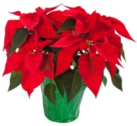  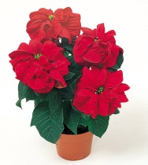 | 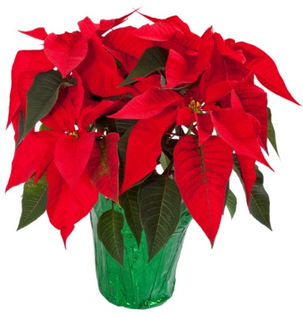 | 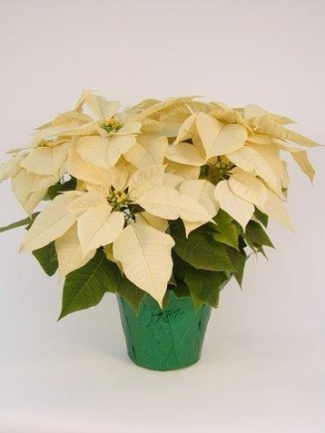 | 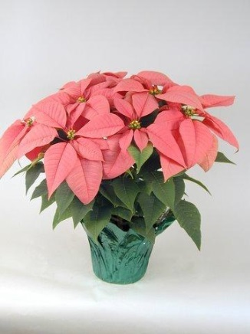 | 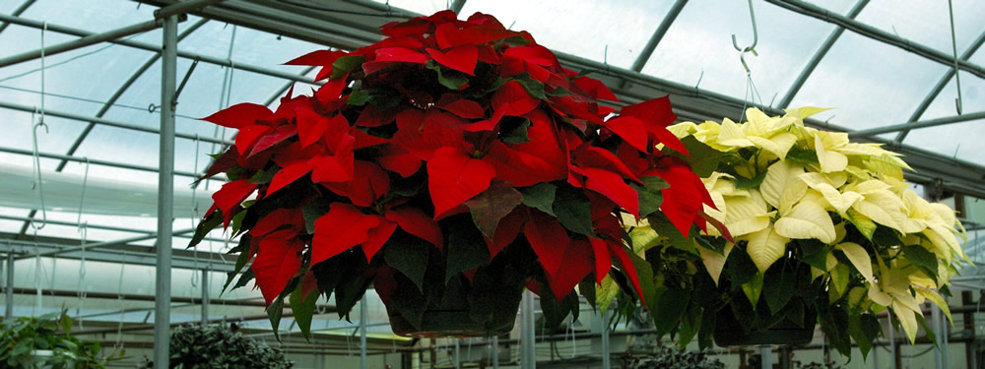 | 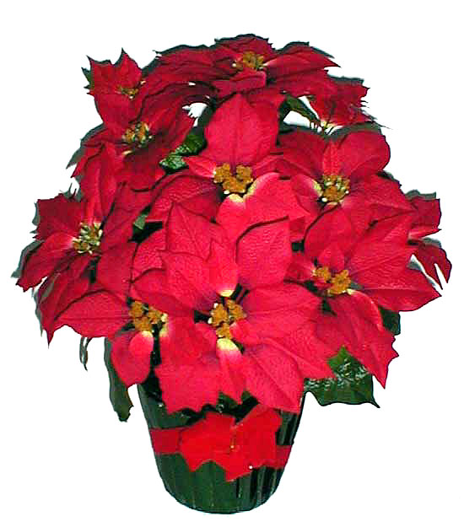
4in pot red or assorted, 3-5 blooms: | 6in red, 5+ blooms with foil pot cover | 6in white, 5+ blooms with foil pot cover: | 6in pot enduring pink,  5+ blooms with foil pot cover: | 10in Pot Hanging Basket, red blooms | 8in red bush, 12+ blooms, approx.:
These small poinsettias may come in any color. Only about 8-10 inches tall. Good for table tops. | The Standard Poinsettia, Approximately 1 foot tall, with 5+ Blooms | The Standard Poinsettia in White, may look slightly yellow or green. Approximately 1 foot tall, with 5+ Blooms | The Standard Poinsettia in pink, Approximately 1 foot tall, with 5+ Blooms | Large Hanging Basket with 12+ blooms, about 2.5 feet tall and 2 feet wide | Large Bush, around 3 feet tall, great for doorways and driveways, 10 inch pot with 20+ blooms!

Red and White Poinsettia , 8in, 5+blooms with foil pot cover, aprox 1.5ft tall

