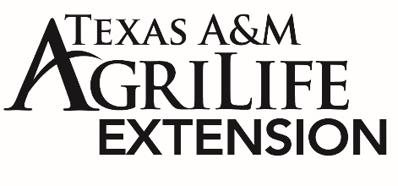
FOR IMMEDIATE RELEASE
Mandy Patrick – Texas A&M AgriLife Extension

National Diabetes Month focuses on Heart Disease in November
November is National Diabetes Month; and this year the National Institutes for Health (NIH) is highlighting the link between diabetes and heart disease.
According the NIH “When blood sugar is high and moving through blood vessels, the vessels and nerves that control the heart can be damaged, causing heart disease”.
“We think of diabetes as having to do with elevated blood sugar levels and heart disease with elevated cholesterol levels; and that is true, but the combination of the two diseases increases the impact of both conditions”, said David Leal, Program Specialist for Texas A&M AgriLife Extension’s Healthy South Texas Initiative. He continues, “We feel as though they are separate diseases, but they very much go hand in hand”.
The NIH reports that we are more likely to develop heart disease and have a greater chance of heart attack or stroke with diabetes. People with Diabetes are also more likely to have certain conditions like high blood pressure or high cholesterol that increase the chances of heart disease or stroke, which is why smoking and the use of tobacco should be stopped.
We might smoke to relax and manage stress; therefore, the NIH also recommends finding healthy ways of coping with stress like walking, being in nature, starting a creative hobby, or listening to music. Also, it is easy, especially around the holidays, to use food as a way of coping with stress. But using these alternatives to “emotional eating” can contribute to a healthy weight.
Lastly the NIH recommends keeping track of your laboratory numbers that indicate diabetes and heart disease like A1c, Blood Pressure, and Cholesterol levels. Remember that your A1c is a test that shows how controlled your blood glucose has been over the past 3 months and is important to know so you and your doctor can track improvement due to medication for diabetes and creating healthy habits like eating vegetables and being more active.
Leal stresses the importance of keeping doctor’s appointments, he says “We can’t wait until our blood sugar and cholesterol numbers are out of control to finally go to a doctor. These are chronic diseases that don’t go away, but they can be controlled and managed with proper medical care”.
For more information on creating a healthy lifestyle, contact the Gregg County Extension Office at (903)-236-8429 or via email: mandy.patrick@ag.tamu.edu

