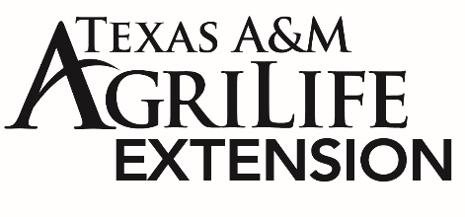
MEDIA ADVISORY
Contact: Mandy Patrick– Texas A&M AgriLife Extension mandy.patrick@ag.tamu.edu 903-236-8429

Celebrate National Nutrition Month® by Eating Right, Bite by Bite
The Academy of Nutrition and Dietetics invites you to celebrate National Nutrition Month® in March with this year’s theme of Eat Right, Bite by Bite! According to the Academy of Nutrition and Dietetics this year’s theme “not only appeals to kids and kids-at-heart, but “bite by bite” also supports the philosophy that every little bit (or bite!) of nutrition is a step in the right direction. Small goals/changes can have a cumulative healthful effect.” Amy Valdez, Extension Program Specialist with AgriLife Extension, shares that “National nutrition month is a great way for us to start our year off right and focus on the importance of making healthy food choices and incorporating physical activity into our routine.”
According to ChooseMyPlate.gov, a healthy eating pattern should include a variety of foods including:
- Fruits such as bananas, strawberries, apples, pears, grapes
- Vegetables such as carrots, onions, green peppers, eggplants, corn
- Grains such as oats, rice, bread, pasta, popcorn
- Dairy such as milk, cheese, yogurt
- Protein such as chicken, beef, seafood, eggs, nuts and seeds

A well-balanced eating pattern can provide us with a variety of nutrients, such as fiber, potassium, calcium, protein and carbohydrates, that are needed for our body’s day to day activities. Valdez explains that “using nutrition tools like ChooseMyPlate.gov can help us personalize our nutrition goals and understand that there is not a “one plan fits all” approach and everyone’s way to “eat right, bite by bite” will look different!”

To celebrate National Nutrition Month, Valdez recommends trying out these ideas below:
- Try New Produce Each Week – Each week or each day, try to incorporate a new fruit or vegetable into your meals. Create a challenge amongst your family members to see who has tried the most variety of fresh fruits and vegetables.
- Healthy Family Fun- Celebrate with your family by shopping and meal prepping together or trying new outdoor activities such as hiking or riding bikes! This is a great way to get the entire family involved and maybe start some healthy family traditions!
- Visit Texas A&M AgriLife Extension’s Dinner Tonight program- Dinner Tonight offers delicious and budget-friendly recipes that are a great way to begin your journey to eat right, bite by bite. To learn more about the recipes, visit https://dinnertonight.tamu.edu
For more information on National Nutrition Month visit EatRight.org or call Gregg County Extension Agent, Mandy Patrick at 903-236-8429.

