Gonzales County
Youth Show Association
P.O. Box 1915
Gonzales, Texas 78629

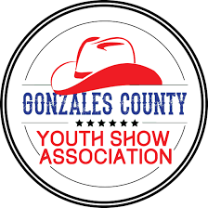

Name: | Age:
Address: | City/Zip:
Parent (s):
Phone: | Email:

Scholarship Information and Instructions: Scholarship amount will be variable based on association availability of monies (minimum of $500). Scholarship payment will be awarded to the recipient upon proof of enrollment in a program of post-secondary study.

All graduating seniors associated with the Gonzales County Youth Show Association are eligible to apply.

Please submit a current resume and high school transcript along with completed questionnaire. Attach additional pages if necessary.

Scholarship Questionnaire:

- What is your plan for your post-secondary education? Include application, acceptance, and planned course of study.

- What has you involvement with the Gonzales County Livestock Show done to prepare you for the future?

- What career do you plan to pursue?

  - Why?

- How are you presently planning to finance your higher education?

Applicant’s Signature___________________________________Date_____________

Please send completed scholarship to P.O. Box 1915 Gonzales, Texas 78629 by March 31st.

Scholarship Application
2021-2022

