“As the Garden Grows”
A Publication of the Gonzales Master Gardeners, Gonzales, Texas
March 2020, Volume 10, Issue 2

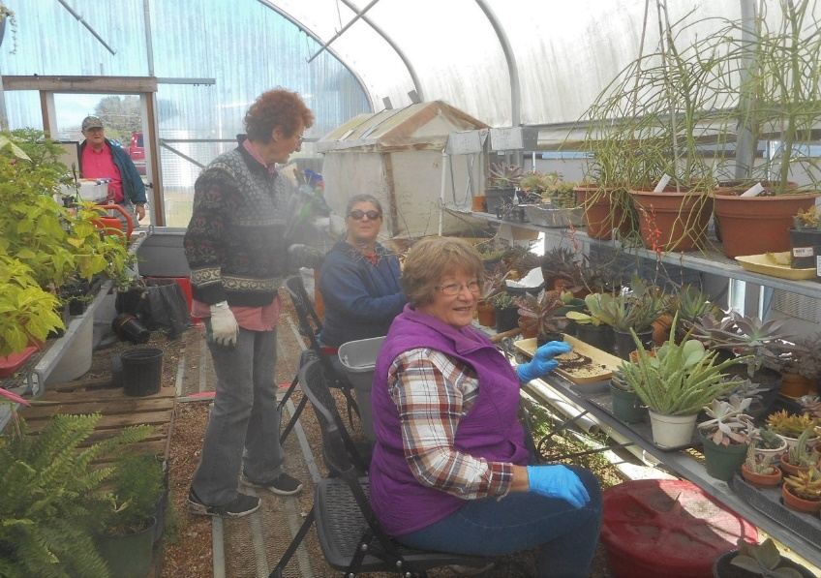
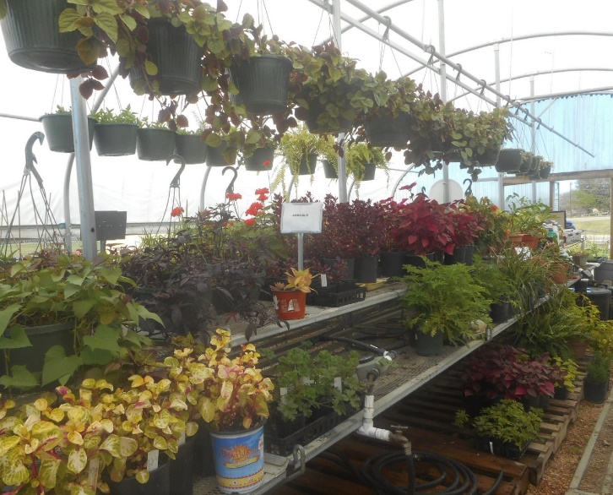
Calling all Gardeners! Spread the word, tell your neighbors and friends, MARCH 28, 2020, is the date for our annual spring plant sale at Hero’s Square, 8:30AM – 1PM, rain or shine. Tomatoes, vegetables, herbs, perennials, succulents, citrus and much more will be available. Meet the Master Gardeners, ask questions – we’re glad to help. This fundraiser provides resources for the children and adult outreach programs. Your support is greatly appreciated! (Please note, we will not be holding a fall tree sale this year.)

Gonzales Master Gardeners & Trainees have been very busy with the Children’s Garden helping the kids plant their vegetable seeds!

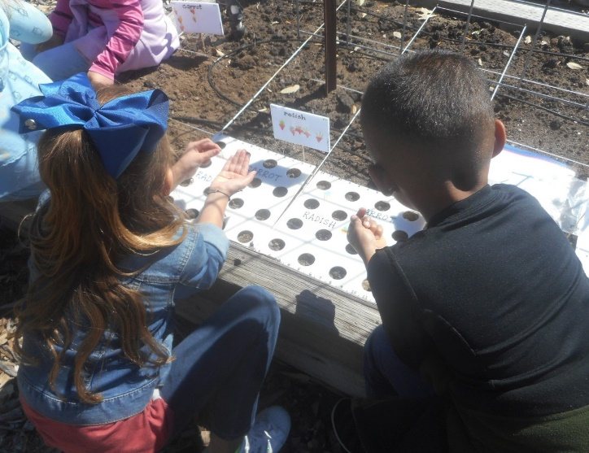
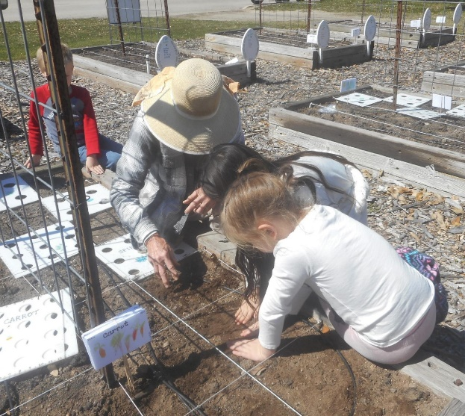

Folks attending the GMG “Lunch & Learn” program were introduced to Vermiculture, the method of using compost worms to produce worm castings.

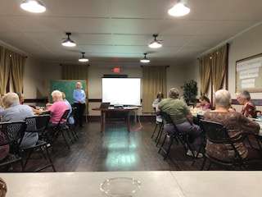

For more information on this process see: https://txmg.org/elpaso/learn/gardening-in-el-paso-articles/vermicomposting-poster-series/
March Dates to Remember

Estimated Last Spring Frost Date – March 21, 2020 (variable +/- 7 days)
Daylight Savings Begins – March 8, 2020
1st Day of Spring – March 19, 2020 (Equinox when day/night is equal)
“Super Moons 2020”: March 9 & April 8 for your viewing pleasure

March Planting Guide

Note: Spring is projected to arrive early with warmer and drier weather than “normal” according to long range forecast.

Vegetables: green beans, lima beans (when soil is warm), beets (last call – early March), Swiss chard, corn, cucumbers, cantaloupe, eggplant (T), warm season greens, mustard, radish, southern peas, peppers (T), summer & winter squash, tomatoes (T), turnip, watermelon. (From seed unless noted with T for transplant).

Tomato Tips – Large fruited “determinate varieties” crop over a short period of time before summer heat shuts down production. If you have room also plant smaller fruited “indeterminate varieties” that continue to produce over a longer period of time and tolerate higher night temperatures.

Blossom End Rot (BER) is caused when soil moisture goes from saturated to dry preventing calcium from reaching the tip end of the developing fruit. This results in obvious rotting of the fruit as it ripens. Soil pH and soil temperature also play a part in calcium availability. Plant tomatoes when soil warms, maintain even soil moisture, mulch root zone to retain moisture and don’t overuse nitrogen fertilizer. Please note BER may also affect peppers and eggplants.

For more information on growing vegetables consult the following references:

https://aggie-horticulture.tamu.edu/vegetable

(English & Spanish versions)
Easy Gardening Fact Sheets – concise overview for the home gardener
Commercial Production Guides – more in-depth information, a must read

Flowering Plants: ageratum, alyssum, amaranthus, bachelor’s button, basil, blue daze, angel trumpet, celosia, coreopsis, cornflower, cosmos, daisy, geranium, Echinacea, feverfew, gaillardia, hollyhock, larkspur, nasturtium, drummondii phlox, California poppy, queen anne’s lace, petunia, pentas just to name a few along with cosmos, nicotiana, four o’clocks, marigold, stock, and verbena. The choices are endless! Use them as “eye candy” in garden beds and cut flowers in arrangements.
Herbs: Rather than a long list of herbs I’ll share several references for your viewing pleasure. Herbs fill so many niches in our garden, culinary uses in the kitchen, crafts too many to mention, AND they attract beneficial insects – what more can you ask for! We’ll have a good selection at our Plant Sale March 28th.

Herbs for the Texas Landscape
https://aggie-horticulture.tamu.edu/vegetable/files/2013/09/EHT094.pdf
Growing Herbs in Texas
https://aggie-horticulture.tamu.edu/organic/files/2011/03/E-561_growing_herbs_texas.pdf

Garden Bulbs, Corms & Tubers: For starters purchase quality bulbs from reputable suppliers. Spring planted bulbs include – Amarcrinum, canna, crocosmia (can be invasive), elephant ear, society garlic, gayfeather, butterfly ginger, gladiolus, crinum, Madonna lily, oxblood lily, spider lily, and Mexican tuberose. Tip: Place your order early before seasonal varieties sell out especially heirloom Texas or Louisiana grown bulbs. On-Line Sources: Brent & Becky’s Bulbs, Old House Gardens & Southern Bulb Company.

March Garden Activities

Gonzales County is in a drought which means homeowners need to water landscape plants, especially newly planted trees and shrubs to keep the root ball from drying out. Provide 1” of water every 2 weeks to St. Augustine lawns to keep grass alive (it doesn’t go dormant), more often if on thin soils less than 6” in depth. Fertilize lawn after grass is actively growing. For more information on Lawn Care see: http://austintexas.gov/sites/default/files/files/Watershed/growgreen/factsheets/Lawncare.pdf

Vegetable gardens need 1” water per week or enough to keep soil evenly moist. Vegetable transplants may need water daily for 7-10 days until established especially during windy, warm to hot conditions. Seeded veggies and flowers need moist soil during the germination process, monitor conditions for best outcome. Be prepared to protect all in case another cold snap arrives. By April 1st we should be well past any chance of cold weather.

Time of remove dead material from perennials, trees and shrubs plus prune as needed after spring growth makes an appearance. Fertilize, add mulch and compost as needed.
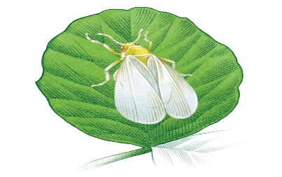
What’s Bugging You? Warm weather signals the arrival of insects, many of which are beneficial or cause no trouble at all. Among the landscape/vegetable garden trouble makers are aphids, leaf-footed bugs, stink bugs, thrips, sharpshooters, cut worms, cabbage loppers, saltmarsh caterpillars, white flies, fire ants, cucumber beetles and flea beetles. In any case don’t assume the insect you see is the one causing the damage. Some don’t come out until nighttime – identify the insect BEFORE using an insecticide and do start with the “least toxic” approach first. Inspect plants, look at the underside of the leaves for egg masses and newly hatched insects (which may not look at all like adults). Don’t kill the good guys!

References to help identify insects:
https://www.insectidentification.org/insects-by-state.asp?thisState=Texas
Books: The Texas Bug Book, Field Guide to Common Insects of Texas, and Insects of Texas a Practical Guide.

Did you know Texas A&M AgriLife Extension offers on-line courses covering many topics including those of interest to gardeners? Well they certainly do! Check out the latest offerings: https://agrilifelearn.tamu.edu/

The gateway to “all things horticultural” is: https://aggie-horticulture.tamu.edu/
Once there you can link to a wide range of information!

Visit our web page at: http://www.gonzalesmastergardeners.org
We meet the first Thursday of the month at 623 N. Fair Street at 12 noon.

Texas A&M AgriLife Extension Office-Gonzales County
1709 E. Sarah DeWitt, Zip 78629
Phone: 830-672-8531
Web Site: https://gonzales.agrilife.org/
Dwight Sexton, County Extension Agent-ANR

Gonzales Master Gardener Newsletter Editors:
Tommie Clayton
tjcgrc@hotmail.com
Charlotte Knox
lotteknox@aol.com

