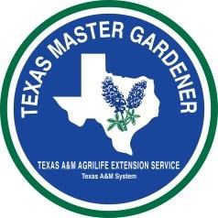

As the Garden Grows
A Publication of the Gonzales Master Gardeners
Gonzales, Texas January 2019, Volume 9, Issue 1
Happy New Year!
As we begin a new year, we should reflect on all that GMG accomplished last year! It was a very busy and productive year. Our Spring and Fall plant sales were a huge success and hopefully fun for all who participated. The first, second and third grade programs are doing great and the children really love their gardening experiences. Our board of officers kept up with all that is going on and are doing a great job. The website is doing great, the newsletter is still being published and our Lunch and Learn seminars are enjoyed by all. We owe all of these successes to a great bunch of volunteers who continue to volunteer their time and talents. Our group would not exist without each of you doing some part of making it the great organization that it has become.
Let’s continue to get involved and keep our programs growing. The community and school children have come to depend on us to help with their gardening questions and search for knowledge. As the year moves forward, reach out to the community and encourage them to join in the next MG training program and attend our gardening programs and events.
First Grade Children’s Garden Program
The Spring Session for the Children’s Garden with the first graders at GISD began on January 10. The children are very excited about planting their gardens this spring. In the first session they learned that all plants start with a seed. They listened to the story by Erick Carle, The Tiny Seed, and learned what a seed needs in order to grow. They were given materials to make plant markers for their gardens that will be planted later in February. Thanks to all the volunteers who helped with this first session. The next session will be on January 24, 2019. They will be learning the parts of the seed and how seeds germinate. In the meantime, the gardens are in need of clean up and preparation for the planting session on February 21. Feel free to go by and pull a few weeds and tidy up the beds. Arline will be in contact via email about any planned clean up days.
Second Grade Program
The next session for the second-grade students from GISD is scheduled for January 31, 2019. Volunteers need to be at PACE by 7:30 am for final preparations and instructions. David DeMent is planning a program about where paper products come from. The students will be making papier mâché Valentine cards. A practice day for the papier mâché process will be held on Tuesday, January 22 at 1:00 pm after the MG training class. The following have volunteered for the event: Nancy F., Arline, Jan, Jeff, Dwaine, Carolyn P., Carolyn W., Brenda, Kristi, Shari and Sandy L. David and Fran will provide a lite lunch after the morning class.

  - Gonzales Master Gardeners
  - 9th Annual Spring Plant Sale

Saturday, March 16, 2019

8:30 am until 1:00 pm

Texas Heroes Square

Downtown Gonzales, TX
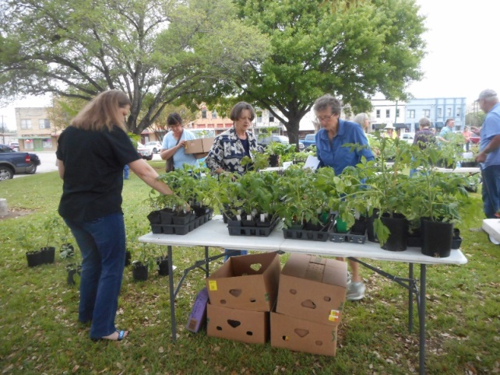
**************************************************************
The Vegetable and Herb teams are very busy growing all those spring vegetables and herbs that you will want for your spring gardens. Getting your beds ready now will mean you can get them planted right after the sale. Work in some compost, remove the weeds and dead stuff and be ready to plant.
We will also have citrus trees (Meyer’s lemons, Satsuma and Mandarin oranges and grapefruit), spring annuals, perennials and adapted natives, and succulents. This year we have a nice variety of roses (Lady Banks, Peggy Martin, Old Blush, Belinda’s Dream and Grandma’s Yellow rose). There will be a Silent Auction, Children’s booth and Plant Give Away drawing.
Thanks to everyone who came to the SPS meeting on January 3 to work out the details. Our next meeting will be after the February 7 noon lunch meeting.
Fall Tree Sale
Donna Bell has been informed that bare root fruit trees for the fall will be delivered the week of January 13, 2019. MG’s will be notified as to when they can pick up trees to take home and grow until fall. Soil and pots will be available. Please let her know if you wish to take some home and to get instruction on how to care for them.

February Noon MG General Meeting

The next general meeting for GMG will be Thursday, February 7, 2019. Lunch will be provided by Donna Bell and Sandy Llewellyn. Bring a door prize and find out what’s happening.

MG Class # 9 is Halfway There!
The current class of 5 students are now halfway finished with their MG training. It has been a delight to see the students jump right in and participate in our MG volunteer program. The following schedule is posted in the event anyone wants to attend the classes along with the students and class assistants.
Planned Gonzales Master Gardeners 2018-2019 Class Schedule
8:30 am-12:30pm, at the Plantatarium: A Center for Exploration (PACE), 623 Fair Street, in Gonzales

1-22 Vegetable Gardening- Chapter 6 -Vegetable and Herb Gardening

1-29 Southern Gardens and Landscaping-William C. Welch, Professor and AgriLife Extension Horticulturist Texas A&M

2-5 Landscape Concepts and Design-Wendy Lovejoy, Landscape Designer at Lovejoy Gardens, Chapter 7

2-19 Plant Pathology-Carolyn Parratt, Gonzales Master Gardener Specialist, Chapter 4-Plant Health Problems

3-5 Turf Grass-Dennis Hale, TAMU AgriLife Extension Wilson Co. CEA-AG, Retired
Chapter 8 – Lawn Care

3-19 Container Gardens- Liz Palfini, Park Superintendent, Palmetto State Park, Botanist
Earth-Kind/Texas Superstars-David DeMent, Botanist, Gonzales Master Gardener Specialist

4-2 Rainwater Harvesting-Brian Davis, Texas A&M AgriLife Extension Specialist

4-16 Field Trip to Lady Bird Johnson Wildflower Center-Austin-Tour and Native Plants in Landscape Design

4-30 Ecosystems Management-Baron Rector, TAMU AgriLIfe Extension Range Specialist, Chapter 3-Earth Kind

5-14 Field Trip and Class Graduation

Area Events
If you wish to see this information every month, someone is needed to compile the events and send them to Fran Saliger, Editor, by the 8th of the Month. Thanks

New Braunfels: The popular library speaker series will be available again in 2019. The New Braunfels Public Library, the Westside Community Center, the Mammen Family Library and Tye Preston Memorial Library will host the series. A number of Comal Master Gardeners have volunteered to speak on timely garden topics, and others have agreed to coordinate the talks with the four libraries.
The schedule for each month follows, except for the New Braunfels Public Library in November (conflicts with Thanksgiving):
- The Westside Community Center in New Braunfels on the 2nd Saturday from 10 to 11 am
- Tye Preston on the 3rd Wednesday from noon to 1 pm
- The Mammen Family Library on the 3rd Thursday from 10 to 11 am
- New Braunfels Public Library on the 4th Wednesday from 3:30 to 4:30 pm.
There will be no talks during the summer months of June, July, August and the end of the year in December.
Speakers and months for the talks are listed below:
- January - Gary Johnstone on Soil Amendments and Composting
- February - Lee Franzel on Vegetables
- March - Richard Vonder Embse and John Cruikshank on Drip Irrigation
- April - Patty Godfrey on Bees, Butterflies and Other Earthlings
- May - Kathleen Scott on Small Space Wildlife Gardening
- September - Gene Carnicom and Clare Helminiak on Medicinal Plants & Herbs
- October - Diane Jones on Propagation
- November - Mary Helen Phillips on Gardening with Children
Further information and reminders will be available throughout the year thanks to the newsletter, the e-minders and the library sites themselves. I hope you are as excited to come to these informative events as those involved are to offer them.

Seguin: Thursday, January 17, 2019 - 7:00 to 8:00 p.m. Why and How to Use Soil Blocks. Presented by William Nodine. Free. Everyone is welcome. AgriLife Extension Service, 210 East Live Oak St., Seguin, TX 78155

Dripping Springs: Thursday, January 17, 1 – 2 pm. “Low Tunnel Raised Garden Beds” with Joe Scott. Hays County Master Gardeners. Dripping Springs Community Library, 501 Sportsplex Dr., Dripping Springs. For more information visit https://txmg.org/hays/in-the-garden-library-series-2018/.
San Antonio: Saturday, January 19, 2019 from 9 am to noon. This hands-on workshop will teach you to construct a rain barrel from start to finish. The workshop is free and open to the public. Participants can take a completed, ready to install, 55-gallon rain barrel home for $55. Payment for rain barrel is due at registration. Registration required by January 15, 2019. 3355 Cherry Ridge Suite 208, San Antonio 78230
San Antonio. January 19, 9 – Noon. “Fruit Tree Basics Seminar” with Larry Stein. This presentation will feature a demonstration of how to properly prune fruit, nut, citrus and grapes for maximum production. You will learn about the overall care of your plants before, during and after harvest. Fanick’s Garden Center, 1025 Holmgreen Rd., San Antonio. For more information visit https://www.fanicknursery.com/upcomingevents.html.
Buda: January 19, 10:30 – 11:30 am. “Spring Vegetable Gardening” with Suzanne Love. Hays County Master Gardeners. Buda Community Library, 405 E Loop St. Suite 100, Buda. For more information visit https:// txmg.org/hays/in-the-garden-library-series-2018/.
New Braunfels: Monday, January 21, 6:30 – 7:30 pm. “The Dominick Arboretum – Recommended Native Trees” with Leon Dominick. The January general meeting of the Comal Master Gardeners will feature a discussion of the Dominick Arboretum. Comal Master Gardeners. GVTC Auditorium, 36101 FM 3159, New Braunfels. For more information visit https://txmg.org/comal/event/general-meeting-3/
Wimberley: Tuesday, January 22, 2 – 3 pm. “Plant Nutrition” with Brad Aldrich. Hays County Master Gardeners. Wimberley Village Library, 400 FM2325, Wimberley. For more information visit https://txmg.org/hays/in-the-garden-libraryseries-2018/.

Seguin: Wednesday, January 23, 12 – 1 pm. “Raised Garden Beds for Vegetables or Flowers” with Jerry McNulty. The January edition of the Guadalupe County Lunch & Learn program. Free and open to the public, just bring your own lunch (optional). Guadalupe County Master Gardeners. AgriLife Extension Office, 210 E. Live Oak, Seguin. For more information visit https://guadalupecountymastergardeners.org/

San Marcos: Wednesday, January 23, 6 – 7 pm. “Ergonomic Gardening to Avoid Aches and Pains” with Helen Aristar-Dry. Hays County Master Gardeners. San Marcos Library, 625 E Hopkins St, San Marcos.
San Antonio: Thursday, January 26, 10:45 – Noon. “Growing Backyard Fruit Trees” with David Rodriguez. Come learn the basics of selecting and growing fruit trees in your backyard or small family orchard. The Garden Center. For more information visit http://www.thegardencenter.com/upcoming-events/.
Victoria: Victoria County Master Gardeners Association will host a Winter Citrus Seminar, Saturday, February 9, at the Victoria County Master Gardener Association Pavilion and Educational Gardens, 333 Bachelor Drive, Victoria. Doors open at 9 a.m., with the seminar starting at 9:30 a.m. and ending around noon. Fee is $10.00 per person. Texas A&M AgriLife Extension Program Specialist Monte Nesbitt will present information on citrus tree and avocado selection and management. Attendees will leave with the latest information and material on the upcoming Victoria County Master Gardener Association Citrus Sale, February 23. There will be a time to tour the Victoria Master Gardener Educational Gardens and ask citrus-related questions of Nesbitt. For additional information, contact Donna McCanlies at donnamccanlies@yahoo.comor (361) 676-3895.

Seguin: Thursday, February 21, 2019 - 7:00 to 8:00 p.m. Phytonutrient Gardening

Learn about growing -Rich Antioxidant-Dense Foods. Presented by Joe Urbach. Free. Everyone is welcome. AgriLife Extension Service, 210 East Live Oak St., Seguin, TX 78155

New Braunfels: March 8, 2019. 8:30 am to 4:00pm. Fee: $55.00. DYNAMICS of the FOUR SEASONS. Selecting and Managing Fruit Trees—Dr. Larry Stein, Ph.D., Associate Head Professor and Extension Horticulturist, Department of Horticultural Sciences, Texas A&M University
David Rodriguez has bachelor’s and master’s degrees in horticulture from Texas A&M University and has been with AgriLife Extension Service for 14 years. David has been gardening for 35 plus years along with extensive experience in the green industry. Four Seasons of Maintenance—Robert “Skip” Richter a horticulturist, gardening educator, gardening writer, and avid horticultural photographer. Skip serves as a contributing editor for Texas Gardener magazine and has appeared weekly on the Central Texas Gardener television program for over a decade.
Twelve Months of Color—Dr. Calvin Finch, Ph.D., a retired Texas A&M Horticulturist who writes every week for the San Antonio Express News, the New Braunfels Herald Zeitung and other area newspapers. He also appears every Saturday and Sunday on Milberger’s Gardening South Texas Radio Show on KLUP 930 The Answer from 12:00 pm – 2:00 pm. McKenna Event Center
801 West San Antonio Street New Braunfels, TX 78130. CEUs- 6 hours. REGISTER online at http://txmg.org/comal/events/seminar

Dripping Springs: WILDFLOWER SPRING MARKET. March 23, 2019 - March 24, 2019. Saturday 10am - 5pm and Sunday 11am - 4pm
Join us at the 8th annual show! Vendors from all over the state will gather to present their wares including clothing and accessories, jewelry, gourmet foods, wood works, artists, handmade items, garden decor, plants and so much more! Dripping Springs Ranch Park,1042 Event Center Drive, Dripping Springs, TX 78620
(On RR12, north of Hwy 290, across from the Dripping Springs Elementary School. GPS will not work for this address!) Admission is $5.00 per person and is good for both days. Children 12 and under are FREE! Bring a non-perishable food item for the Helping Hands Food Pantry and receive a $1.00 discount on your admission! http://www.TexasMarketGuide.com

Upcoming Advanced Training Offerings
Home Fruit (South Texas) – February 7-8, 2019, hosted by Gonzales County in Gonzales, TX
Vegetables – February 13-15, 2019, hosted by Dallas County in Dallas, TX
Tree Care – March 13-15, 2019, hosted by Dallas County in Dallas, TX
Turfgrass – March 14-15, 2019, hosted by Montgomery County, in Conroe, TX
Tree Care – June 12-14, 2019, hosted by Kerr County, in Kerrville, TX
Earth-Kind® – May 16-18, 2019, hosted by Henderson County, in Athens, TX
Vegetables – August 13-15, 2019, hosted by Bexar County, in San Antonio, TX

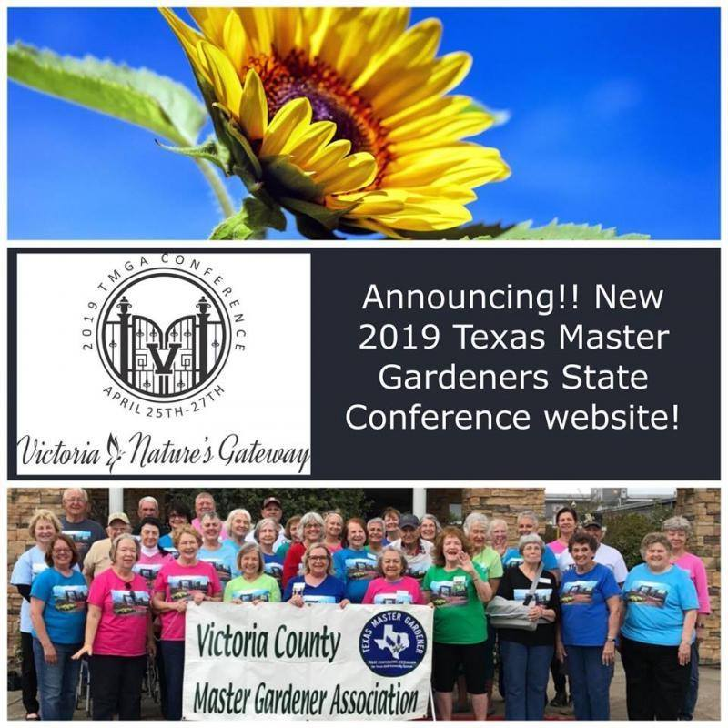
Visit the 2019 Texas Master Gardener Association Conference website for complete information. The Victoria County Master Gardener Association is very proud to host the April 25-27 event at Victoria Community Center, 2905 E. North St., Victoria, TX 77901.
http://2019tmgaconference.com/

Check out www.txmg.org for events around the state
New Braunfels area: http://txmg.org/comal/events
Austin Area: http://aggie-horticulture.tamu.edu/travis/
San Antonio, Texas- http://www.bexarcountymastergardeners.org

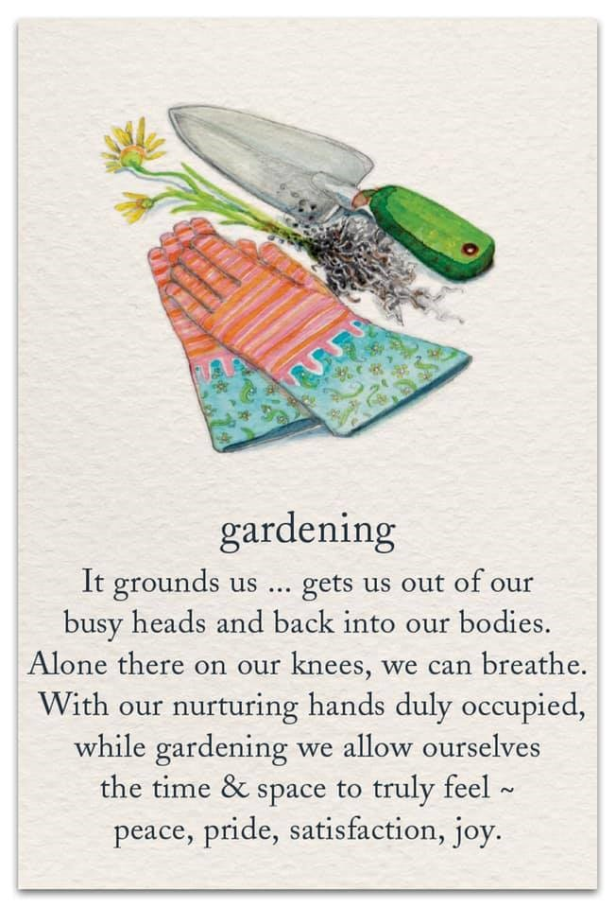
DATES TO REMEMBER: (Check elsewhere in newsletter for details)
Unless otherwise noted, all meetings/classes are at
623 N. Fair Street (Plantatarium: A Center for Exploration-aka PACE)

6 | 7  GH Workday 10 am | 8  MG Class  How to Plant Trees- Mark Kroeze | 9 | 10  1st grade Class Session 7:50 to 10 am East Avenue School | 11 | 12
13 | 14  Delivery of Bare Root Fruit Trees | 15 | 16 | 17 | 18 | 19
20 | 21 | 22  MG Class Vegetable Gardening  2nd grade practice session 1:00 pm | 23 | 24  1st grade Class Session 7:50 to 10 am East Avenue School | 25 | 26
27 | 28 | 29  MG Class Southern Gardens and Landscaping-William C. Welch | 30 | 31 Board Meeting  2nd Grade Program 7:30 to 11:30 am  Volunteer hours due | February 1 | 2
3 | 4 | 5 | 6 | 7  Noon MG lunch meeting  SPS mtg 1:30 pm | 8 | 9
10 | 11 | 12  MG Class Landscape Concepts and Design-Wendy Lovejoy | 13 | 14 | 15 | 16
17 | 18 | 19  MG Class Plant Pathology-Carolyn Parratt | 20 | 21  1st graders plant gardens | 22 | 23
24 | 25 | 26 | 27 | 28 Board Meeting  Volunteer hours due

Editors: Texas A&M AgriLife Extension Office
Fran Saliger 1709 E. Sarah DeWitt Drive
fsaliger@gvec.net Gonzales, TX 78629
Charlotte Knox Phone: 830-672-8531
lotteknox@aol.com Fax: 830-672-8532
Carolyn Parratt: Photographer E-mail: gonzales@ag.tamu.edu

Web pages: http://gonzalesmastergardeners.org

http://gonzales.agrilife.org

Extension programs serve people of all ages regardless of socioeconomic level, race, color, sex, religion, disability, or national origin. The Texas A&M University System, U.S. Department of Agriculture, and the County Commissioners Courts of Texas cooperating. Individuals with disabilities who require an auxiliary aid, service or accommodations in order to participate in this meeting are encouraged to contact the County Extension Office at 830-672-8531 to determine how reasonable accommodations can be made. The information given herein is for educational purposes only. Reference to commercial products or trade names is made with the understanding that no discrimination is intended and no endorsement by the Texas A & M AgriLife Extension

