As the Garden Grows
A Publication of the Gonzales Master Gardeners
Gonzales, Texas November 2018 Volume 8, Issue 10
Fall Tree & Plant Sale
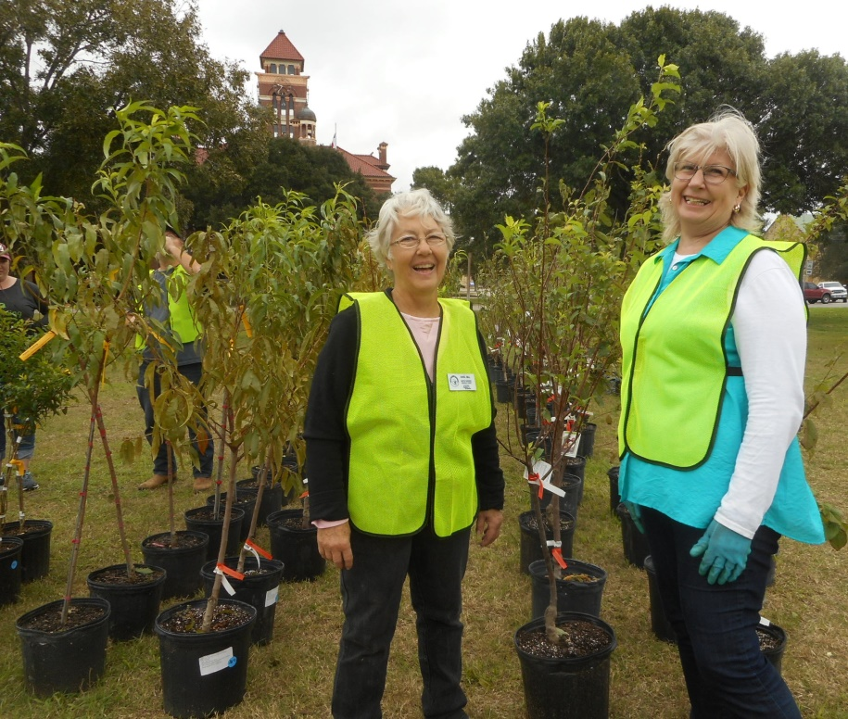
A great time was the topic of the day as we held our second annual Fall Tree and Plant Sale on October 20, 2018. Thanks to our two leaders, Donna Bell and Shirley Frazier the day was a great success. Thanks to all the volunteer Master Gardeners who worked the event through the week and on Saturday. The grounds were completely set up in a very short period of time on Saturday morning. There were very few trees and plants left at the end of the sale. Fruit trees (Santa Rosa Plum) that were left are still available for sale. Contact Shirley or Donna if you still want some trees.

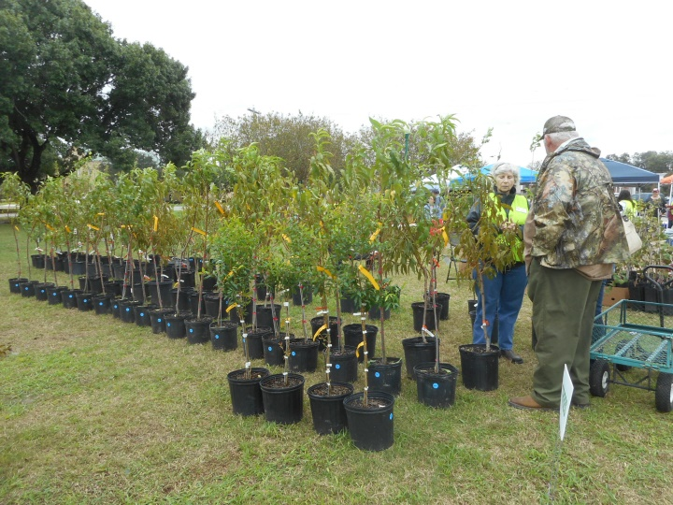
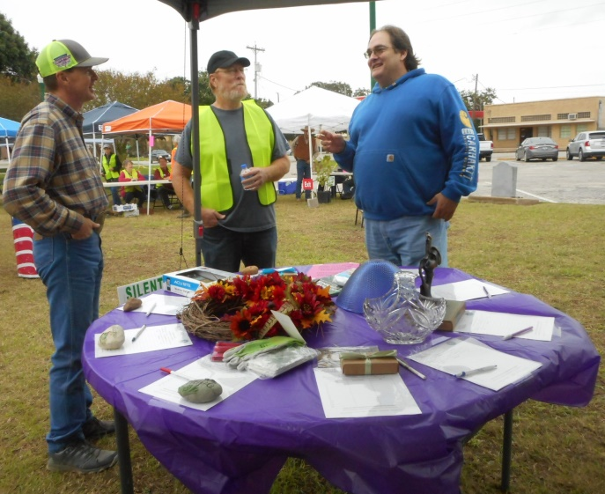
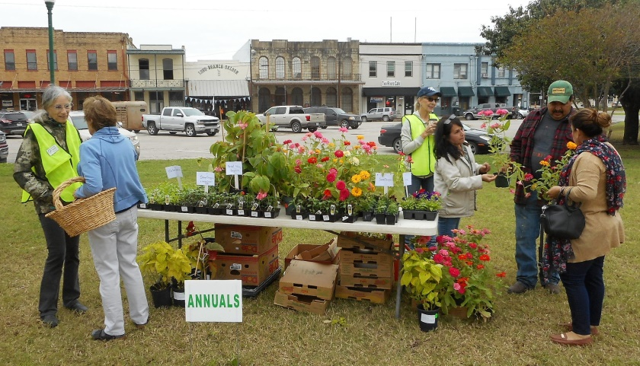

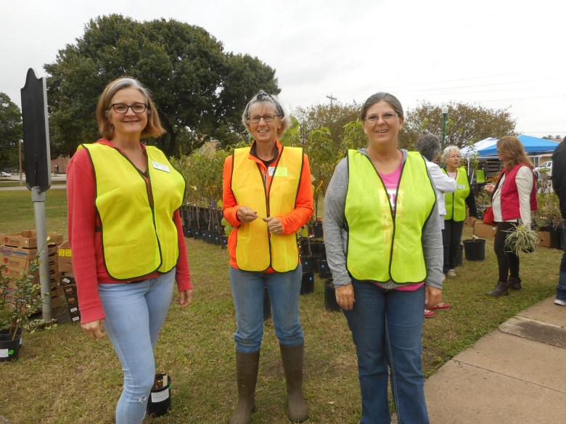
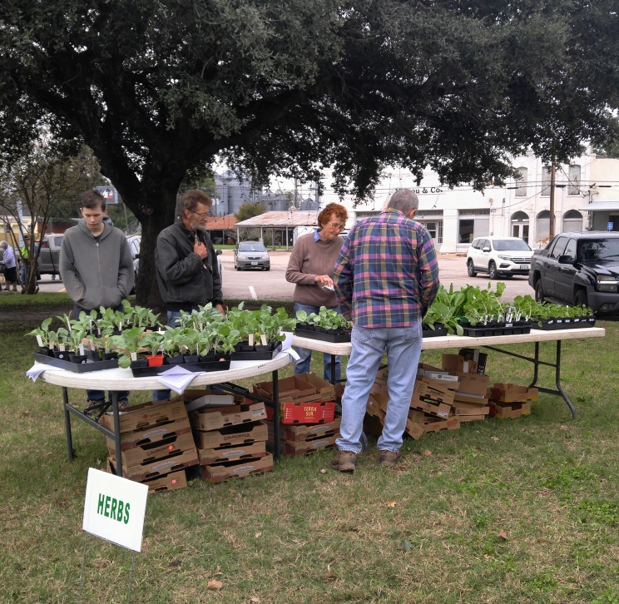

Are You Smarter Than a Second Grader?
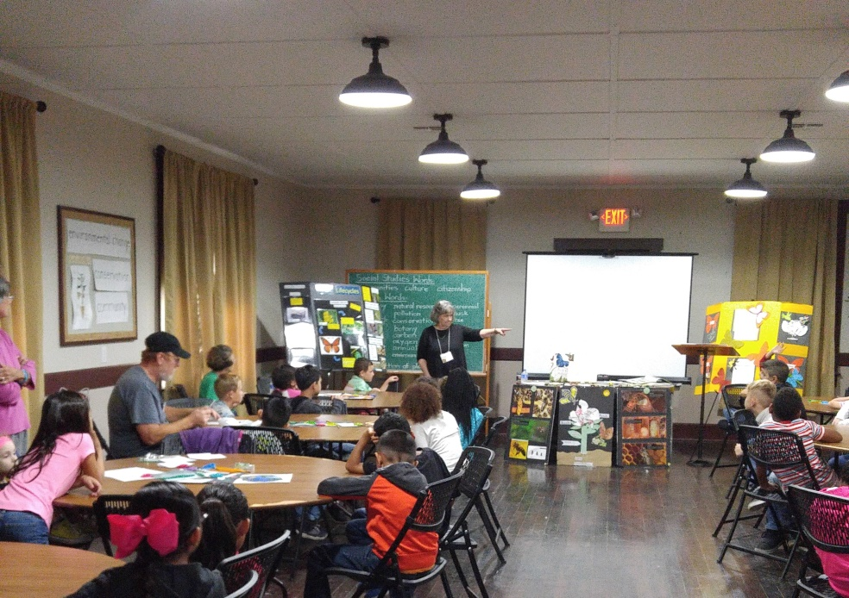
Margaret Bass, Bexar County Jr. Master Gardener teacher, taught the 2nd grade children from East Avenue Primary School about Insect Life Cycles on November 8, 2018. The children enjoyed the class sessions and made an Insect Life Cycle wheel demonstrating Complete and Incomplete Metamorphosis. Thanks to the eight volunteers who worked with the children during the five - thirty minute class sessions. We all learned, or should I say, refreshed our memories about Entomology and insect life cycles. The children were given worksheets to take back to class. Let’s see if you remember your MG training class about insects! The answers will be given out at the next noon MG general meeting!

Draw a line from the vocabulary word to its best meaning.
Metamorphosis the stage between molts
Pupae to change form
Instars resting stage of an insect
Larvae shedding skin to grow
Chrysalis the stage of an insect
Naiad the second stage of an insect in an incomplete lifecycle
Nymph four stage lifecycle
Adult hard outside skeleton
Molt houses an adult butterfly before birth
Incomplete an aquatic larvae
Complete the reproductive stage of an insect
Exoskeleton three stage lifecycle

Ture or False
1._______A nymph does not have wings
2. ______A pupa must eat a lot so that it can grow quickly.
3. ______When a larva molts, it sheds its outer layer of skin.
4. ______Most adult insects have six legs, three body parts, and antennae.
5. ______Incomplete metamorphosis involves a drastic change in body form.

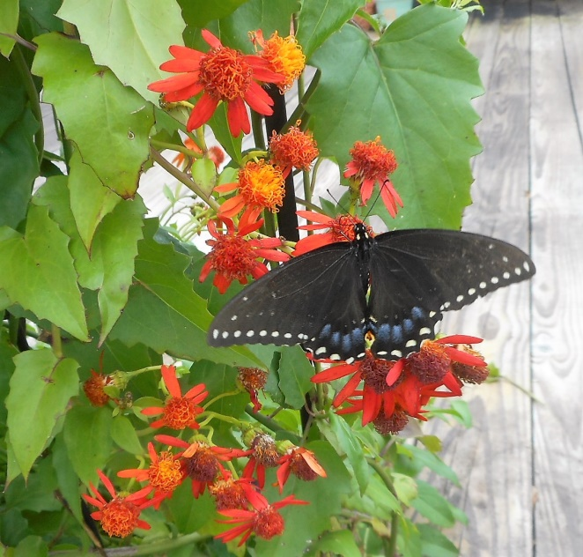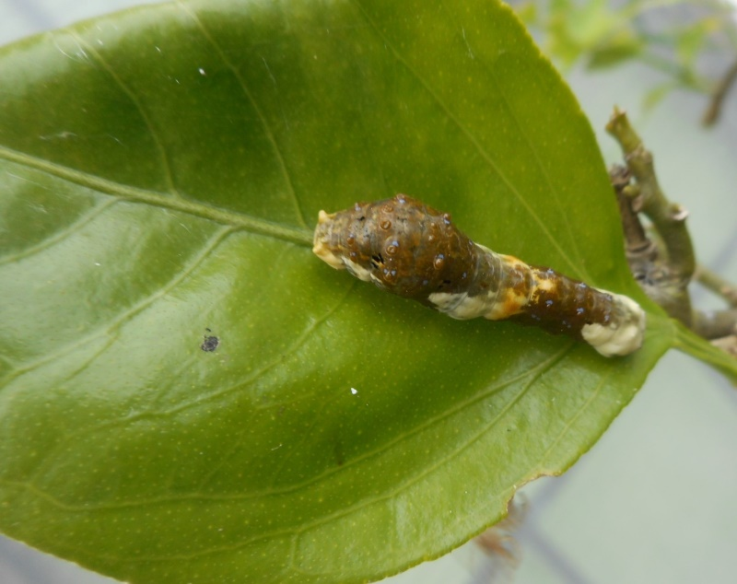
Black Swallowtail on Mexican Flame Vine Orange Dog Caterpillar (Giant Swallowtail Larvae on (photo by Carolyn Parratt) Citrus Tree) (photo by Carolyn Parratt)
NOTE: The next 2nd grade program will be in January. The children will be making paper mache Valentine Cards. If you have a blender that you can donate for the class, please drop them off at PACE and let Fran know. Thanks,
3rd Grade Black Walnut Tree Restoration Project
October 2, 2018-Thirty-two Black Walnut trees were given to the Gonzales Rotary Club to honor the 32 Gonzales Heroes who answered the call to help General Travis at the Battle of the Alamo in 1836. They will be planted on the grounds next to the bridge in J.B. Wells Park (as soon as the grounds dry out from all the rains)
11/13/18 –Black Walnut tree give away for the remaining trees planted by the 2017-2018 third graders from GISD.
11/15/18-“Pot Party” Filling tree pots with soil for the upcoming 3rd grade session. 9:00 am PACE
11/28/2018- Planting black walnuts with the 3rd grade students at PACE
Donna Bell will lead the program for the 3rd Grade class session. Numerous volunteers will be needed to get the tree pots ready on November 15 and assisting with the class on November 28. Please contact Donna Bell if you plan on volunteering for these two dates.
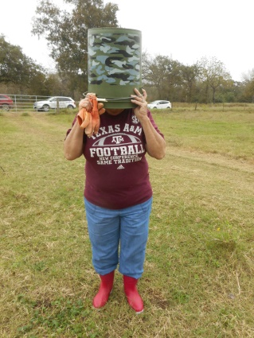
Thanks to the volunteers (Arline, Sandy Llewellyn, Nancy Foster, Carolyn Parratt and Bucket Head) who went out to Waelder on Monday, November 5 to gather walnut seeds for the upcoming planting session. Thanks to David DeMent who will once again prepare the seeds for the class (removal of the mushy outer husk).

NOTE: The board is working on ways to keep the area for the Gonzales Elementary Orchard from retaining so much water. Donnie Brzozowski, County Precinct 2 Commissioner, is working with GMG on the problem. His effort to help us resolve the issue is greatly appreciated so if you see him about the county give him a BIG Thank You. The unusual amount of rain we have had the last couple of months has created a problem with the upkeep of the trees.

Winter Social on December 6

Everyone and their wife, husband, friend or guest is welcome to our Annual Winter Social on December 6, 2018. The Board of Directors will provide the meat (Turkey and Ham) and beverage. Everyone else is asked to bring a side dish. Come out and enjoy a great meal and visit with fellow MGs and friends. The Volunteer(s) of the Year will be announced. Bring a door prize if you wish.

Gonzales Master Gardener Annual Dues

Gonzales Master Gardener member dues for 2019 are now being accepted. Dues are payable by cash or check, made out to GMG. Please submit your dues payment to GMG Treasurer, Nick Wentworth, by December 31, 2018.

Dues are $20 per year for certified MGs along with the required volunteer hours and CEU. If you graduated in May 2018 and did not certify, you do not pay dues until December 2019 if you become a certified MG (50 hours of MG training and 50 hours of volunteer time).

DATES TO REMEMBER: (Check elsewhere in newsletter for details)
Unless otherwise noted, all meetings/classes are at
623 N. Fair Street (Plantatarium: A Center for Exploration-aka PACE)

November 11 | 12 | 13 MG Class  Drip Irrigation,  Greenhouses,  Seed Starting-  Black Walnut Tree Distribution | 14  Propagation Workday in GH  9:00 am | 15  “Pot Party”  9:00 am | 16 | 17
18 | 19 | 20 | 21 | 22 | 23 | 24
25 | 26 | 27  MG Class  Entomology and Integrated Pest Management-Molly Keck  8:am 30-12:30 pm | 28  3rd Grade Black Walnut Project  7:45 am -noon | 29  Board Mtg. 9:30 am | 30  Volunteer hours due | DECEMBER 1
2 | 3 | 4 | 5 | 6  Winter Social- Noon Lunch | 7 | 8
9 | 10 | 11  MG Class-  Fruit Production-Gail Johnson 8:30 a.m-12:30 pm | 12 | 13 | 14 | 15
 | 17 | 18 | 19 | 20 | 21 | 22
23 | 24 | 25 | 26 | 27 | 28 | 29
30 | 31  Volunteer hours due | JANUARY 1 | 2 | 3  Noon MG lunch meeting | 4 | 5

Editors: Texas A&M AgriLife Extension Office
Fran Saliger 1709 E. Sarah DeWitt Drive
fsaliger@gvec.net Gonzales, TX 78629
Charlotte Knox Phone: 830-672-8531
lotteknox@aol.com Fax: 830-672-8532
Carolyn Parratt: Photographer E-mail: gonzales@ag.tamu.edu

Web pages: http://gonzalesmastergardeners.org

http://gonzales.agrilife.org

Extension programs serve people of all ages regardless of socioeconomic level, race, color, sex, religion, disability, or national origin. The Texas A&M University System, U.S. Department of Agriculture, and the County Commissioners Courts of Texas cooperating. Individuals with disabilities who require an auxiliary aid, service or accommodations in order to participate in this meeting are encouraged to contact the County Extension Office at 830-672-8531 to determine how reasonable accommodations can be made. The information given herein is for educational purposes only. Reference to commercial products or trade names is made with the understanding that no discrimination is intended and no endorsement by the Texas A & M AgriLife Extension

