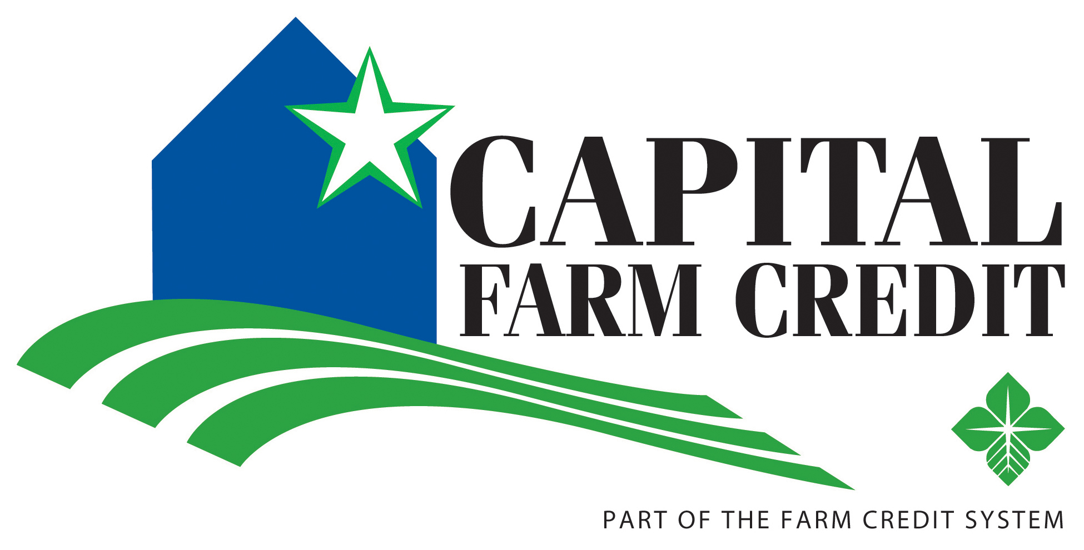 Scholarship Application
Sponsored by:
Burnet, Fredericksburg, Goldthwaite, Mason and San Saba Credit Offices

Ten $1,000 one-time scholarships to be awarded to students pursuing a degree in an agricultural or natural resources related field of study. Student must reside in one of the following counties: Blanco, Burnet, Coleman, Gillespie, Kimble, Lampasas, Llano, Mason, Menard, McCulloch, Mills, San Saba.

Capital Farm Credit supports rural communities and agriculture with reliable, consistent credit and financial services. And because a steady flow of credit means more jobs and economic growth, Capital Farm Credit is also helping invest in the vibrancy of communities throughout rural Texas through our scholarship program.

Scholarships awarded using eligibility requirements listed below:

- Funds used to attend an accredited vocational or technical school, college or university full time.

- Applicants must be upcoming high school graduates, within school year applied.

- Applicant must demonstrate that they have a tentative educational plan and goals, related to fields in

  - Agriculture or natural resources (may include ag communications, ag economics/business, ag education, ecosystem science & management, animal science, viticulture, etc.)
  - Technical vocation supporting agriculture and rural communities and industries

- Applicants must include the following documents for consideration.
(Please send all documents together)
  - Completed application** b. Current High School Transcript
- 1-2 letters of recommendation d. Essay on topic given in application

- Applications and all supporting evidence must be received by March 5, 2021.
  - No late submissions will be accepted.
  - The guidance counselor of each scholarship winner will be notified.

Mail or hand deliver to: Email Submission:
CFC Scholarship Committee Leslie.Krieg@CapitalFarmCredit.com
150 E. Main St. Suite 310 *you will receive a reply email acknowledging receipt of
Fredericksburg, TX 78624 your application (if you don’t please call)
830-992-2110

2021 Scholarship Application

Student Name: Cell Phone: Student Email:

Address:
^{Address City State ZIP}
High School: Year Graduating

GPA (College 4.0 from transcript): Class Rank: /

Parent/Guardian Names & Occupations:

Parent Cell Phone: Parent Email:

What University/Institution do you plan to attend?

Selected Major:

Are your parents/grandparents employees of Capital Farm Credit? Yes or No
If yes, name and office location:

Are your parents/grandparents members of Capital Farm Credit? Yes or No

Academic Honors:

Extracurricular Clubs and Activities:

Community Involvement:

Work Experience:

Other Scholarships Applied for:

Essay Portion:

Please write (or attach) a 100-200 word essay on one of the following topics.

- Why you chose the Major/Trade you did?
- How agriculture has shaped who you are today?
- What involvement you have had in agriculture and how you think that has benefited you?
- What do you think are the most significant challenges facing agriculture and rural America?

In applying for this scholarship I vow that all information contained within this application and all supporting documents are true and no attempt to falsify information has been made.

I agree to permit review of this application and relevant information by the scholarship committee.

Should applicant be awarded a scholarship, applicant and parent/guardian agree to allow Capital Farm Credit to publish recipient’s name and photograph in news publications.

Signature of Applicant: _________________________________________Date:______________

Signature of Parent/Guardian: ___________________________________Date:______________

