HGAC-W / LOWER COLORADO REGION

REGIONAL OFFICE LOCATION
Fort Bend County
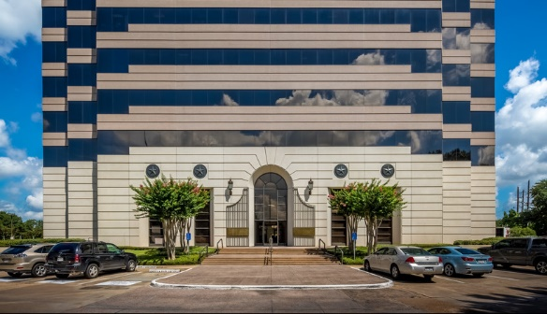
Sugar Land
1 Sugar Creek Center Boulevard, Suite 200
Sugar Land TX 77478
Hours:
- Monday - Friday 8:00 a.m. to 6:00 p.m.
- Saturday - 8:00 a.m. to 4:00 p.m.

SATELLITE INTAKE CENTER LOCATIONS
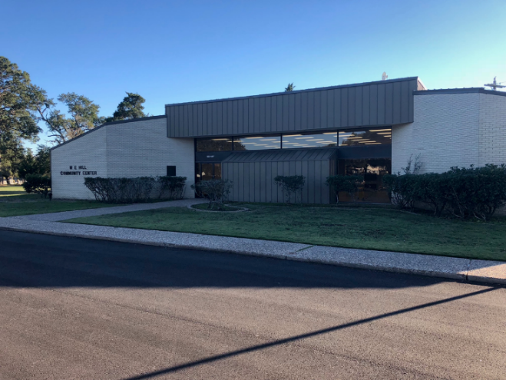
AUSTIN COUNTY
W.E. Hill Community Center
1000 Main St
Sealy TX 77474
Hours:
- Tuesday 9 a.m. - 4 p.m.
- Thursday 9 a.m. - 4 p.m.

COLORADO COUNTY
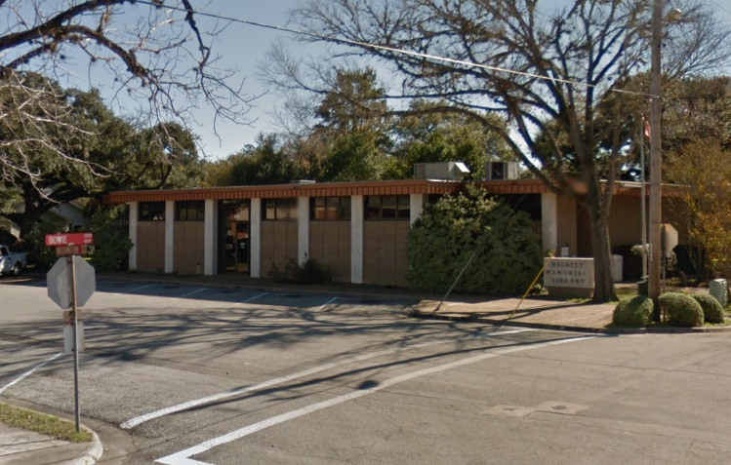
Nesbitt Memorial Library
529 Washington Street
Columbus TX 78934
Hours:
- Monday 12 p.m. - 7 p.m.
- Tuesday 12 p.m. - 7 p.m.
- Wednesday 9 a.m. - 6 p.m.
MATAGORDA COUNTY
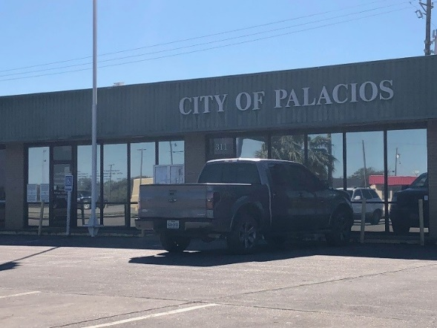
Palacios City Hall
311 Henderson Avenue
Palacios, TX 77645
Hours:
- Tuesday 9 a.m. - 4:30 p.m.
- Wednesday 9 a.m. - 4:30 p.m.
- Thursday 9 a.m. - 4:30 p.m.

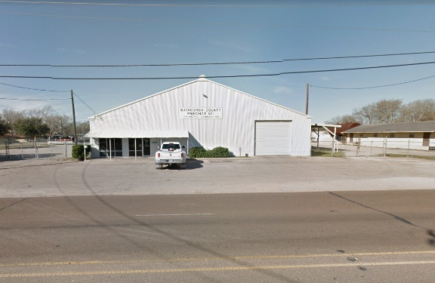
Precinct 1 Barn
2604 Nichols Avenue
Bay City, Texas 77414
Hours:
- Monday 8:30 a.m. - 4:30 p.m.

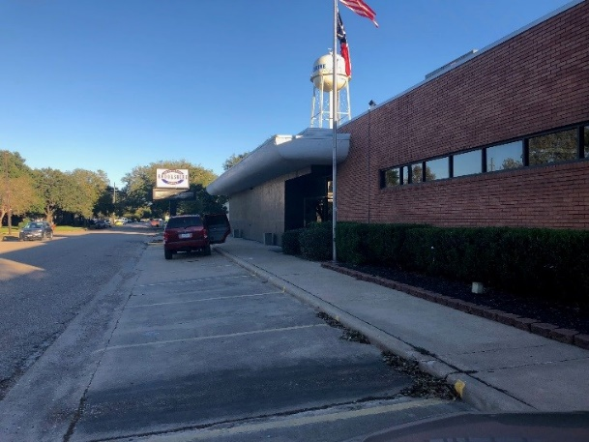
WALLER COUNTY
Brookshire Convention Center
4029 5th Street
Brookshire, TX 77423
Hours:
- Monday 9 a.m. - 4 p.m.
- Wednesday 9 a.m. - 4 p.m.

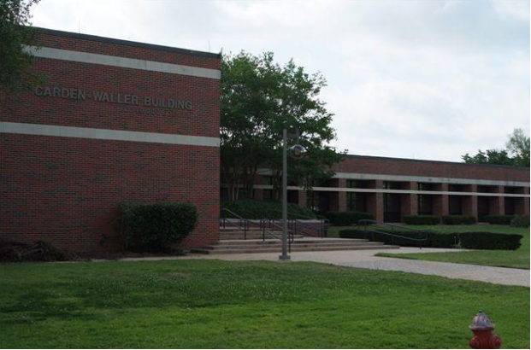
Carden-Waller Cooperative Extension Building - Prairie View A&M University
250 E. M. Norris Street
Prairie View, TX 77445
- Tuesday 9 a.m. - 4 p.m.
- Thursday 9 a.m. - 4 p.m.

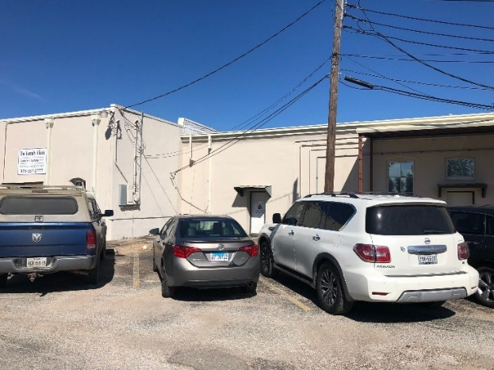
WHARTON COUNTY
Wharton Recovery Team
307 W. Milam Street, Suite 307
Wharton, TX 77488
Hours:
- Tuesday 9 a.m. - 4 p.m.
- Wednesday 9 a.m. - 4 p.m.
- Thursday 9 a.m. - 4 p.m.

