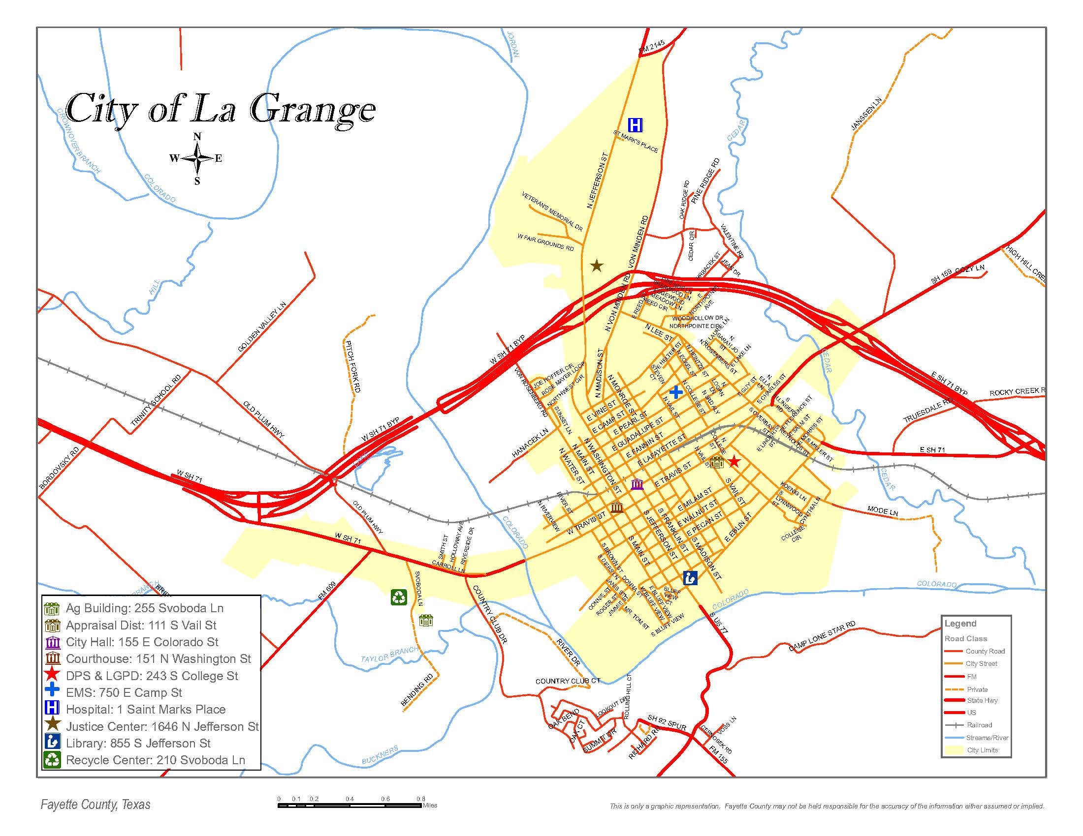
If coming from Brenham area on US-290
Take US-290 W for (35.7 mi)
Take 237 S to E Hwy 71 Business/E Travis St in La Grange
Continue on East Travis St Drive to Bending Rd (2.6 mi)
Turn left onto Bending Rd (.25 mi)
Fayette County Agriculture Building will be on the left

If coming from the Austin area (54 mi)
Follow TX-71 E to TX-71 Bus E/W Travis St in La Grange
Take the TX-71 Bus exit from TX -71 E (46 mi)
Continue on TX-71 Bus E/Travis St Dr to Bending Rd
Turn right and follow Bending Rd to Fayette County Agricultural Building on the left

Directions from Houston

Directions from Victoria

