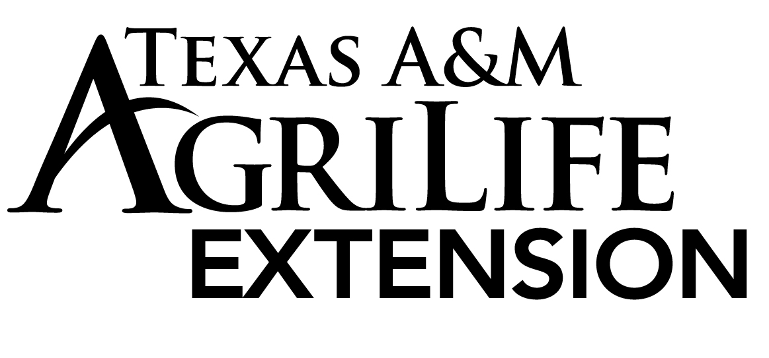

Food Handlers
Registration Form

Course Information
COUNTY
CLASS DATE
INSTRUCTOR
COST | $20.00

Participant Information (Please Print Clearly) - $5 WILL BE CHARGED FOR A NEW CORRECTED CARD TO BE SENT TO YOU. CARDS RETURNED TO US WILL NOT BE RE-MAILED, UNLESS WE ARE CONTACTED. THANK YOU.
NAME:
MAILING ADDRESS:
CITY, STATE, ZIP
PHONE #:
EMAIL:
ESTABLISHMENT:
RECEIPT #: Circle One - CASH or CHECK

Please make check or money order payable to:
FPM Account # 230202

