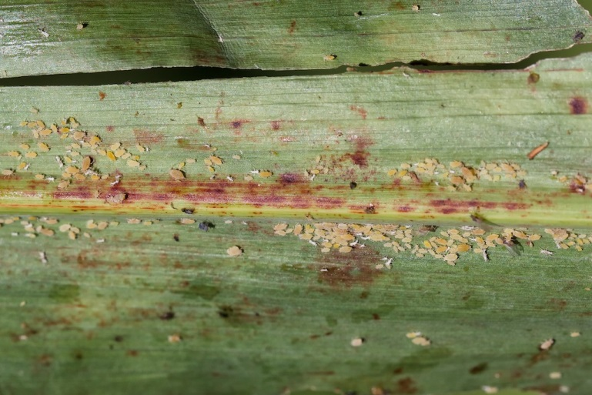

Pictured are about 180 sugarcane aphids on a sorghum leaf, well above the 50-aphid trigger-to-treat number experts advise. (Texas A&M AgriLife Extension Service photo by Dr. Pat Porter)

Sugarcane aphid, the pest that devastated thousands of acres of grain and forage sorghum crops last year across the south, has again been spotted in West Central Texas, an expert warns.

Blayne Reed, Extension Agent - IPM in Hale, Swisher and Floyd has alerted that the Sugarcane Aphid has been spotted in his counties. It has also been alerted that the aphid has been spotted in Lubbock and Crosby counties at the economic threshold of 50-125 aphids per leaf.

Dr. Charles Allen, Texas A&M AgriLife Extension Service state integrated pest management leader at San Angelo, said Michael Palmer, AgriLife Extension agent in Coleman County, alerted him to the threat.
After confirming the find as sugarcane aphid, Allen made several more spot checks, which all proved positive.

“Sugarcane aphid infestations of grain sorghum were found June 26 in Coleman, Runnels and Tom Green counties,” Allen said. “In all cases, the infestations had been present for less than a day to three days.

“Sugarcane aphids do three things really well. First, they are capable of migrating long distances. Second, they have a very high reproductive capability and their populations can increase to damaging levels very quickly. And third, they produce large amounts of sticky honeydew, which negatively affects the host plants, the aphids’ natural enemies and our ability to harvest crops. The sticky residue, excreted as waste from the bug, gums up harvesting equipment and if heavy enough, makes harvesting all but impossible. Sticky leaves and stalks can actually choke down the equipment, be it a combine or hay swather.”

The discovery of sugarcane aphids in the region means growers should now begin inspecting their grain sorghum and forage sorghum crops weekly for the pest. Allen said action should be taken if sugarcane aphid levels exceed 50 aphids per leaf.

Complete sugarcane aphid scouting instructions are available at, http://ccag.tamu.edu/files/2015/05/ScoutCard.pdf .

Allen said two insecticides have been found to be effective, Sivanto and Transform.

“The trouble is, it’s difficult for insecticides to work on thick vegetative growth in grain sorghum and especially in forage sorghum fields, because good spray coverage of the insects is essential,” Allen said. “On large stands of forage sorghum, cutting the crop for hay may be a better option.”

Allen said hope is on the horizon as the first round of sugarcane aphid-resistant grain sorghum varieties are now available and appear to help curb damage caused by the aphid.

“Natural enemies of the aphid, referred to as ‘beneficials,’ also help hold back populations of this pest,” he said. “However the colonies found in West Central Texas had not yet attracted significant populations of natural enemies for any effective control. And when these aphids ramp up to their biotic reproductive potential, natural enemies usually just can’t keep up with their rapidly expanding populations. So, I’m warning grain and forage sorghum producers to be proactive now in protecting their crops, before it’s too late.”

Allen said the bountiful rains most of Texas has enjoyed this spring and summer suppressed the sugarcane aphid in South Texas, but those rains also delayed cotton planting in many areas forcing many farmers to plant sorghums instead, thus increasing the potential for trouble.

“This is about the time sugarcane aphids showed up in our West Central Texas area last year,” Allen said. “Most of our producers are now familiar with the damage they can do, so I’m not expecting any widespread panic, though I do urge growers to practice due-diligence and be ready to act if conditions warrant. Doing so may well save their crop, as the pest left unchecked can easily damage a field in a matter of days.”

Sugarcane aphid, first discovered in Florida in 1977, has historically been a pest of coastal sugarcane crops, but was never seen to damage Texas sugarcane. For some reason, it acquired a taste for sorghum with the first documented instance occurring near Beaumont in 2013, Allen said.

“Since that first sighting, things started happening fast; populations literally exploded during the fall of 2013-2014 and then again last year,” he said.

“We’ve learned a lot since that first sighting, specifically, that the best defense is an aggressive offense, starting with that field scouting. Check at least 20 plants in four locations in each field, whether it’s grain sorghum or forage sorghum for that 50-aphid threshold. If the majority of the plants in a field are sticky and shiny with honeydew, you’ve already exceeded that threshold…by a lot.

“So get out in your fields at least once a week now and have a good look around, because they’re here.”

