**2016 Texas Panhandle Cotton Variety Trials**

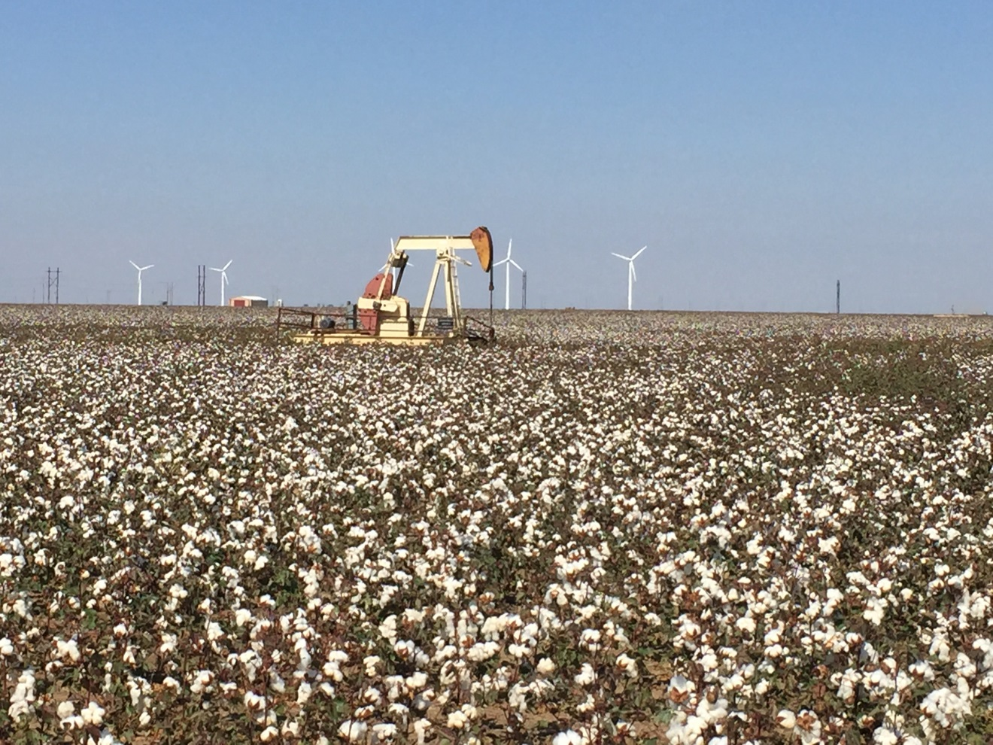

**Jourdan Bell, PhD**

**Extension and Research Agronomist – Amarillo**

**Seth Byrd, PhD**

**Extension Cotton Agronomist – Lubbock**

**Preston Sirmon, Extension Assistant**

**Carla Naylor, Research Associate**

**Bronc Finch, Research Technician**

**Rick Auckerman, Deaf Smith County Agent**

**Michael Bragg, Hartley County Agent**

**Marcel Fischbacher, Moore County Agent**

**John Villalba, Swisher County Agent**

**Curtis Preston, Bailey County Agent**

**Jody Bradford, Carson County Agent**

**Mike Jeffcoat, Gray County Agent**

We wish to express our appreciation to the cooperators (Frank Bezner – Deaf Smith County, Middlewater Farms - Hartley County, Williams Family – Parmer County, Jeremy Reed – Swisher County, Ryan Davis - Gray County, Tommy Cartrite - Sherman County) for providing the land, equipment and time to conduct these trials. Furthermore, we thank Dr. Jane Dever and Ms. Valerie Morgan (Texas A&M AgriLife Research) for the use of the ginning facilities and Dr. Eric Hequet (Texas Tech University Fiber and Biopolymer Research Institute) for HVI fiber quality analyses. We sincerely thank **Cotton Incorporated through the Texas State Support Committee** (Project 07-947TX) for supporting these trials.

**2016 Texas Panhandle Cotton Variety Trials**

While variety selection is one of the most important decisions a producer makes in all cotton producing regions, cotton varietal selection in the northern Texas Panhandle counties can be especially challenging as a result of a narrow production window between planting and harvest. The Northern Texas Panhandle cotton production is generally limited by sufficient growing degree days (GDD) to drive the maturation of long-season cotton varieties. Uniform germination and timely establishment are essential for adequate GDD accumulation and yield optimization; however, the combined effect of cool spring temperatures and a short growing season often results in reductions in early season vigor and seasonal GDD accumulation. Commonly, early and medium maturity varieties that are better adapted to the region’s short growing season are planted, but these varieties are also susceptible to non-ideal conditions at planting resulting in poor germination and vigor. Consequently, knowledge of varietal performance under Texas Panhandle environmental conditions is critical to maximize net return. Early to mid-season varieties are well positioned for this cotton region. Early and medium maturing varieties have a shorter bloom period and are generally more determinant than full season varieties. As a result, early maturing varieties are less able to recover from in-season stress; specifically severe weather that results in the need for average storm tolerance. The objective of this project was to evaluate the profitability of newer early- and medium- maturing cotton varieties grown in large-plot, on-farm trials under Texas Panhandle environmental conditions and production practices.

**Materials and Methods**

Varieties were planted in a randomized complete block design with three replications at three locations. Varieties and characteristics are outlined in Table 1. The 2016 trials were located in Deaf Smith County (Hereford) with Frank Bezner, Hartley County (Middle Water) with Middlewater Farms, Parmer County (Farwell) with the Williams Family, Sherman County (Sunray) with Tommy Cartrite, and Swisher County (Kress) with Jeremy Reed. A sixth location was planted in Gray County (Pampa), but due to emergence issues the trial was terminated on June 29, 2016. All locations were under center pivot irrigation. All plots were eight rows by a minimum length of 500 feet and replicated three times. Agronomic practices including planting date and planting populations are outlined in Table 2 for all locations. Weed and insect control measures, if needed, and harvest aid applications were performed by cooperating producers. Plots were harvested using producer/cooperator equipment, and grab samples were taken by plot and were be ginned at the Texas A&M AgriLife Research and Extension Center at Lubbock. Resulting lint samples were submitted to the Texas Tech University – Fiber and Biopolymer Research Institute for HVI fiber analysis and CCC loan values were calculated for all locations. The Commodity Credit Corporation lint loan value was calculated using the high-volume instrument (HVI) classing information to apply either premium credits and/or discounts from the base loan value of $0.52/pounds for upland cotton for all varieties. Ginning costs were calculated at $2.75/cwt (2016 Texas Agricultural Custom Rates, <http://agecoext.tamu.edu/files/2013/07/TxCustomRateSurveyMay2016.pdf>). Seed value was calculated at $200/ton.Yield and quality were evaluated for significant statistical differences. Statistical analyses represent the significance of the difference between varieties. A CV (coefficient of variation) describes the variability of the data with a target CV value of 15% or less. The LSD (least significant difference) describes the statistical difference between varieties with 95% confidence.

**2016 Highlights**

Cool temperatures and late spring precipitation prevailed through the 2016 cotton planting season. As a result, most locations were planted with good soil moisture. While soil temperatures at all locations were above 60°F at planting, cool, wet conditions slowed germination at all locations except the Hartley County location where the sandier soil at the likely resulted warmer soil temperatures and more uniform emergence (Table 3). Due to cool, wet planting conditions, there was poor emergence at the Swisher County location planted on May 6, 2016. The trial was replanted on June 7, 2016.

Cool, wet conditions coupled with low nightitime temperatures resulted in delayed early-season development as reflected in the growing degree days (GDDs) accumulated (Fig. 1) at all locations. Late July and early August were marked by several weeks with daily highs that reached or exceeded 100°F causing some stress during the peak bloom period. September brought much need precipitation and cooler temperatures; however, this also resulted in secondary regrowth at several locations requiring aggressive PGR management.

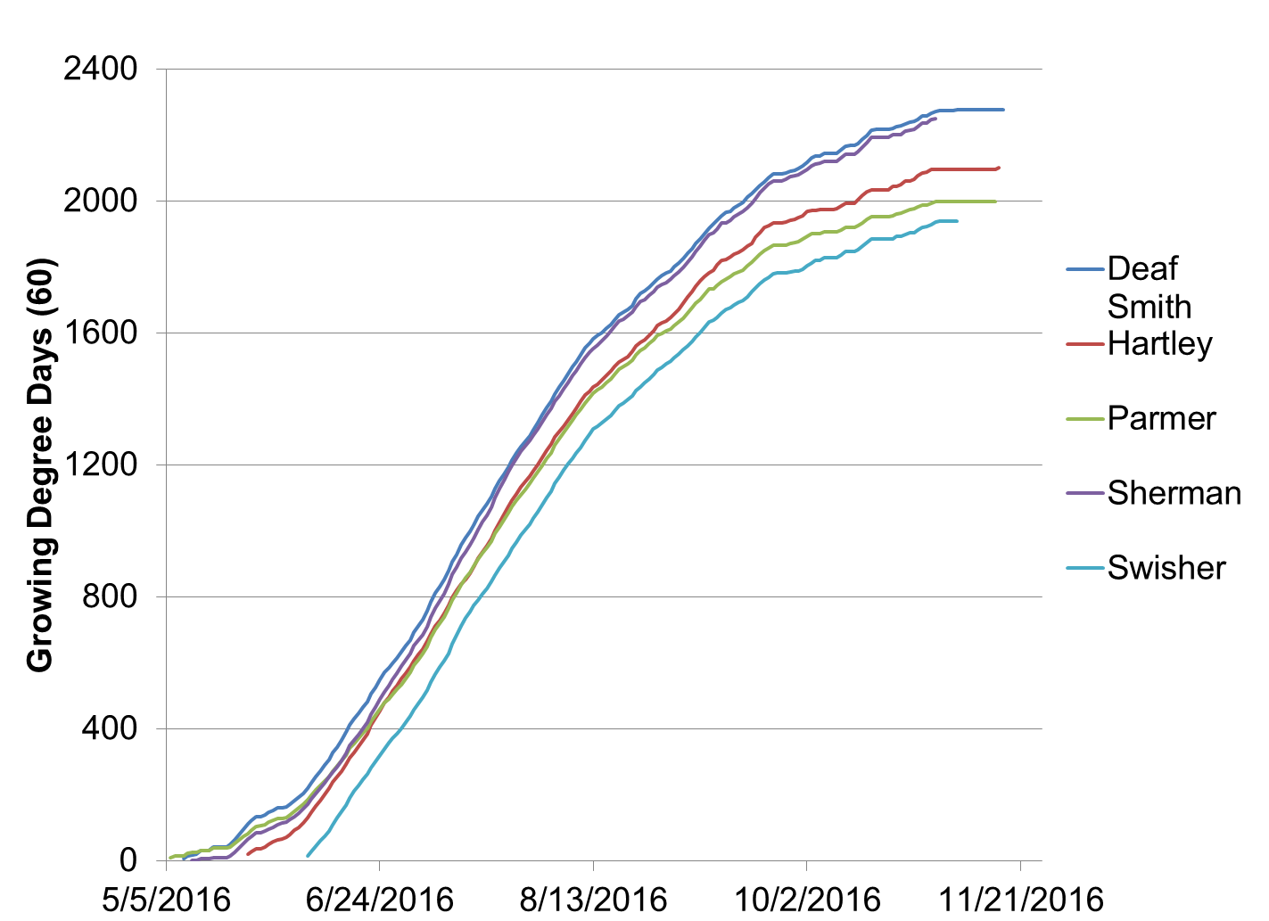

Figure 1. Growing Degree Day (GDD60) accumulation for all locations from planting.

Lint production was greatest at the Deaf Smith, Hartley and Sherman County locations for all varieties (Fig. 2). Production at Parmer County was affected by Verticillium Wilt that resulted in premature defoliation especially for non-tolerant varieties. At the Parmer County trial, all plots were rated for defolation damage (Table 4), and the greatest yields were achieved with tolerant varieties such as Phytogen 243 and Stoneville 4747GLB2. Verticilium was also found at the Sherman County trial, but not at yield limiting levels that warranted ratings. Lint production at the Swisher County trial was affected by the late planting. Detatiled yield and quality results are presented for all locations in Tables 7-16. Varieties ranked by lint yield (lb/ac) and net value (return/ac) are listed in Tables 15 and 16, respectively to evaluate yield stability. In the 2016 Texas Panhandle Cotton Variety trials, there was not a specific variety that topped yields at all locations; however, Deltapine 1612B2XF, Fibermax 1320GL, NexGen 3405B2XF, and NexGen 3406B2XF all yielded above 1600 lbs/acre lint at the Deaf Smith, Sherman and Hartley County locations where yield was not limited by disease or late planting (Fig. 2).

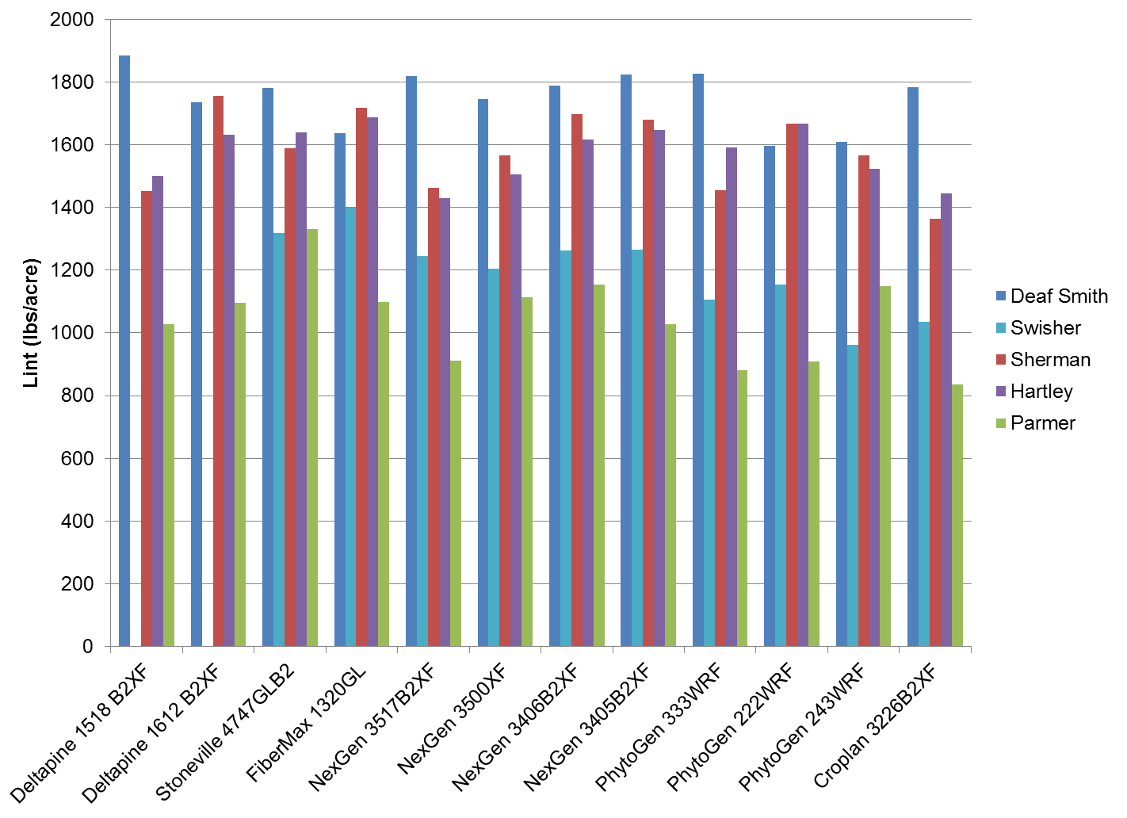

Figure 2. 2016 Lint yield (lbs/ac) distribution across trial sites.

Table 1. 2016 Variety Characteristics



Table 2. 2016 Agronomic information by location.



Table 3. Four-week stand counts by location.



Table 4. Verticillium ratings at Parmer County.

|  |  |  |
| --- | --- | --- |
| **Variety** | **Rating†** | |
| Deltapine 1518 B2XF | 3.0 | abc |
| Deltapine 1612 B2XF | 2.6 | abc |
| Stoneville 4747GLB2 | 1.8 | c |
| FiberMax 1320GL | 4.8 | a |
| NexGen 3405B2XF | 2.6 | abc |
| NexGen 3406B2XF | 1.8 | c |
| NexGen 3500XF | 2.8 | abc |
| NexGen 3517B2XF | 3.0 | abc |
| PhytoGen 222WRF | 4.2 | ab |
| PhytoGen 243WRF | 3.7 | abc |
| PhytoGen 333WRF | 1.0 | c |
| Croplan 3226B2XF | 2.0 | bc |
| † Rating Score: 0=no verticillium damage | | |
| to 10=100% verticillium damage | | |

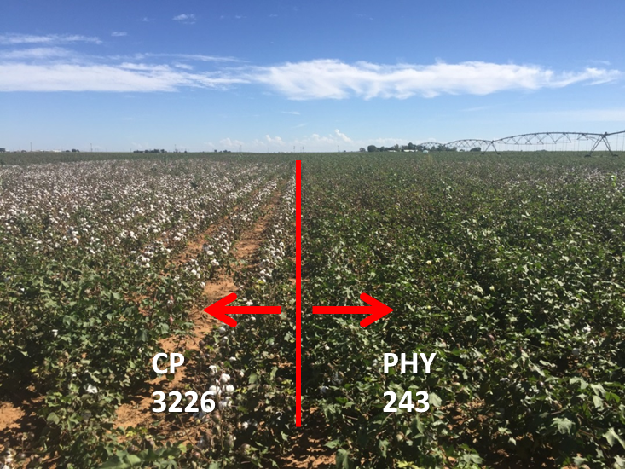

Figure 3. Visual differences in defoliation damage from Verticilium Wilt at the Parmer County trial between non-tolerant Croplan 3226 (left) and tolerant Phytogen 243 (right).





















Table 15. 2016 Varieties ranked by lint yield (lb/ac).



Table 16. 2016 Varieties ranked by net return ($/ac).

