Relevance
Corn & Sorghum in-depth programming was conducted by the Texas AgriLife Extension Service. The purpose of in-depth educational effort was to help producers be profitable in a very challenging market climate. Since crop production is a very involved and management intensive in an always changing environment the more informed producers are the better prepared they are to make sound management decisions that impact profitability. These decisions start many times a year in advance selecting weed control options, markets, crop rotations, soil fertility and others before the seed is ever planted. Dallam & Hartley Agriculture Program Area Committee has recognized that producers are being challenged with traditional crops like corn & sorghum because of many factors some of which (weather related) we have little recourse. The producers in this area are very innovated and are experienced in growing crops in a very challenging environment.

Response
Corn & Sorghum in-depth programming featured a combination of educational, programs, result demonstrations, news media presentations, turn row meetings and field days.

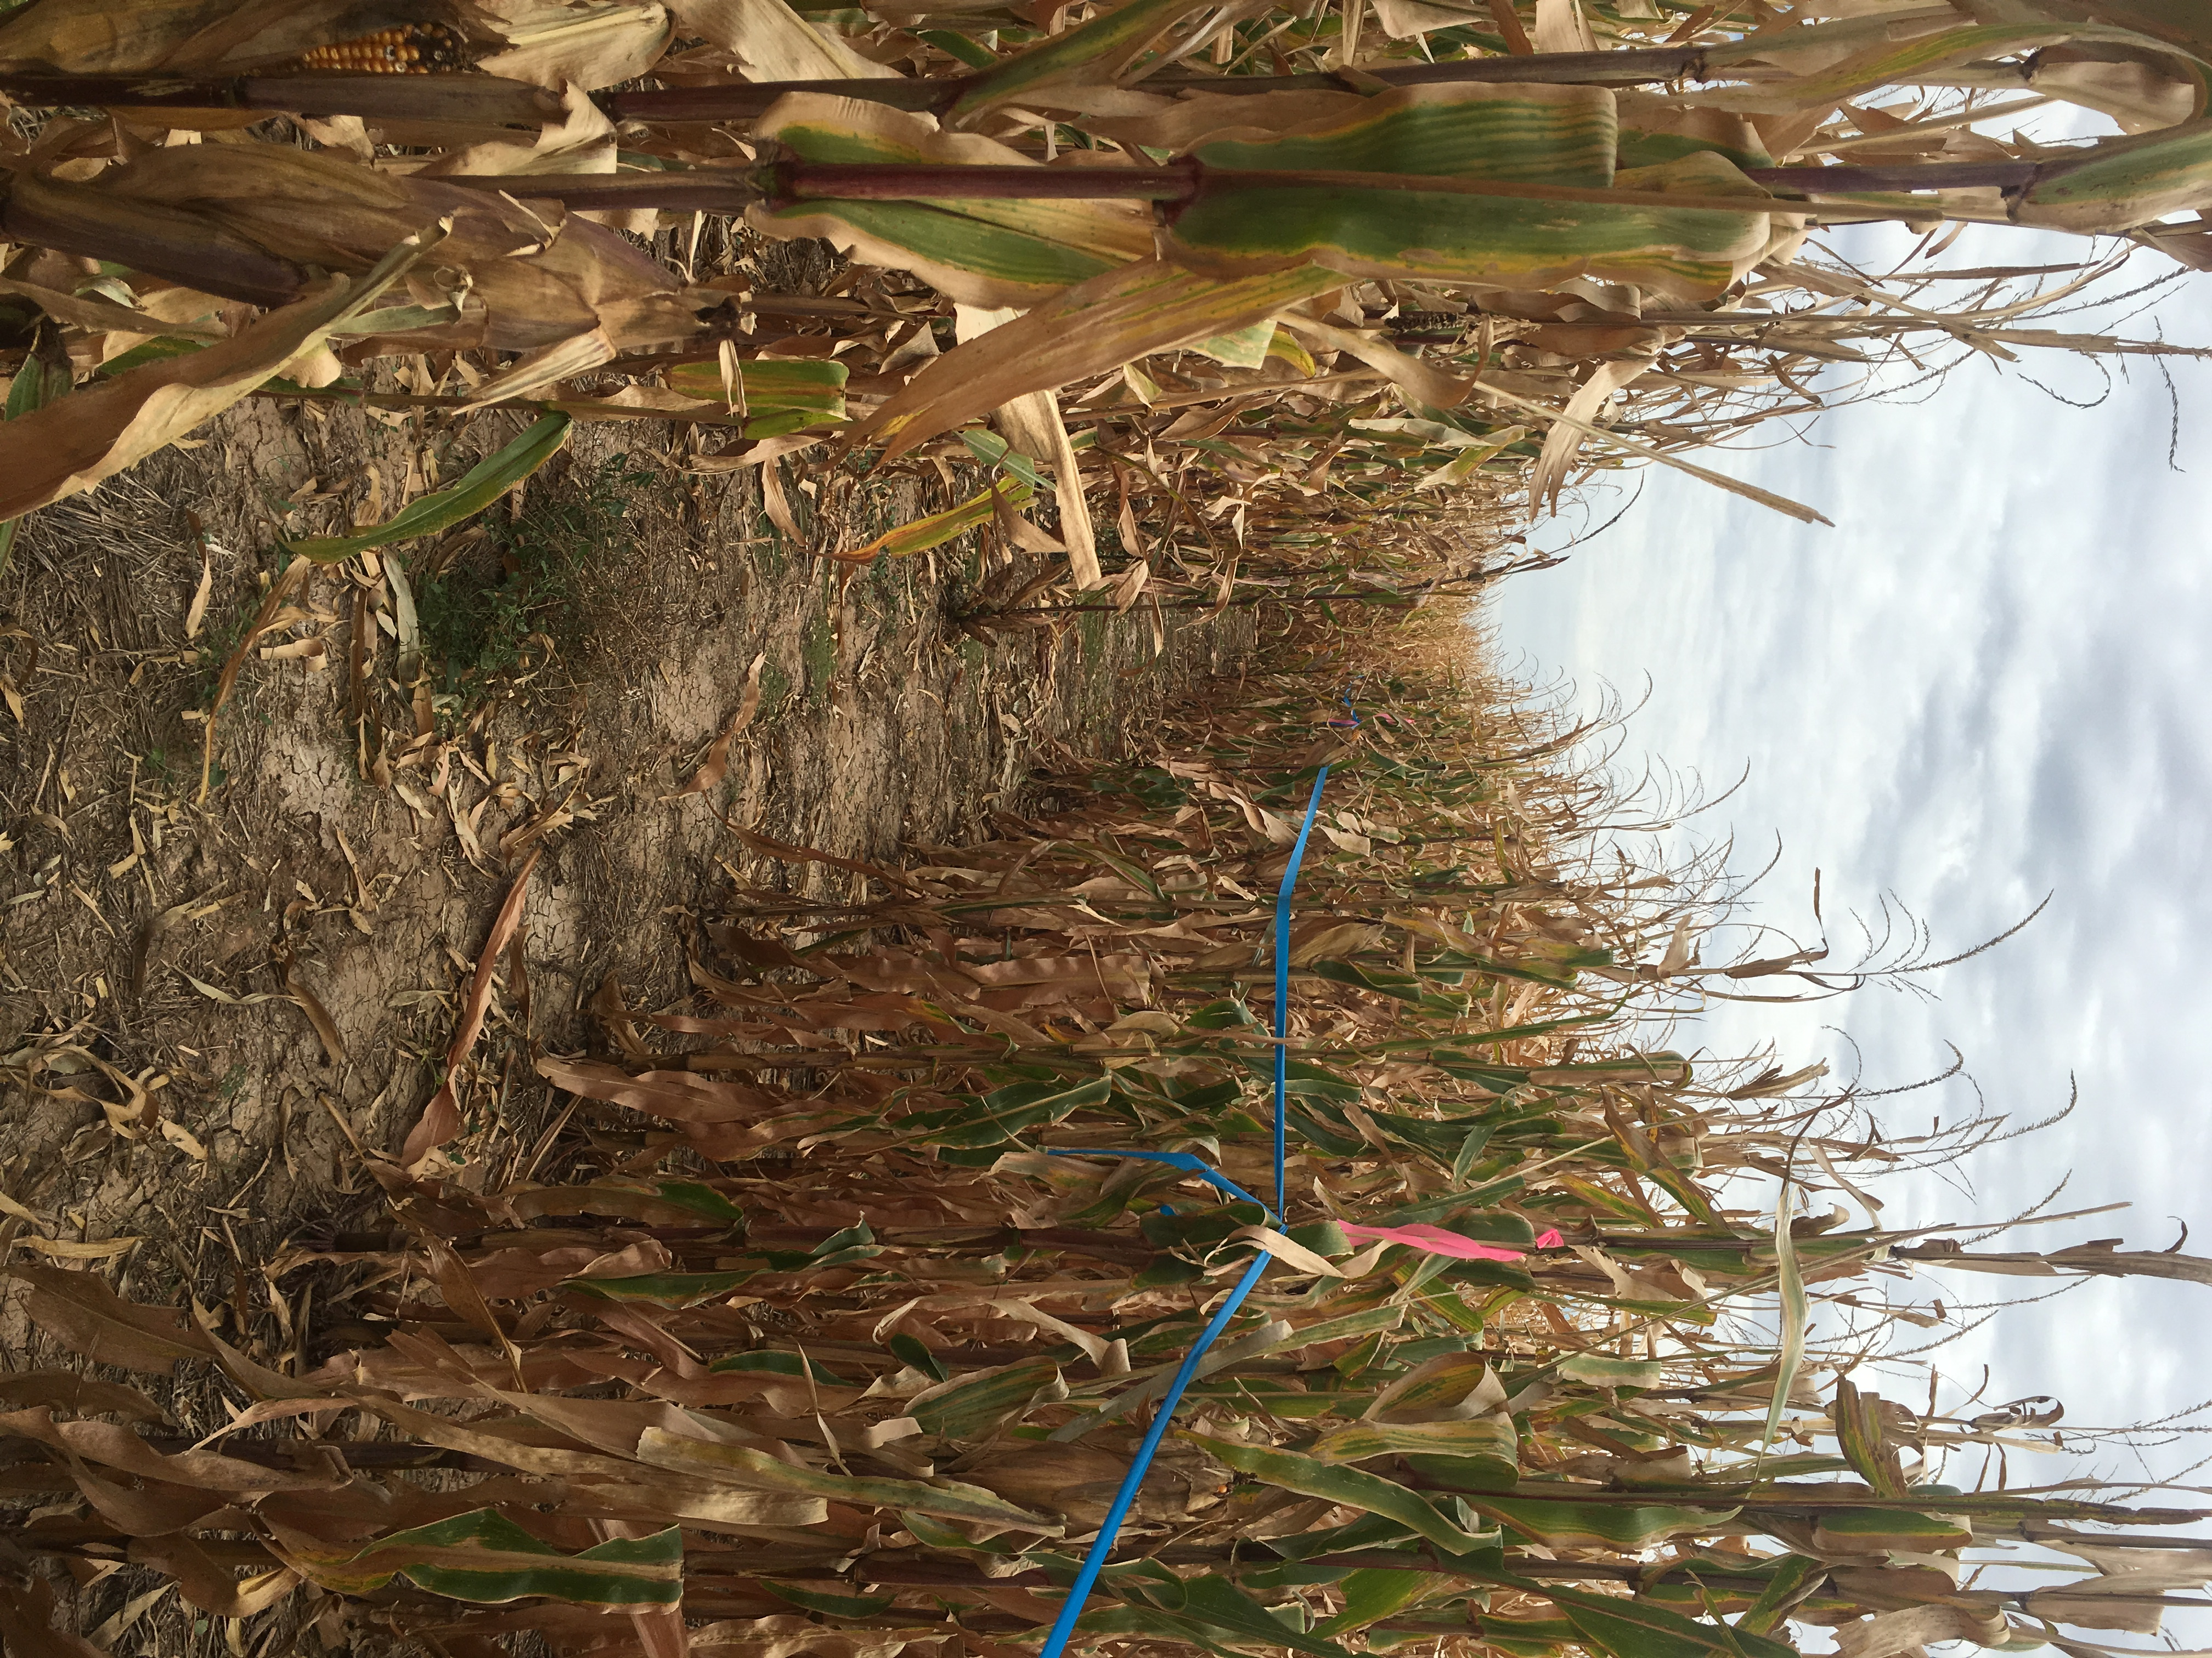
Multi-County Corn/Sorghum Conference held in Dalhart in January was attended by 130 producers. Result Demonstration work in Overwintering of Sugar Cane Aphid, Texas A&M Corn Variety Test, Local County Agent Corn Variety Test, and Panhandle Moth Trapping Survey all were supporting this in-depth program. News Media presentations on topics such as bubble vs sprinkler irrigation, fertigation of nitrogen in corn and grasshopper control in corn were presented by agent. Turn row meetings both at the field and indoors assisted producers with emerging needs with integrated pest management and irrigation. For example grasshoppers and late season spider mites were definite major pest this year. These turn row meetings focused on how to scout and manage pest. Field Day highlighted variety test plots and moth trapping survey. Weekly text blitz from the Ag Agent to producers and consultants have been a popular approach to communicating with producers and can be a very valuable method to notify producers of emerging needs during the growing season.

Above is an example how we mark for the producer the corn that is in our test plot.

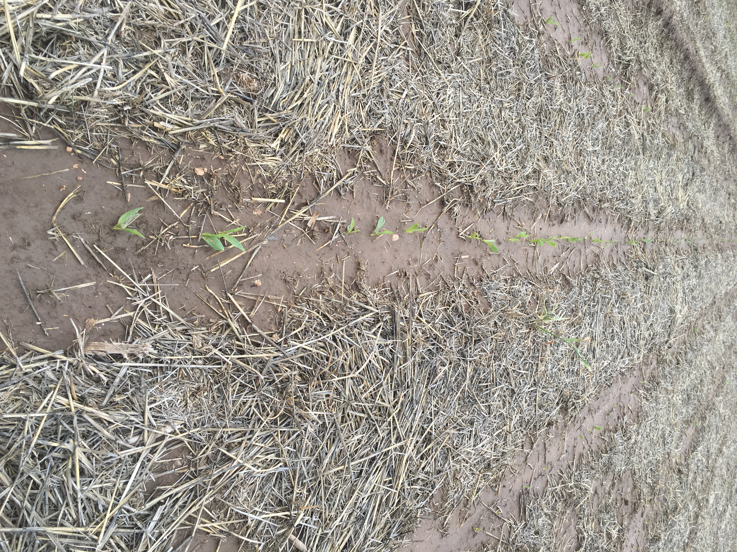
Crop consultants receiving this information have clients totaling approximately 200,000 acres in Dallam, Hartley, Moore, Sherman, Hansford Counties in Texas, Union County in New Mexico and Cimarron County in Oklahoma and Morton and Stevens County Kansas. This communication with these individuals can provide very timely information concerning major crop pest and facilitate efforts to minimize crop yield losses. Since every year is different regarding a multitude of crop growing conditions it is important to maintain a good network of communication to provide assistance to producers and insure profitability.

Utilizing sound corn and grain sorghum management concepts we can monitor the crops condition and enhance production. The cropping ecosystem is complex so years of site history provides a producer a better understanding of production capabilities and best management practices to apply. We know that a healthy and productive cropland has more value economically. Our challenge in this semi-arid region is to manage these croplands and their state of health and production through these cycles unpredictable weather.

Example of emerging corn planted in wheat stubble a very popular practice in Texas Panhandle
Results
Objectives of the corn and grain sorghum outcome was to
• Increase producer awareness of corn and grain sorghum opportunities.
• Educate producers on management practices to enhance of corn and grain sorghum production.

30 producers were surveyed at the Corn Field Day in Dalhart. These producers represented a total of over 90,000 acres of Cropland in Texas, New Mexico and Oklahoma. The top three highest percentages in increasing knowledge before and after the training was;
- 40% - pest control management and field scouting methods
- 30 % - irrigation efficiency
- 25% - fertility management

Producers intending on adoption of at least one practice or technology were 53% in these categories resulting in an economic benefit with an average economic of an additional $12.00 per acre.

