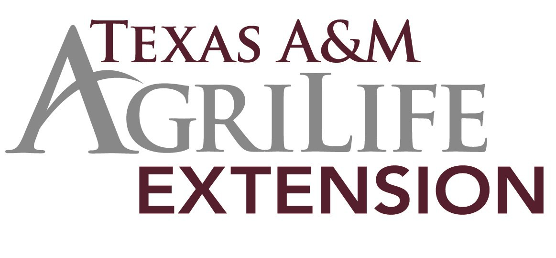

Crane 4-H News

July 2018

Inside this issue:
County Extension Agent Introduction | 1
Buying Sheep & Goats | 2
Keep Your Pens Clean | 2
Upcoming Fairs | 2
4-H Kickoff! | 3
Sheep & Goat Expo | 3

Hello Everyone!
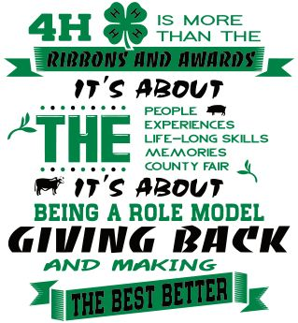

Hi Everyone! I am Sami Lindsey and I am the new County Extension Ag. Agent for Crane County. I am so excited to get to
meet each of you and work with you on your 4-H pro- jects.

I grew up on a cotton farm in a small town called Memphis, the Texas one that is. 4-H was my favorite pass time. I competed and showed thru all my years in school.

I can’t wait to help you start looking for your livestock projects and gearing up for the new year. IT’S GOING TO BE SO MUCH FUN!!!

For all of you cookers, this fall is going to be a BLAST! I look forward to seeing what each of you are going to whip up in the kitchen.
Please feel free to contact me if you have any questions.

C R A N E C O U N T Y
E X T E N S I O N O F -
F I C E

9 0 0 W. 6 T H S T.

CRANE, TX

432.558.3522

sami.lindsey@ag.tamu.edu

I graduated from Texas Tech University with a Bachelors in Animal Science/Animal Production.
Come stop by the Extension Office and say hi!!

I have always had a love for animals ever since I was a little girl. I look forward to sharing that love with each of you as we get ready to raise this year’s projects.

Time to Buy Sheep & Goats

It is that time of year again! The agent will start going on buying trips for sheep & goats in July and August for the 2018 Spring Show Season. If you are planning on showing lambs or goats next year, be sure to give us a call so we can start looking for your projects.
You are free to buy your own pro- jects, but remember if you ever need any help finding animals, give us a call.
Keep Your Pen Areas Clean

It is a bad time of year for snakes, rodents and other creepy crawly things, so it is very important to keep all of your pens and areas around your pens clean.

High weeds could not only be a hazard for you, but for your animals. Snakes like to hide in these weeds and could strike you without you ever even noticing them. Additionally, not all weeds are good for your animals. A lot of times we think we can just put the animals in there and let
them eat it down but there are several plants that could be toxic. Always check the pens carefully and identify all weeds and make sure the area is safe for grazing.

Be sure and keep all trash and debris picked up around your pens. Trash can cause choking or digestion problems when swallowed by your animals. Clutter and debris can cause hurt legs and feet on your animals or even you.
Keep feces and manure cleaned up and removed from pen area. This will help to cut down on flies and other pests that can cause numerous diseases and problems.

These practices are good to follow whether you keep your animals at the county pens or somewhere else.

A good rule of thumb to remember
is ...If you wouldn't want to sleep there or set there all day, then don’t expect your animals to.

Time to Enter Permian Basin

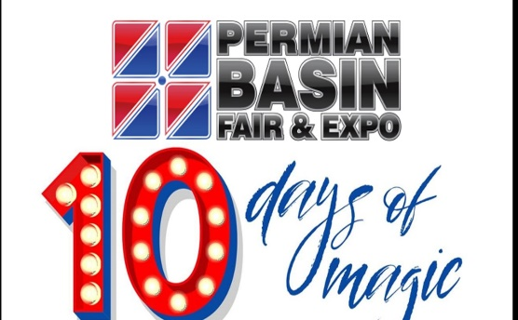
The Permian Basin Fair will be held in Odessa from August 31-September 9. 4-Hers can enter their sheep, goats, hogs, steers or rabbits in the PBF. Cost per entry varies. Deadline is August 3, 2018. PBF does allow a late entry fee with a penalty of $20 per entry.

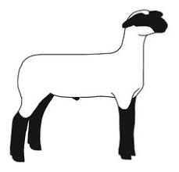
Texas Sheep and Goat Expo: Youth Program
Auto Wrangler Sale Pavilion, San Angelo TX
AUGUST 18th- 8:30 A.M.
Be a part of this unique Youth Workshop. Youth will be engaged in hands on learning revolved around the sheep industry. Emphasis will be put on areas that will help you prepare for the Sheep Skillathon and other related 4-H contest. The Sheep Skillathon is a knowledge based competition designed to enhance the educational experience of youth by incorporating production and industry perspectives for Texas 4-H exhibitors. Contestants will be challenged with questions, skill stations, and a public speaking component encompassing various facets of the sheep industry. This contest is not only designed for those exhibitors who exhibit sheep projects, but those students who simply have a strong interest in the sheep industry. Please contact the office if you are interested.

Enrollment for the 2018-2019 4-H year will begin on August 15th. Everyone must re-enroll each year. Mark your calendars. You don’t want to miss out on anything.

It’s KICKOFF TIME!!
Who’s ready for the upcoming 4-H year??? I know I am! This year’s 4-H Kickoff will be held on September 4th of 2018 at 6:30pm. So be sure and mark your calendars! I look forward to meeting all of you!

