In an East Texas study on sandy, low-fertility soils, bermudagrass pastures which have not received nitrogen fertilizer since the fall of 1984 are still producing.

JUNE 29, 2018
Related: Researcher Sees Big Gains from Stockers on Pasture, DDG Supplement
Although some changes have taken place in the ecotypes of bermudagrass prevalent, the combination of the right stocking rate with nutrient recycling by the cattle via urine and feces distributed back onto the pastures produced an affordable and potentially profitable pasture management situation, says Monte Rouquette, research forage physiologist for Texas A&M AgriLife at Overton.
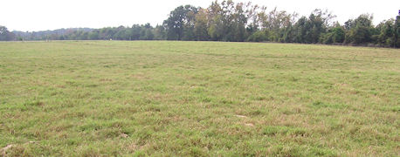
Staying power: This Coastal bermudagrass received no nitrogen fertilizer in a 30-year study of the effects of stocking rates and nitrogen rates on pastures. Because stocking rates were kept low, about one cow/calf unit per acre, the stand showed little invasion of less-productive bermudagrass ecotypes.
Rouquette adds another factor in the success of the program was overseeding of clovers in the fall onto some of the pastures.
Note that these pasture management tests were run under conditions of variable but continuous stocking through the warm season, with a break in the winter. Specifically, the pastures were continuously stocked during active forage growth seasons of Februarythrough September, using put-and-take stocking to achieve high, medium, or low stocking rates. Pastures were vacant and not grazed from October until mid-February each year, which corresponded to time of establishment and growth of cool-season annual forages, Roguette explains.
Bermudagrass is an important pasture resource in East Texas and the South. Yet improved bermudagrass varieties are commonly thought to have an Achilles' heel: to support their higher production, it is believed they need substantial amounts of nitrogen fertilizer applied yearly.
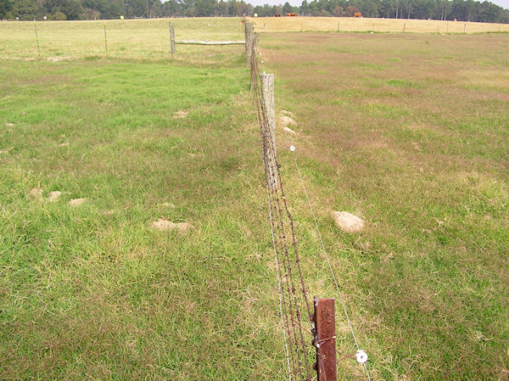Stocking rate matters: The purple-colored patches on the right side of the fence are signs of invasion of common bermudagrass into Coastal bermudagrass pasture under a high stocking rate. On the left side of the fence, the stocking rate was medium and shows much less invasion of common ecotypes. Photo courtesy Texas A
Changing course
The study actually began in 1968 on pasture-research areas at Overton, and has been conducted by Rouquette since 1971. Originally, the study was designed to evaluate various forage varieties for production and persistence using cow/calf pairs at different stocking rates.
By 1984, rising fossil fuel costs and higher nitrogen fertilizer costs was becoming a game-changer for beef producers. Rouquette says he responded by redirecting the grazing study to evaluate the persistence of both common and Coastal bermudagrass under two different fertility-management strategies:
1. Over-seeding with ryegrass and using commercial nitrogen fertilizer
2. Over-seeding with clover without applying nitrogen
"I thought that would be a good time to initiate a nutrient cycling experiment wherein pastures could be treated with nitrogen fertilization and over-seeded with ryegrass versus no nitrogen and over-seeded with clovers for nitrogen fixation," Rouquette says.
Related: 6 Tips for Improving Nitrogen in Cattle Pastures
Rouquette added that in 1984 all the test pastures had adequate levels of potassium and phosphorus. As the study proceeded, all test pastures received potassium and phosphorus fertilizer yearly in the form of 0-60-60. Lime was applied as needed.
From 2002 through 2008, the price of nitrogen fertilizer increased drastically again, he adds.
More bermudagrass outcomes listed >>
~~~PAGE_BREAK_HERE~~~
More outcomes listed
Once the experiment was set in motion, there were very few immediate plant responses, Rouquette says. However, by documenting soil status, forage stands and animal performance in the ecosystem over time, Rouquette found three significant trends:
• Bermudagrass stand composition and longevity are impacted more by stocking rate than lack of commercial nitrogen fertilizer.
• Phosphorous fertilizer levels can be largely replenished by animal excreta.
• Despite what is commonly thought, improved Bermudagrass stands can be maintained indefinitely under grazing at "low" stocking rates without adding commercial nitrogen fertilizer, instead relying on nutrient recycling from animal urine and dung.
Until 1974, both types of bermudagrass were evaluated for production and quality as pure stands under different stocking rates.
The average stocking rates on Coastal bermudagrass were:
Low - 1 cow/calf pair per acre
Medium - 1.7 cow/calf pairs per acre
|High - 3 cow/calf pairs per acre.
On the common Bermudagrass paddocks, the average stocking rates were:
Low - 0.8 cow/calf pairs per acre
Medium - 1.4 cow/calf pairs per acre
High - 2.0 cow/calf pairs per acre.
Also for reference, until 1984 common and Coastal bermudagrass pastures received about 200 pounds of nitrogen fertilizer, and 100 pounds each of phosphorus and potassium fertilizers per acre, per year. The nitrogen was split and applied over the growing season, while the potassium and phosphorus were applied in the fall in a single application.
Related: Subtropical, Tropical Grasses Need Different Management
From 1974 to 1983, Rouquette kept the same fertilization rates, but paddocks of both bermudagrass types were overseeded with mixtures of clover and Gulf annual ryegrass in October.
In subsequent years, the type of clover was varied among Yuchi, Arrowleaf, Tibee crimson and subterranean clover. Grazing of bermudagrass was halted in early October to allow the cool-season over-seeded clovers to become established.
New thinking on pasture management >>
~~~PAGE_BREAK_HERE~~~
New thinking
"When you look solely at Coastal Bermudagrass forage production, then added nitrogen and ryegrass is the clear winner," Rouquette says. "But when you're looking for sustainability, then reduced input, mainly no-nitrogen plus clover is the way to go."
These results run counter to the common perception of bermudagrass pasture management, Rouquette says. It's commonly thought that without nitrogen fertilization, an improved Bermudagrass stand will be taken over by such low quality grasses as Bahia grass.
"But that's true only if the stand is over-grazed as well," he says. "Under our 'low' stocking rates, which was about one cow/calf pair per acre, this didn't happen."
He adds that one cow/calf pair per acre is actually a considerably higher stocking rate than used by many commercial livestock producers. Instead, with no nitrogen fertilizer, the originally planted Bermudagrass stands were reduced over time by the invasion of other ecotypes of Bermudagrass, Rouquette says.
"The invading ecotypes were more similar to common Bermudagrass," he says. "They were still productive — they just were just not as productive as Coastal."
Related: Pasture Crop Building Soil And Putting Weight On Cows
This lower productivity was largely offset by lower production inputs with high nitrogen fertilizer costs, he says.
Rouquette thinks there are two or three important lessons here:
At high stocking rates, without nitrogen, there was a major invasion of other ecotypes and Bahia grass.
At low stocking rates, about 75% of the original Coastal bermudagrass stand remained, even without nitrogen fertilizer applications, although the over-seeded legumes did supply some nitrogen.
"It's commonly thought that without nitrogen fertilizer, bermudagrass fields will turn to sand and brush," he says. "But that's only true if animal grazing is ceased too. With animal grazing, nutrient recycling of animal excreta will maintain the stand – possibly forever."

