Insects that feed on developing grain in the head
Sorghum midge
The sorghum midge (Stenodiplosis (Contarinia) sorghicola) is one of the most damaging insects of sorghum in Texas, especially in the southern half of the state. The adult sorghum midge is a small, fragile-looking orange-red fly with a yellow head, brown antennae and legs, and gray, membranous wings.
During the single day of adult life, each female lays about 50 yellowish-white eggs in the flowering spikelets of sorghum. The eggs hatch in 2 to 3 days.
At first, the larvae are colorless, fully grown larvae are dark orange. They complete development in 9 to 11 days and pupate between the spikelet glumes. Shortly before the adult emerges, the pupa works its way toward the upper tip of the spikelet. After the adult emerges, it leaves a clear or white pupal skin at the tip of the spikelet—a sure sign of sorghum midge damage.
Under favorable conditions, a generation is completed in 14 to 16 days. When sorghum is planted late, midge numbers can increase to damaging levels because more generations occur during the season.
Sorghum midges overwinter as larvae in cocoons in spikelets of sorghum or Johnsongrass that fall to the ground and become covered with litter. When sorghum is shredded, spikelets containing larvae fall to the ground and are disked into the soil. Sorghum midges emerge in spring before flowering sorghum is available, and these adults infest Johnsongrass. Sorghum midges developing in Johnsongrass disperse to fields of sorghum when it flowers.
Early-season infestations in sorghum are usually below damaging levels. As the season progresses, sorghum midge populations increase, especially when late planting makes flowering sorghum available in the area. Numbers often drop late in the season.
The larva damages sorghum by feeding on a newly fertilized ovary, which prevents normal kernel development. Grain loss can be extremely high. The glumes of an infested spikelet fit tightly together because no kernel develops. Typically, a sorghum grain head infested by sorghum midges has normal kernels scattered among spikelets that do not bear kernels, depending on the degree of damage.
The most effective cultural management is to plant sorghum early and uniformly so that flowering occurs before the sorghum midges reach damaging levels. It is critical that hybrids be planted early enough to avoid late flowering of grain heads.
Cultural practices that promote uniform heading and flowering in a field are also important for reducing sorghum midge infestations. Use cultivation and/or herbicides to eliminate johnsongrass inside and outside the field. Where practical, disk and deep plow the previous year’s sorghum crop to destroy overwintering midges. Late-planted and late-flowering sorghum is especially vulnerable to sorghum midge.
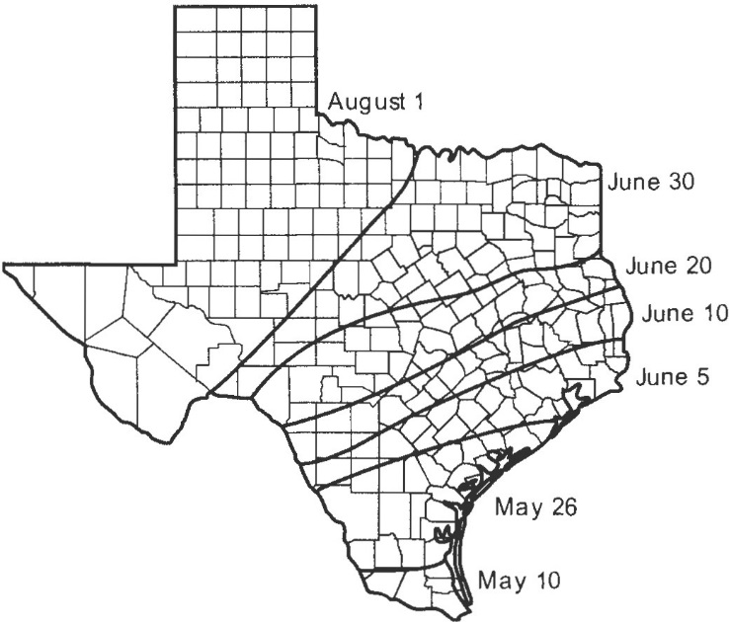
This midge lays eggs in spikelets when yellow anthers are visible on the sorghum head. An individual grain head requires 7 to 9 days to complete flowering; all heads in a field may take 2 to 3 weeks to complete flowering. Thus, a field can remain susceptible to midge infestation for several weeks, depending on how uniformly the plants flower. Once anthers turn reddish brown, they are no longer susceptible to midge infestation.
Figure 3. Estimated latest sorghum flowering dates most likely to escape significant damage by sorghum midge
Begin scouting for sorghum midge soon after head emergence, when yellow blooms first appear in the field. Scout at midmorning when the temperature rises to about 85°F. The adult lives for one day, and each day a new brood of adults emerges. For this reason, you need to sample flowering fields almost daily.
Inspecting carefully and at close range all sides of randomly selected flowering grain heads. Look for the reddish, gnatlike adults crawling on or flying about flowering heads. Handle the grain heads carefully during inspection to avoid disturbing the adult midges. Another sampling method is to gently but quickly slip a 1-gallon clear plastic bag over the head and tap the head to disturb the midges, which will fly up in the bag, where they can be easily seen and counted. A faster yet still efficient method is to turn the head downward into a white plastic bucket or pail and beat the head in the bucket to knock the midge from the head. Remove the head and count any sorghum midge in the pail or bucket. A 1-gallon milk jug with the bottom cut out also works well for this type of sampling.
Because they are relatively weak fliers and rely on wind currents to help them disperse, adult sorghum midges usually are most abundant along edges of sorghum fields. For this reason, inspect plants along field borders first, particularly those downwind of earlier flowering sorghum or johnsongrass. If you find only a few or no sorghum midges on the grain heads along the field edges, there should be little need to sample the entire field.
However, if you find more than one sorghum midge per flowering grain head in a field border area, inspect the rest of the field. Sample at least 20 flowering grain heads for every 20 acres in a field. For fields smaller than 20 acres, sample 40 flowering grain heads. Flowering heads are those with yellow blooms. Avoid plants within 150 feet of field borders. Record the number of sorghum midges for each flowering head sampled and then calculate the average number of midges per flowering head. Almost all the sorghum midges seen on flowering sorghum heads are female.
Next, calculate the number of flowering heads (those with yellow blooms present) per acre. Record the number of flowering heads along a length of row equal to 1/1000 of an acre. As an example, for a row spacing of 40 inches, 13.1 row feet is equal to 1/1000 acre. Make counts in at least four areas of the field. If flowering (plant maturity) is highly variable across the field, sample additional sites. Average all counts and multiply by 1,000 to estimate the number of flowering heads per acre. If there is only one head per plant, the number of flowering heads per acre is the percentage of heads in bloom multiplied by the number of plants per acre.
Sorghum midge density per acre is then calculated as the average number of midges per flowering head x number of flowering heads per acre. For example, if there are 30,000 flowering heads per acre and scouting records show an average of 0.5 sorghum midge per flowering head, then there are an estimated 15,000 sorghum midges per acre (0.5 sorghum midge per head x 30,000 flowering heads per acre). The percentage of flowering heads changes rapidly during bloom and should be determined each time the field is sampled.
Studies have shown that the larvae from a single female sorghum midge will destroy an average of 45 grain sorghum kernels. The seed weight of sorghum hybrids averages 15,000 seeds per pound (range of 12,000 to 18,000 depending on the hybrid). A loss of 45 kernels per midge, therefore, represents 0.0030 pounds (1.364 grams) of grain.
The economic injury level for sorghum midge can be calculated from the following equation:
Value of grain as $/cwt × Number of flowering heads
Number of sorghum midges/flowering head
Cost of control as $/A × 33256
=

In the equation above, the control cost is the total cost of applying an insecticide for sorghum midge control and the grain value is the expected price at harvest as dollars per 100 pounds. The value 33256 is a constant and results from solving the economic injury equation. The number of flower heads per acre is determined as described above.
For example, assume field scouting yields an average of 1.1 sorghum midge per flowering head and field sampling shows the number of flowering heads is 18,000 per acre. (This is equal to a plant population of 90,000 with 20 percent of the heads flowering and one head per plant). If the value of the crop is estimated to be $ 4.00 per 100 pounds and the cost of control is $5.00 per acre, the above equation yields the injury level as:
2.3 sorghum midge/ flowering head
$5.00 × 33,256
$4.00 × 18,000
=

In this example, the field density of 1.1 sorghum midges per flowering head is below the injury level of 2.3 per head, and treatment would not be justified. If the field is scouted 2 days later and the sorghum midge density is again 1.1 midge per flowering head, but now the number of flowering heads has increased to 45,000 per acre (50 percent of the plants now have a flowering head in a plant density of 90,000 plants per acres), the economic injury level is now
$5.00 × 33256 / $4.00 × 45,000 = 0.9 sorghum midge per flowering head
In this example, finding an average of 1.1 sorghum midge is now above the economic injury level of 0.9 per flowering head and treatment would be justified. This shows the importance of considering the number of flowering heads (grain susceptible to midge damage) in estimating the economic injury level.
Economic injury levels, as determined from the above equation, are shown in Table 17 for a range of typical treatment costs per acre, market values per 100 pounds of grain, and numbers of flowering heads per acre. Use the equation for estimating injury levels for your actual control costs, crop value and number of flowering heads per acre.
These variables can be entered into a calculator available online to determine the economic threshold for midge. The calculator is available at http://entomology.tamu.edu/extension/apps/.
Insecticide residues should kill adults and prevent egg laying 1 to 2 days after treatment. However, if adults still are present 3 to 5 days after the first insecticide application, immediately apply a second insecticide treatment. Several insecticide applications at 3-day intervals may be justified if yield potential is high and sorghum midges exceed the economic injury level (Table 18).
Table 17. Estimated economic injury levels for sorghum midge for a range of factors. (This table is only a guide. Use the equation in the text to estimate the economic injury level in your field.)
Control cost, $/A | Crop value, $100 lb | Economic injury level—mean number of midges/flowering head
 |  | Flowering heads = 18,000/A | Flowering heads = 45,000/A | Flowering heads = 16,500/A
5 | 6 | 1.6 | 0.6 | 0.4
5 | 7 | 1.3 | 0.5 | 0.34
5 | 8 | 1.2 | 0.5 | 0.3
6 | 6 | 1.9 | 0.8 | 0.5
6 | 7 | 1.6 | 0.7 | 0.4
6 | 8 | 1.4 | 0.6 | 0.35
7 | 6 | 2.2 | 0.85 | 0.6
7 | 7 | 1.9 | 0.75 | 0.5
7 | 8 | 1.6 | 0.65 | 0.45

Table 18. Insecticides labeled for sorghum midge control in grain sorghum. Follow label directions.
Active ingredient | Insecticide | Mode of action | Rate | Remarks | REI | PHI
Post-emergence treatments
alpha cyhalothrin | Fastac | 3A | 1.3-3.8 fl oz/A | Restricted use. Danger | 12H | 14D
beta-cyfluthrin | Baythroid XL | 3A | 1.0-1.3 fl oz/A | Restricted use | 12H | 14D
chlorpyrifos | Lorsban 4E, Lorsban Advanced, generics | 1B | 0.5 pt/A | Do not use on sweet sorghum varieties. Restricted use | 24H | 30D (1pt) 60D (>1pt)
chlorpyrifos + gamma cyhalothrin | Cobalt | 1B | 7-13 fl oz/A | See label. Restricted use | 24H | 30D for up to 26 oz/A and 60D for more than 26 oz
chlorpyrifos + lambda cyhalothrin | Cobalt Advanced | 1B+3A | 6-13 fl oz/A | See label. Restricted use | 24 H | 30D for up to 26 oz/A and 60D for more than 26 oz
chlorpyrifos + zeta-cypermethrin | Stallion | 1B, 3A | 3.75 -11.75 oz/A | Direct spray to the base of plants with sufficient spray volume to penetrate the soil/stem interface, leaf collars, and sheaths. Restricted use | 24H | 30D
cyfluthrin | Tombstone | 3A | 1.0-1.3 fl oz/A | Restricted use | 12H | 14D
deltamethrin | Delta Gold 1.5EC | 3A | 1.3-1.9 fl oz/A | Restricted use. Danger–Poison | 12H | 14D
esfenvalerate | Asana XL generics | 3A | 2.9-5.8 fl oz/A | Restricted use | 12H | 21D
gamma cyhalothrin | Declare 1.25  Proaxis 0.5 | 3A | 0.77-1.02 fl oz/A, 1.92-2.56 fl oz/A | Restricted use | 24H | 30D
lambda cyhalothrin | Warrior II Zeon  generics | 3A | 0.96-1.28 fl oz/A 0.96-1.28 fl oz/A  1.9-2.56 fl oz/A | Restricted use | 24H | 30D
lambda-cyhalotrhin + chlorantraniliprole | Besiege | 3A, 28 | 5-6 oz/A | Do not exceed total of 18 fl oz/A per year. Restricted use | 24H | 30D
spinosad | Blackhawk (2ee) | 5 | 1.5-3.3 oz/A | For low to moderate midge infestations | 4H | 21D
zeta-cypermethrin | Mustang Maxx Respect | 3A | 1.28-4.0 fl oz/A | Restricted use | 12H | 14D

