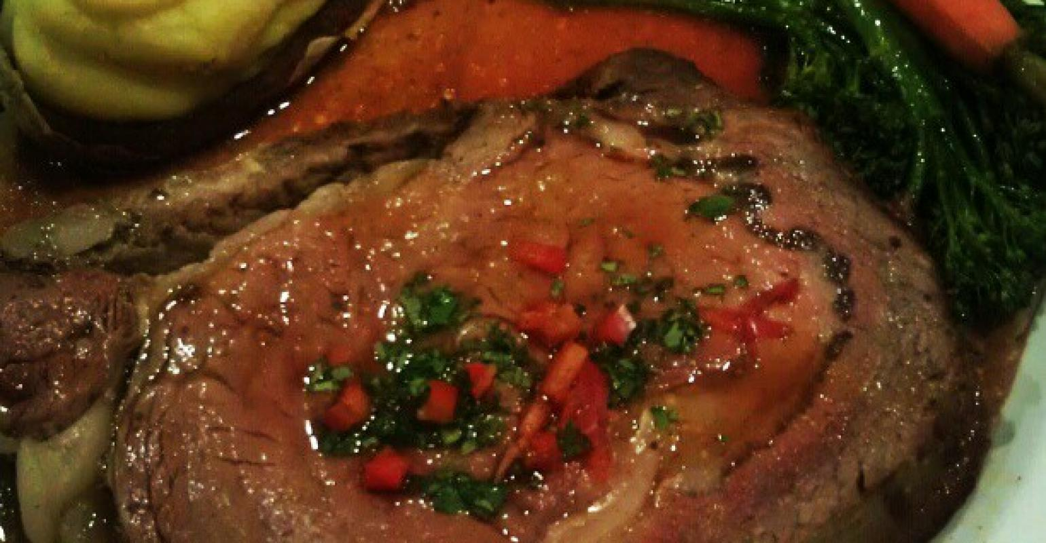Amanda Radke
Including beef with the Mediterranean Diet improves heart health
The Mediterranean Diet is getting a face lift, thanks to a new nutritional study that shows including red meat, instead of avoiding it in favor or poultry and fish, can reduce the risk factors for heart disease.
Amanda Radke | Jul 02, 2018
July is here, which means we are on the downhill slope of 2018. The year seems to be flying by, and going into the seventh month of the year, New Year’s resolutions may have fallen by the wayside. According to statista.com, nearly half (45%) of Americans hoped to lose weight or get into shape in 2018.
Whether that’s joining a gym or counting calories, it seems everywhere you turn, there’s a new strategy or diet that promises to fulfill these goals for those seeking to get healthy. Yet, each year, gym memberships go unused and protein shakes are ignored in the kitchen cupboard.
With so much conflicting information out there, it can be difficult for consumers to come up with a game plan to achieve their health and wellness goals.
The number one diet recommended by Consumer Reports is the Mediterranean-style eating pattern. Promoted as the “world’s healthiest diet,” the Mediterranean Diet is abundant in fruits, vegetables, legumes, red wine and olive oil (over butter) and lean proteins like fish and poultry (over red meat). It has been clinically proven to improve heart health and reduce risk factors for heart attack and strokes.
READ: Cardiac surgeon says beef can improve heart health
If this diet sounds familiar, it’s probably because it’s essentially what is recommended by the flawed Dietary Guidelines for Americans (DGA), which for an entire generation has promoted fruits and vegetables while demonizing animal proteins and fats in the diet. Not surprisingly, the DGA endorses the Mediterranean Diet, as well.
However, the Mediterranean Diet may be getting an upgrade that includes red meat, thanks to a new nutritional study conducted at Purdue University.
Published in the American Journal of Clinical Nutrition, the study was funded by the beef and pork checkoff programs with support from the National Institutes of Health’s Indiana Clinical and Translational Sciences Institute and a National Institutes of Health pre-doctoral training grant through the Ingestive Behavior Research Center at Purdue.
“This study is important because it shows that red meat can be part of a heart-healthy eating pattern like a Mediterranean-style eating pattern,” said Wayne W. Campbell, professor of nutrition science, in a press release.
“Most healthy eating pattern recommendations include a broad statement to reduce red meat intake,’” added Lauren E. O’Connor, lead author and recent doctoral degree recipient. “Our study compared Mediterranean-style eating patterns with red meat intake that is typical in the United States, about 3 ounces per day, versus a commonly recommended intake amount that is 3 ounces twice per week. Overall, heart health indicators improved with both Mediterranean-style eating patterns. Interestingly, though, participants’ LDL cholesterol, which is one of the strongest predictors we have to predict the development of cardiovascular disease, improved with typical but not lower red meat intake.”
READ: Teicholt tells consumers to ignore American Heart Association advice
According to the press release, “The study assessed the health-promoting effects of a Mediterranean-style eating pattern, without intended weight loss, for adults who are overweight and at risk for developing heart disease. All 41 study participants – 28 females and 13 males – completed three study phases. The phases included a five-week period of consuming a Mediterranean-style eating pattern containing 3 ounces per day of lean, unprocessed red meat, an amount of red meat the typical United States resident consumes; a five-week return to their regular eating pattern; and a five-week period of consuming a Mediterranean-style eating pattern with less red meat, 3 ounces twice weekly, which is commonly recommended for heart health. The order of the typical and lower red meat interventions were randomly assigned among participants.”
Of the results, Campbell said, “It’s also very encouraging that the improvements these people experienced – which included improvements in blood pressure, blood lipids and lipoproteins – were noticeable in five weeks.”
As the result of this study, researchers have concluded, “Adults who are overweight or moderately obese may improve multiple cardiometabolic disease risk factors by adopting a Mediterranean-style eating pattern without or with reductions in red meat intake when red meats are lean and unprocessed.”
While this study nor this diet are a slam dunk for beef, this is certainly a step in the right direction. The Mediterranean Diet is widely promoted, and if it now can include beef, that better aligns with the sound science and research that supports red meat as an important food for promoting heart health and reducing the risk factors for heart attacks and stroke.

