We are excited to offer Plant Identification training in the Range Science Project to 4-Hers of Colorado County! No prior experience is required to join. This is a great way to learn about plants and the functions they serve. We will not only learn names of plants, but will explore the roles each species plays in an ecosystem, which plants support livestock and wildlife, and how they support human life. Youth are encouraged to attend every practice, but are only required to have a minimum of four (4) learning experiences (practices or competitions) to have “completed” the project. Call for more information: 732-2082
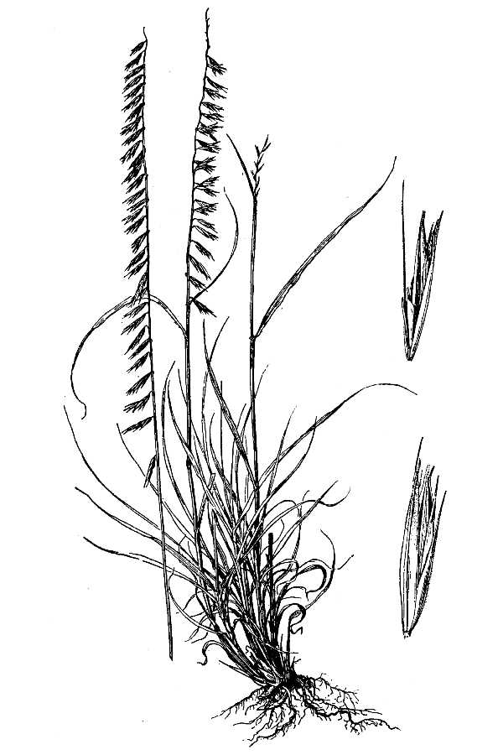Practice Dates (Subject to change based on feedback)
Sideoats grama – The State Grass of Texas
Tuesday, October 13th 6:30pm, Extension Office
Monday, October 19th 6:30pm, Extension Office
Monday, November 2nd 6:30pm, Extension Office
Monday, November 23rd 6:30pm, Extension Office
Monday, December 7th 6:30pm, Extension Office
Monday, January 4th 6:30pm, Extension Office
Monday, January 18th 6:30pm, Extension Office
Monday, February 1st 6:30pm, Extension Office
Monday, February 15th 6:30pm, Extension Office
Monday, March 7th 6:30pm, Extension Office
Monday, March 21st 6:30pm, Extension Office
Monday, April 4th 6:30pm, Extension Office
Monday, April 18th 6:30pm, Extension Office
Plant ID Competition Dates
(More dates may be added as they become available)
Sept. 27 Dallas State Fair of TX
January 23 Ft. Worth SS&R
April 5 Hackamore Ranch, Cameron, TX $20/person. Buckles, $5000 scholarship for senior
March 5 Houston LSR Plant ID contest. Belt Buckles awarded
April 23 Multi-District 4-H Judging Contests, College Station

