2021 4-H Virtual Bass Fishing Skill-a-thon

General Information

What is a Skill-a-thon?
The Virtual Bass Skill-a-thon is comprised of two parts:
1. Learn and Earn Educational Opportunities – to provide information in which youth participants and adults can gain knowledge on fishing tips and techniques, healthy cooking with fish, safety situations, laws and regulations, and trivia fun. These opportunities will be posted on the 2021 4-H Fishing Facebook page. No fee to participate.

2. Fishing and Wishing to Win Tournament – scheduled dates for youth to fish at their location with the chance of winning weekly and overall tournament awards and prizes based upon fish length. See entry fees below for participation.

Participation Requirements
  - Be enrolled in 4-H as a youth member or Clover Kid for the 2020-2021 year.
- Join the 2021 4-H Fishing Facebook page by clicking here or going to https://www.facebook.com/groups/1202432833284039/
  - Youth may use an adult’s Facebook account to join and participate.

Part I: Learn and Earn Information

Educational Opportunities
- Posted on the following days for three weeks on the 2021 4-H Fishing Facebook page:

  - Monday: Fishing Techniques and Tips
  - Tuesday: Cooking with Bass: Healthy Food Demo and Recipe
  - Wednesday: A Visit with the Game Warden
  - Thursday: Fishing Safety
  - Friday: Fun Facts, Trivia and 10 for 10 Catfish Game
- Participate to LEARN new knowledge and EARN prizes! Weekly trivia contests posted on Fridays offer anglers the opportunity to win additional prizes based upon participation in the Monday-Thursday education components.

Part II: Fishing Tournament Information

Registration
  - Registration will open on 4-H Online at 8:00 a.m. on March 1, 2021. Go to 4-H Online at https://texas.4honline.com and select 2021 4-H Virtual Fishing - Bass from the event list and submit your entry fee(s).
  - Entry to 4-H Online is due by April 8, 2021 to participate in the April 10th tournament. Only those registered on 4-H Online by the deadline will be eligible to participate.
  - 4-H Online will reopen again on April 12th for registration for the April 17th tournament (you only need to register if you did not register for the first tournament) and close at 11:59 pm on April 16th.
  - 4-H Online will reopen again on April 19th for registration for the April 24th tournament (you only need to register if you did not register for the first or second tournament) and close at 11:59 pm on April 23rd.

Entry Fees
- 4-H youth members, including Clover Kids, may enter the statewide, district and Big Bass tournaments.
  - Clover Kids participate for bragging rights and earning ribbons. There is no fee for their participation, however, they must be registered on 4-H Online.
  - Participation at the state level is REQUIRED (individual and/or team).
  - District and Big Bass entries are optional.
  - Competing teams are comprised of 2 to 4 members of any 4-H age division (Junior, Intermediate or Senior – see below for Clover Kid team participation).
  - Mixed 4-H age-division teams are permitted.
  - Teams with members from other counties are also permitted.
  - Clover Kids may participate on a team; however, they are eligible for placing only within this designate group and will be provided ribbons for their participation.
  - Three separate fishing dates are provided (April 10, 17 and 24).
  - Pay one time entry fee and then compete by fishing one, two or all three dates.
  - Prizes will be awarded for each fishing date and overall tournament.

REQUIRED ENTRY
State Events - $25 per individual per category (you must enter one of these categories)
Categories:
    - State individual – Exhibit your skills against all entered 4-H’ers across the state.
    - State team – Exhibit your skills as a 2-4 member team against all entered 4-H’ers across the state.

OPTIONAL ENTRY
District Events - $15 per individual per category
Categories:
    - District individual – Exhibit your skills against other registered district participants in YOUR district for separate awards and prizes.
    - District team – Exhibit your skills as a 2-4 member team against other registered district participants in YOUR district for separate awards and prizes.

OPTIONAL ENTRY
Big Bass Events - $10 per individual per category
Categories:
    - State Big Bass individual – Exhibit your skills against all entered 4-H’ers across the state for the biggest bass.
    - State Big Bass team – Exhibit your skills as a 2-4 member team against all entered 4-H’ers across the state for the biggest bass.
    - District Big Bass individual – Exhibit your skills against all entered district participants in YOUR district for the biggest bass.
    - District Big Bass team - Exhibit your skills as a 2-4 member team against other registered district participants in YOUR district for the biggest bass.

Example Registration Fees
  - Registered in state event (required) as an individual - $25
  - Registered in optional district event as an individual - $15
  - Registered in option big bass event as an individual - $10
  - TOTAL Participation Fees $50

Fishing Schedule
- Dates: April 10, 17 and 24 (you may participate in one, two or all three fishing dates).
- Times: 8:00 am to 3:00 pm - postings before or after contest times will mean a disqualified post.

Participation Species for ALL Events
- Bass of any of the following varieties: Largemouth, smallmouth, spotted, Guadalupe
- You may enter all of one variety or a combination of varieties for judging.
- Maximum of 5 bass caught by registered youth may be entered for judging.
- See link below to learn how to identify specific fish species in Texas.
https://tpwd.texas.gov/landwater/water/aquaticspecies/inland.phtml

Supplies Needed for Participation
  - Rod and reel
  - Bait or lure
  - Phone or tablet with internet
  - Official Check-it-Stik® (can be purchased at Academy stores or via online shopping venues)
  - First 200 registered 4-H members by March 12th will receive a FREE official Check-it-Stik®.

Location
- Fish anywhere permitted by law (freshwater, ponds, stock tanks, rivers, lakes, etc.).
- Fishing from a pier, edge of pond/lake/river, or boat is allowed for this event as long as the location is permitted by law.

Safety and State Fishing Regulations
- Be sure to follow all Texas regulations regarding fishing licenses, bag limits, length requirements and other rules https://tpwd.texas.gov/regulations/outdoor-annual/fishing/
- Each 4-H family entered is responsible for the safety of youth anglers during the tournaments.

Awards and Prizes
- Awards for State entries will be mailed to your county Extension office after completion of skill-a-thon.
- Awards for District events will be provided by your District office.
- All awards and prizes to be determined by the 4-H Fishing committee. (Awards are determined by the number of individuals/teams registered for this tournament.)
- If registered in the optional State “Big Bass” event, the top placing big fish (individual and team) will be presented one replica of the winning fish. (Winner will be determined by fish length and girth). Replicas will be sent to county offices 6-9 months after tournament.
- Prizes will also be awarded for each date of fishing.
- Clover Kids participate for bragging rights and earning ribbons.
- Entry via 4-H Online gives permission to the District 5 office to use the participant’s name and photograph as needed for marketing and promotion purposes.

Judging Criteria for All Events - IMPORTANT
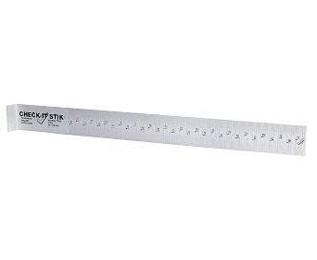
- Posting Limits: 5 bass of any combination of largemouth, smallmouth, spotted, or Guadalupe. If more are posted, only the first 5 posts will count.
- Photograph of fish WITH tournament card (see last page for card) must be posted to the 2021 4-H Fishing Facebook page between 8:00 am and 3:00 pm on Saturday. You must receive approval to join this group before the tournament begins. Photographs posted before or after tournament times will be non-scoring. Note: This may mean that you change locations before time is up to ensure you have internet service.
Check-It-Stik ®
  - Fish must be photographed laying on an Official Check-It-Stik® brand measuring board. Check-It-Stiks can be purchased at Academy, on-line and at other fishing gear stores (be sure tournament card is also in the picture; fish pictures without cards will not count).
  - Photograph must be able to be clearly seen and measurement on board must also be legible.
  - You may hold your fish on the board, just be sure to NOT cover the mouth and tail with anything that blocks these views.
  - Fish must be laying with its left side up and in full view of photograph. Fish photographed on right side will be non-scoring.
  - Pinch the tail fins together to get accurate length in photograph.
  - Mouth of fish must be touching the board. If measurement cannot be read from photograph, the entry will be disqualified. See example below:

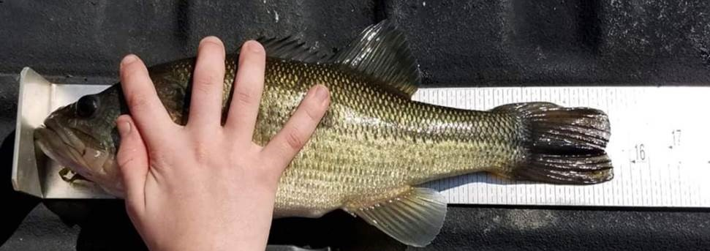

  - You will be given a unique six letter/digit code for each day an event is held to display on an index/note card, or you may use the preprinted tournament card below in your fish photograph.
  - The code will be revealed on the 2021 4-H Fishing Facebook page one hour before the tournament begins.
  - Tournament card must have District, County, youth name(s) (if a team), fish number, and six-digit code. Cards that cannot be read will be disqualified. Suggestion: Place each card in a Ziplock bag so it remains dry and ink does not run.
  - For teams, place the angler who caught the fish on the top line. Team posts can count for your individual entry and team entry if you entered as an individual and on a team.

Optional State Big Bass Event Judging Criteria
- Youth entered in the optional State Big Bass contest will compete against other 4-H anglers across the state. Must be entered on 4-H Online before start of the tournament.
- Awards/prizes will be given to the top big bass from entire tournament for individual and team. When documenting your fish on notecard, be sure to add the fish length and girth to your card so that one replica per individual winner and team can be made for the top “big bass.”
  - Length is measured in inches from mouth to tip of tail, not the fork.
  - Girth is measured in inches around the fish at the widest part, usually right in front of the dorsal fin. Use a tailor’s tape to measure.

2021 Bass Tournament Card

Please print – must be legible!

District ________________ County _________________________

Fish Number (1 – 5): __________

6-digit code: _________________________
(posted 1 hour before tournament on 2021 4-H Fishing Facebook group page)

Angler Name 1: _____________________________________________________
(Team member that caught this fish if registered on a team)

(Complete below if registered as a team)

Angler Name 2: _____________________________________________________

Angler Name 3: _____________________________________________________

Angler Name 4: _____________________________________________________

(Complete below if entered in Big Bass optional contest)

Fish length: _____________________ Fish girth: _________________________

