4-H in Bastrop County
County Extension Office Location & Mailing Address:
Office Location: 901 Pecan Street, PO Box 650, Bastrop, TX 78602
Email: bastrop-tx@tamu.edu ~ Phone: (512) 581-7186 ~ Fax: (512) 581-7187
12-13-18
IF YOU HAVE ANY QUESTIONS ABOUT ANY OF THESE ACTIVITIES PLEASE DON’T HESITATE TO CALL THE CEO (County Extension Office)
Rachel W. Bauer April F. Kuck Hillary Long
CEA-AG-NR CEA-4-H & Youth CEA-FCS

SCHOOL TOURS ARE AS FOLLOWS:
San Antonio- Feb. 13 and Feb 20
Rodeo Austin-March 27
You must be signed up with the Extension Office by Dec. 20 to participate. Seniors are reminded of the possible scholarship for participating in San Antonio. Please call 512-581-7186 to confirm that you are signed up. Must be 9th-12th grade.

12/24-25- Extension Office Closed- County Holiday
1/1- Extension Office Closed- County Holiday
1/3- Consumer Decision Making Practice, 5:00 p.m., Extension office
1/4 & 5- Elgin Livestock Show and Youth Fair, Elgin Show Barn
1/11- Bastrop Area Livestock Show & San Antonio Livestock Show Broilers Arrive, Extension Office
1/19- Rockne Livestock Boosters’ Annual Steak Supper Fundraiser, 5:30-8 p.m., Sacred Heart Church, Rockne
1/25- Houston Livestock Show Broilers Arrive, Extension Office
1/26- Smithville Livestock Show Hog Validation, Smithville HS Ag. Shop, 2-3 p.m.
2/8- Pecan Auxiliary Valentine’s Day Bake Sale, First National Bank of Bastrop
2/8- Rodeo Austin Broilers Arrive, Extension Office
2/8- Bastrop Area Livestock Show Breeding & Market Rabbit Validation, Floral, Art and Ag. Mechanics entries due, Bastrop Show Barn 5:30-6:30 p.m.
2/16- District Consumer Decision Making Contest, San Antonio
2/24- Bastrop Area Livestock Show Mandatory Exhibitor Workday, 2 p.m., Show Barn
Whether you are at a stock show, riding on a parade float, or wearing a 4-H shirt, you are representing the Bastrop County 4-H Program. People will judge all of us by your actions and language. Each 4-H member signs a code of conduct as to behavior. Please make sure you are meeting that standard when you represent Bastrop County 4-H.

- Elgin Livestock Show and Youth Fair- will be held January 4-5 at the Elgin Show Barn. Be sure to go out and support our fellow 4-H and FFA exhibitors in Elgin! The show will begin at 5 p.m. on Friday with broilers and rabbits, and at 8 a.m. on Saturday morning.

- Show Broiler Arrival for the San Antonio and Bastrop Area Livestock Show will occur January 11. Birds will arrive at the Extension office around lunchtime. We will call exhibitors to let them know the exact arrival time. You will need to pick up your birds ASAP to get them on feed and water and under heat lamps. Have your feed and your broiler house ready 2 to 3 days beforehand!

- Rockne 4-H & FFA Boosters Steak Supper Fundraiser- will be held January 19 beginning at 5:00 p.m. at the Rockne Sacred Heart Parish Hall. Steak plates are $25 each, and hamburger plates for kids are $5 with the purchase of a steak plate. A silent and live auction will also be held. All proceeds benefit youth participating in the Bastrop Area Livestock Show or Smithville Livestock Show. Contact the Extension office if you need to purchase tickets. 4-H and FFA members must fill out an application to be eligible for funds from the Steak Supper Fundraiser. Applications are available at the Extension office.

- Show Broiler Arrival for the Houston Livestock Show will occur January 25.
Show Broiler Arrival for Rodeo Austin Livestock Show will occur February 8.
We will call exhibitors to let them know the exact arrival time. You will need to pick up your birds ASAP to get them on feed and water and under heat lamps. Have your feed and your broiler house ready 2 to 3 days beforehand!

- Smithville Livestock Show Hog Validation- will be held January 26 from 2 to 3 p.m. at the Smithville High School Ag. Shop. If you plan to show a hog at the Smithville Show, your hog will need to be validated at this time. See the Show Rules for details.

- Bastrop Area Livestock Show Breeding & Market Rabbit Validation will be held February 8 at the Bastrop Show Barn from 5:30-6:30 p.m. All exhibitors and a parent must attend validation. Entry fees are due at this time.

- Bastrop Area Livestock Show Floral, Art and Ag. Mechanics entries due- February 8 at Bastrop Show Barn from 5:30-6:30 p.m. Rules are available at the Extension Office. The champion Ag. Mechanics entries will be allowed to sell in the Auction sale at the Bastrop Show this year.

- BALS Mandatory Exhibitor Workday- is February 24 at 2 p.m. at the Bastrop Show Barn. Bring work gloves, pliers, rakes to set up the show barn. Exhibitors must be on time and present at sign in (2 p.m.) to avoid being fined. Failure to participate in clean up and tear down activities will result in a fine which will be deducted from the exhibitors premium check.
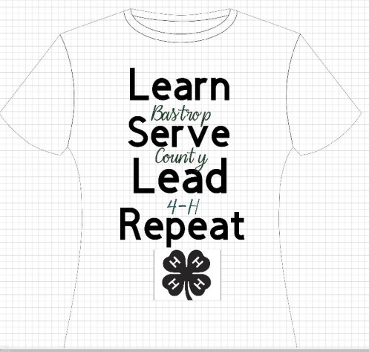

4-H shirts for sale NOW! Lots of sizes…just $10 each! Great for stock show season or showing your Bastrop County 4-H Pride!

National 4-H Conference Applications Open
Held April 6-11, 2019 at the National 4-H Conference Center in Chevy Chase, Maryland just outside of Washington DC. - National 4-H Conference is a working conference in which youth and adults, at the invitation of the Secretary of Agriculture, assist in the development of recommendations to help guide 4-H Youth Development programs nationally and in local communities.

There is no fee for a member to apply. However, a fee of $2,000 will be due for members selected to participate by February 4, 2019.

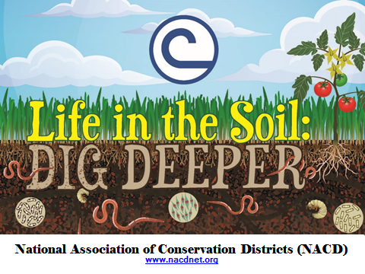
For more than 70 years, local conservation districts have celebrated soil and water stewardship. Each year, the National Association of Conservation Districts selects a theme, prepares material, and distributes them through the nation's 3,000 local conservation districts. This year, there will be three Bastrop County Conservation District winners that will receive a check for $100, $50, and $25. All prizes are sponsored by the Bastrop County Soil and Water Conservation District.-Bastrop County Soil and Water Conservation District (512) 321-2489 ext. 3 http://www.bastropswcd.org/events/2018/9/10/2019-poster-contest
Capital Farm Credit, La Grange credit office, is offering one $1,000 scholarship to a 2019 high school graduate from a Bastrop, Fayette or Lee County high school. Attached please find the scholarship application and eligibility requirements. The deadline for this scholarship is February 23, 2019. Please feel free to contact me if you have any questions
The Beekeeping Essay Contest is sponsored by the The Foundation for the Preservation of Honey Bees, Inc. For over 50 years, the American Beekeeping Federation has been serving the needs of the U.S. beekeeper. Any youth interested in participating in the contest must follow the instructions for the Texas 4-H selection process. Email jcbarrett@ag.tamu.edu with questions on the beekeeping contest.
Design a TV, radio or billboard ad that tackles the issue of texting and driving. Your advertisement could win you $5000 in scholarships. Due March 1, learn more at projectyellowlight.com
4-H FOUNDATION SCHOLARSHIPS MUST BE ENTERED ONLINE THROUGH 4-H CONNECT AND MUST BE RECEIVED BY JAN. 15. THIS INCLUDES ALL THE ATTACHMENTS INCLUDING CLASS RANK.
A metal insulated cup and a brown jacket were left at the Lost Pines Winter Classic Showmanship Clinic. If they are yours please call the office to claim.
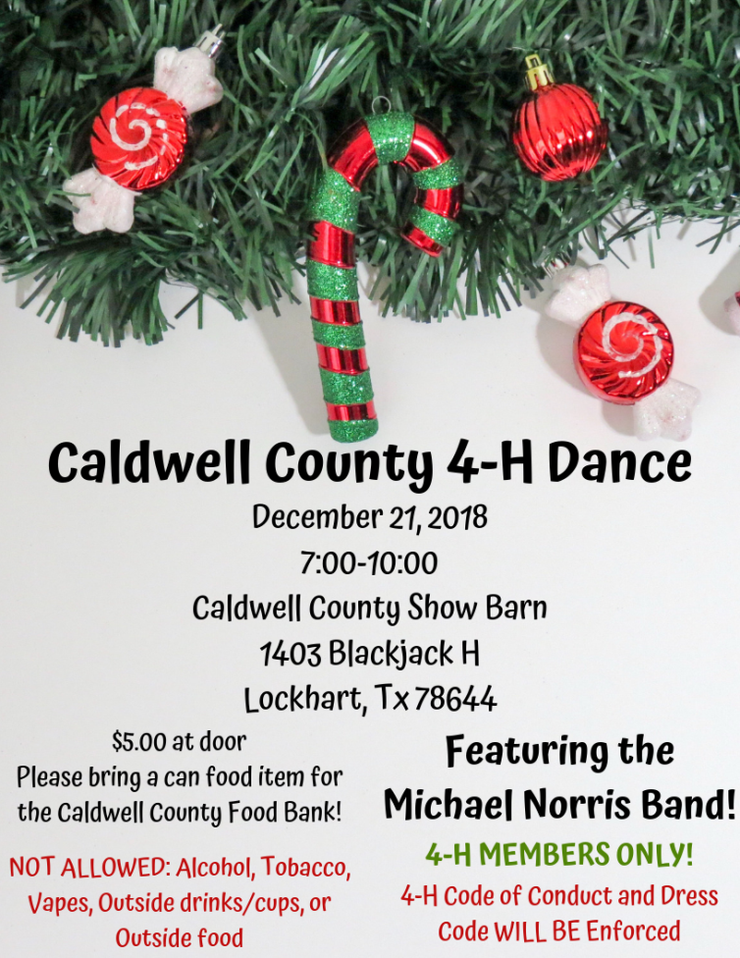
2018 Bastrop County Pecan Bake Show Rules
Friday, December 14, 2018-First National Bank Civic Room, Bastrop
Any adult or youth from Bastrop County may enter.
Sponsor: Bastrop County Pecan Growers Auxiliary
Judged Divisions:Junior - 3rd Grade through age 13
Senior - age 14 through high school-Adult
Clover Kids - Kindergarten through 2nd grade - Ribbon Award for Entry
CLASSES OF ENTRY: Must contain at least ½ cup of pecans. Make sure pecans are clean, no hulls. Recipe must accompany entry on 8 ½” x 11” paper, with name and year on back of sheet, for all entries.
A. Cookies - 14 or more displayed on a paper plate
1. Ice Box and Cut-out 3. Brownie or Bar Type 2. Drop 4. No-Bake
5. Cookie pizza - around 12"
B. Pastries
1. Traditional Pecan Pies 3. Cobblers 2. Other Pies using pecans 4. Tarts (7 tarts
C. Cakes
1. Fruit 3. Loaf/Bundt 2. Layer 4. Sheet Cake5. Other cakes using pecans
D. Breads
1. Yeast 3. Coffee Cake – Yeast 2. Quick 4. Coffee Cake - Other
E. Candies - 14 or more pieces on a paperplate. At least ½ pound
F. Sugared, Salted or Other Pecans - One cup displayed on a paper plate.
G. Miscellaneous Foods - Salad, Vegetable, Meat, Cheese, etc. that do not require
refrigeration.
H. Novelty Table - Craft items made with pecans.

Share your #MyBootsDo story! Submit a photo and caption here showing how you or your kids are inspired to put on your boots, roll up your sleeves and get things done in your lives or your community for a chance to win a pair of REBA by Justin™ boots! Plus, 5% of all REBA by Justin™ sales between now and January 14, 2019 will directly benefit kids in 4-H. Must be 18 or older to enter. Entrants submitting their child’s story must be the parent/legal guardian of a child age five (5) years or above.

