4-H in Bastrop County
County Extension Office Location & Mailing Address:
Office Location: 901 Pecan Street, PO Box 650, Bastrop, TX 78602
Email: bastrop-tx@tamu.edu ~ Phone: (512) 581-7186 ~ Fax: (512) 581-7187
11-16-18
IF YOU HAVE ANY QUESTIONS ABOUT ANY OF THESE ACTIVITIES PLEASE DON’T HESITATE TO CALL THE CEO (County Extension Office)
Rachel W. Bauer April F. Kuck Hillary Long
CEA-AG-NR CEA-4-H & Youth CEA-FCS
Mark your calendar:::: County 4-H Christmas Tree Decorating and Refreshments 5 p.m. on Tuesday Dec. 4 on Courthouse Lawn
COUNTY COUNCIL MEETING ON TUESDAY DEC. 4 AT GRADY TUCK BUILDING. ALL DELEGATES AND Officers are required to attend!

IF YOU ARE INTERESTED IN …..
Livestock Judging contact Melissa Goodman
Leaders 4 Life or Consumer Decision Making contact County Extension Office Signups end this week!
Beekeeping or Photography call the Extension Office

11/29 Smithville Livestock Show Validation for steers, lambs, goats, broilers, heifers and rabbits, 6-7 p.m. at Smithville High School Ag. Shop
11/27- Major Show Hog Validation, 5-7 p.m., Smithville High School Ag. Shop
12/1-Bastrop Area Livestock Show Hog, Lamb and Goat Validation 8-10 a.m.,
10 a.m. Showmanship Clinics & Practice Show, Bastrop Show Barn
12/4- County Courthouse Christmas Tree Decorating, 5 p.m.; 4-H Council Meeting, 6 p.m.
12/7- District Roundup Food Show, Entomology Contest and Food Challenge, Kerrville
12/8- District Roundup Beef, Horse and Nutrition Quiz Bowl Contests, Educational Presentations & Public Speaking , Kerrville
12/14- Pecan Auxiliary Bake Show and Sale, 8 a.m., First National Bank of Bastrop

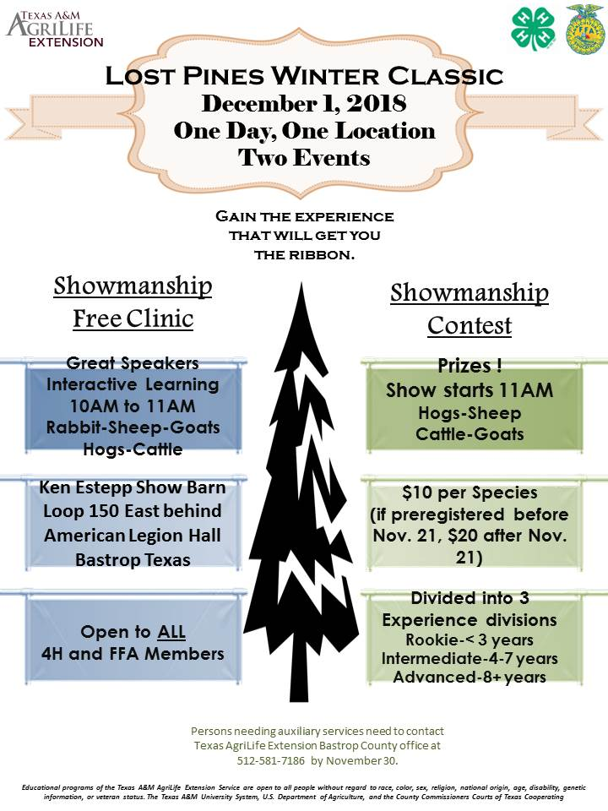
SMITHVILLE LIVESTOCK SHOW ENTRIES AND VALIDATION NIGHT MOVED TO NOV. 29 FROM 6-7P.M. AT SHS AG SHOP. PLEASE LET US KNOW IF YOU HAVE QUESTIONS.

SAVE THE DATE: DECEMBER 1-COUNTY WIDE SHOWMANSHIP CLINICS AND PRACTICE SHOWS FOR CATTLE, GOATS, SHEEP, PIGS AND RABBITS. Open to all 4-H and FFA members
The members of Texas A&M AgriLife will provide equal opportunities in programs and activities, education, and employment to all persons regardless of race, color, sex, religion, national origin, age, disability, genetic information, veteran status, sexual orientation or gender identity and will strive to achieve full and equal employment opportunity throughout Texas A&M AgriLife.
Major show swine validation on Nov. 27 from 5-7 at Smithville HS Ag shop.
BALSFA entries and validation on Sat. Dec. 1 from 8-10 a.m.

Mark your calendar:::: County 4-H Christmas Tree Decorating and Refreshments 5 p.m. on Tuesday Dec. 4 on Courthouse Lawn
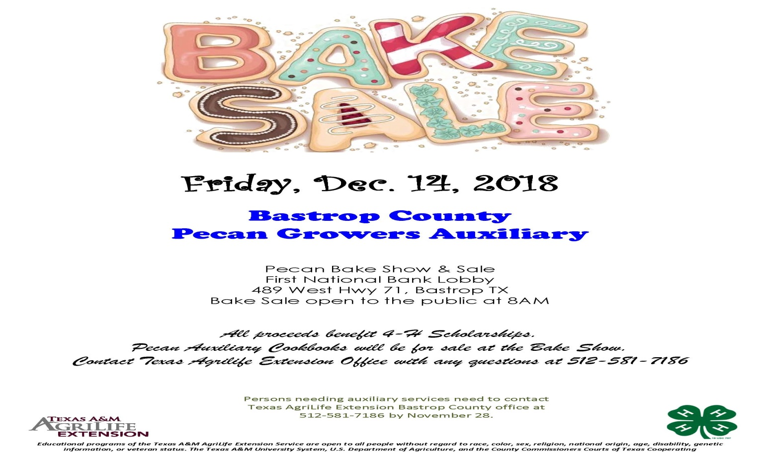
2018 Bastrop County Pecan Bake Show Rules
Friday, December 14, 2018-First National Bank Civic Room, Bastrop
Any adult or youth from Bastrop County may enter.
Sponsor: Bastrop County Pecan Growers Auxiliary
Judged Divisions:Junior - 3rd Grade through age 13
Senior - age 14 through high school-Adult
Clover Kids - Kindergarten through 2nd grade - Ribbon Award for Entry
CLASSES OF ENTRY: Must contain at least ½ cup of pecans. Make sure pecans are clean, no hulls. Recipe must accompany entry on 8 ½” x 11” paper, with name and year on back of sheet, for all entries.
A. Cookies - 14 or more displayed on a paper plate
1. Ice Box and Cut-out 3. Brownie or Bar Type 2. Drop 4. No-Bake
5. Cookie pizza - around 12"
B. Pastries
1. Traditional Pecan Pies 3. Cobblers 2. Other Pies using pecans 4. Tarts (7 tarts
C. Cakes
1. Fruit 3. Loaf/Bundt 2. Layer 4. Sheet Cake5. Other cakes using pecans
D. Breads
1. Yeast 3. Coffee Cake – Yeast 2. Quick 4. Coffee Cake - Other
E. Candies - 14 or more pieces on a paperplate. At least ½ pound
F. Sugared, Salted or Other Pecans - One cup displayed on a paper plate.
G. Miscellaneous Foods - Salad, Vegetable, Meat, Cheese, etc. that do not require
refrigeration.
H. Novelty Table - Craft items made with pecans.

Any adult or youth from Bastrop County may enter. Entries must be brought to the First National Bank Conference Room, Second Floor, 489 West Hwy 71, Bastrop, between 7:30 A.M. and 8:30 A.M. on Friday, December 14, 2018, the date of the show. Pecan baked products must have been prepared by the person exhibiting them. Mixes may be used. Be sure to use disposable container. You will not get your plate back. Cover all entries with plastic wrap.

Ribbons will be awarded to each judged entry on the basis of merit. Grand and Reserve Champion in Junior, Senior, and Adult Division will receive an award.

NOTE: ALL ENTRIES WILL BE FOR SALE. PROCEEDS GO TO THE 4-H SCHOLARSHIP. PECAN AUXILIARY COOKBOOKS WILL BE FOR SALE AT THE PECAN BAKE SHOW.

