4-H in Bastrop County
County Extension Office Location & Mailing Address:
Office Location: 901 Pecan Street, PO Box 650, Bastrop, TX 78602
Email: bastrop-tx@tamu.edu ~ Phone: (512) 581-7186 ~ Fax: (512) 581-7187
9-7-18
IF YOU HAVE ANY QUESTIONS ABOUT ANY OF THESE ACTIVITIES PLEASE DON’T HESITATE TO CALL THE CEO (County Extension Office)

Rachel W. Bauer April F. Kuck Hillary Long
CEA-AG-NR CEA-4-H & Youth CEA-FCH
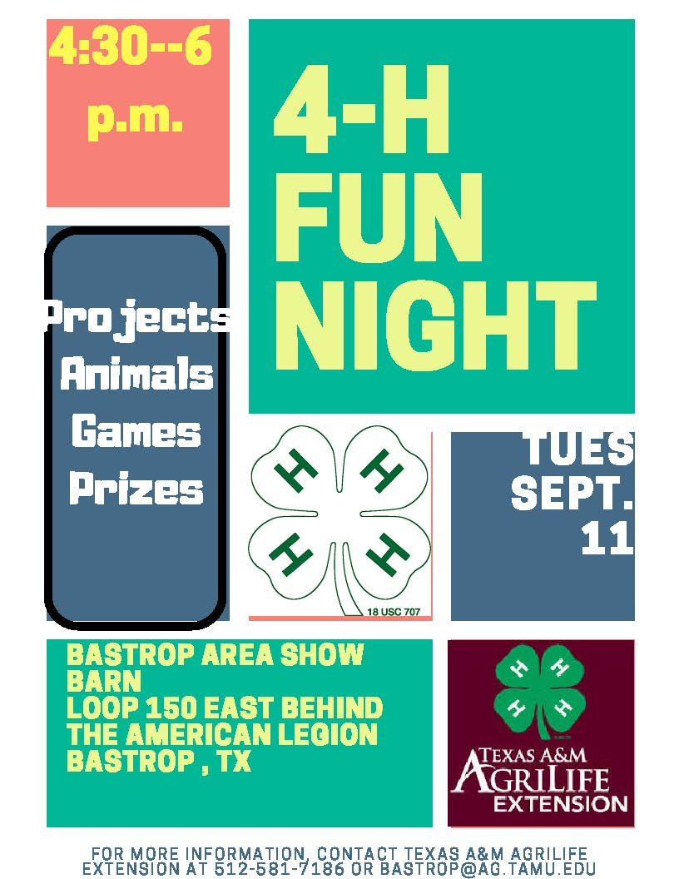

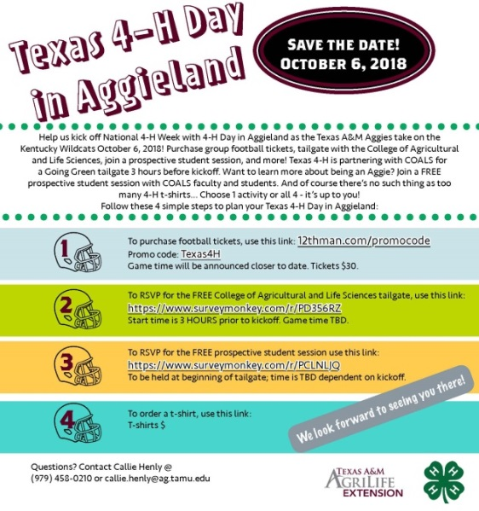

OUR ONE DAY PROJECT IS GOING TO BE AWESOME…MARK YOUR CALENDARS NOW!

National 4-H Week is October 7-13
Oct. 8-Wear a 4-H shirt
Oct. 9- Thank a supporter with your hands by
writing thank you note
Oct. 10-Wear Green
Oct. 11-Thank first responders for Helping with
your health for all they do with a snack
Oct. 12-Thank a teacher for helping with your head

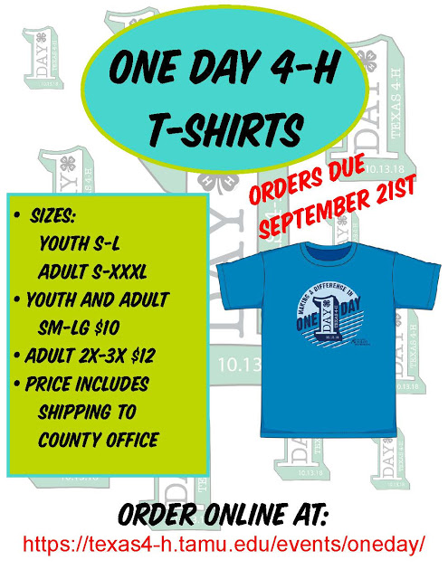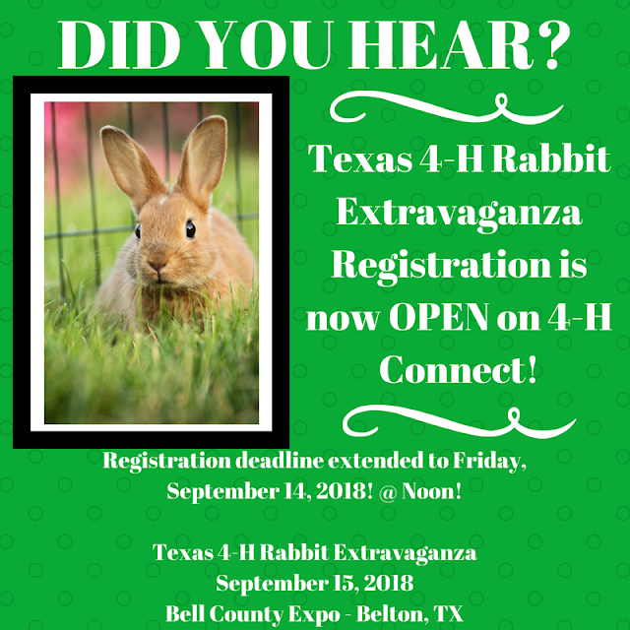
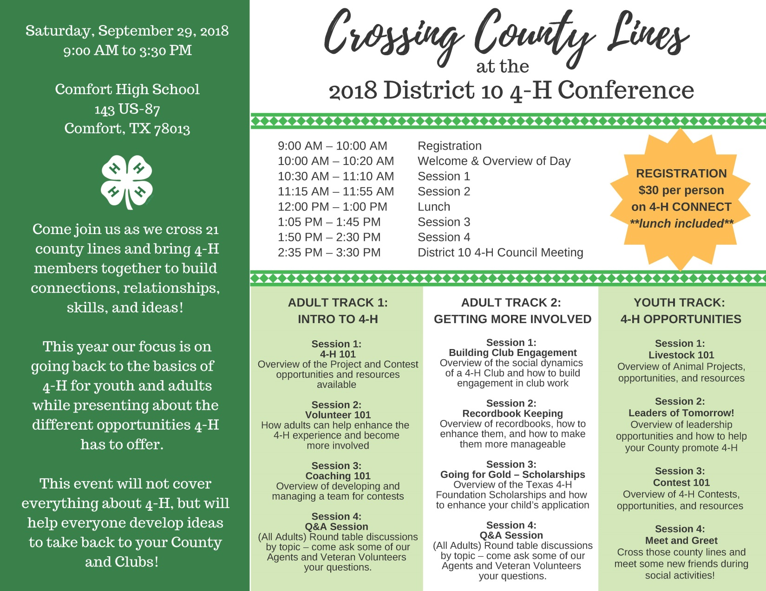

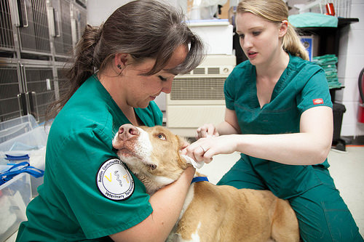
Veterinary Science project meeting-Sept. 27 at 6:30 p.m. Pioneer Bank in Elgin

Looking for a neat leadership opportunity? Serve at the Lone Star Cattlemen Wild Game Dinner on Saturday, Sept. 29. Call office to sign up!
We need YOU! We want to fill the Bastrop County Commissioners Court on Monday, Sept. 24 with 4-H GREEN! Online sign up at https://bastrop.agrilife.org/commissioners-court-proclamation-survey/
Dates to remember:
Sept. 7- Last date to sign up for Calf Scramble
Sept 10-Major show broiler orders due
December 7, 2018:District Food Challenge District Food Show District Entomology Contest
December 8, 2018: District Beef Quiz Bowl, District Horse Quiz Bowl, District Nutrition Quiz Bowl
- District Educational Presentations
- District Public Speaking
The registration period on 4-H Connect will be October 22, 2018 – November 7, 2018.
Late registration will be November 8-9, 2018 ONLY.
All paperwork will be due to the District Office by November 13, 2018.

- Major Show Hog Validation Tag Orders Due
Must order validation tags to show in a major show.
Cost is $20.00 per tag and the deadline for ordering is September 7, 2018.
Validation will be November 27 from 5 to 7 p.m. at Smithville High School Ag. Shop.

- Bastrop Area Livestock Show Fundraiser Raffle- September 22 at Sacred Heart Church Hall in Rockne. Cost is $75 per ticket. Each 4-H Club member who participates in the BALS is required to provide a door prize of $25 value. Door prizes can be brought in to the Extension office by September 20 at Noon, or delivered to the Sacred Heart Parish Hall on September 21 from 5 to 7 p.m., or September 22 between 8 and 10 a.m.

- 2019 Bastrop & Elgin Show Rules
The revised rules for the 2019 Elgin Livestock Show and Bastrop Area Livestock Show are now available on the Extension website. It is the responsibility of the exhibitor and their family to be knowledgeable of show rules and validation dates, so please read them.

- NEW Quality Counts Certification Required To Show At Major Shows and Elgin, Bastrop and Smithville Shows
Beginning in September, the Quality Counts verification system will change.
Therefore, you will need to complete the new Quality Counts test by the end of October. Don’t wait until the last minute, as the training takes two hours to complete.
After September 1, we will send out information on how to access the system, and complete the training/testing, which will be located at www.texaslivestockvalidation.com.

- Major Show Broilers Orders Due-Need to place an order with the Extension office by September 10. A minimum order per exhibitor or family unit is 25 chicks, with a maximum of 75 chicks, in increments of 25.

- Bastrop Area Livestock Show Steer Validation and Heifer entries due September 10 - the Bastrop Show Barn from 4:30 to 6:30 p.m. Entry fees of $15 per head and COMPLETED entry forms with exhibitors and parent or legal guardian signatures. Each exhibitor may validate three market animals in this division. A family with two or more exhibitors may validate two market animals per exhibitor in each division in a pool and cross validate.

- Bastrop Area Livestock Show Broiler Entries Due September 10. If you plan to show broilers at the 2019 Bastrop Show, you must turn in entry cards and order broilers on September 10 from 4:30 to 6:30 p.m. at the Bastrop Show Barn. The cost will be $1.50 per bird. An entry fee of $15.00 per broiler pen will be due at validation.

- Elgin Buckles, Banners & Blackjack Casino Night - October 6 at the Elgin SPJST Hall.
For tickets and more information- www.elginlivestockshowassociation.com or email elginlivestockshow@gmail.com.
- The Elgin Back to School Bull & Barrel Bash -September 14 & 15 at Lost Pines Riding Club arena in Elgin. For more information https://www.facebook.com/100000948225660/posts/2184258964949023/
- Cattlemen for Cancer Research Fundraiser- for the M.D. Anderson Michale E. Keeling Center for Comparative Medicine and Research Cancer- October 20 at Hills Prairie Auction Barn at 10 a.m. This is one of our 4-H Club community service projects, where each club is responsible for donating a basket to the fundraiser’s silent auction. Club managers, please have your club decide what type of basket they want to donate, and bring it to the Extension office by 4 p.m. on October 18.
- Major Show Sheep and Goat Validation- Tuesday, October 24 from 5 to 7 p.m. at the Bastrop Area Livestock Show Barn

- Fall Major Show Heifer Validation- If you plan to exhibit a heifer at the upcoming major shows (Fort Worth, San Antonio, San Angelo, Houston or Rodeo Austin), and your heifer has not yet been validated, you will need to attend heifer validation on October 24 from 5 p.m. to 7 p.m. Validation will be held at the Bastrop Show Barn.

ALSO, if your child plans to show animals in one of our County livestock shows, they MUST BE an enrolled member by:

Elgin Livestock Show- must be an enrolled member by November 1, 2018
Bastrop Area Livestock Show- must be an enrolled member by November 1, 2018
Smithville Livestock Show- must be an enrolled member by October 17, 2018

- Major Show Hog Validation- Tuesday, November 27 from 5 to 7 p.m. at the Smithville High School Ag. Shop. A parent and exhibitor(s) must attend validation to sign all state validation paperwork.

- Major Livestock Show Entry Sign Up November 6-8 from 8:30 to 4:30 p.m. If you plan to enter the 2019 Fort Worth, San Antonio, San Angelo, Houston or Rodeo Austin Livestock Shows, you will need to fill out entry forms and pay fees at this time.
Exhibitors MUST HAVE a current Quality Counts number and a social security number to fill out entry forms.

Question of the week: When is 4-H Fun Night? Be the first to call in and win a t-shirt!

