Stocking Rates and Financial Considerations for Restocking

April 14, 2015 from 6-8 pm

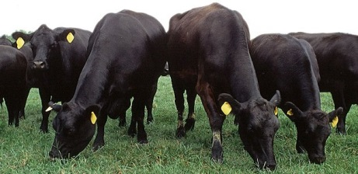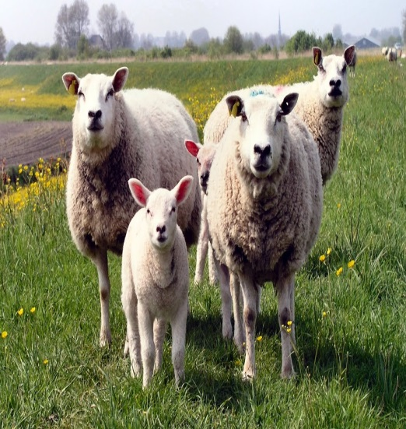
Educational programs of the Texas A&M AgriLife Extension Service are open to all people without regard to race, color, religion, sex, national origin, age, disability, genetic information or veteran status. The Texas A&M University System, U.S. Department of Agriculture, and the County Commissioners Courts of Texas Cooperating

Special Guests:

Dr. Bob Lyons - Extension Range Specialist

Setting and Managing a Stocking Rate

Dr. Rick Machen - Extension Livestock Specialist

Economics of Restocking or Destocking

$10/person and will include program materials and refreshments.
One hour of General CEU will be offered to attendees.
Please call the Bandera County Extension Office at 830-796-7755 to sign up.

Educational programs of the Texas A&M AgriLife Extension Service are open to all people without regard to race, color, religion, sex,
national origin, age, disability, genetic information or veteran status.The Texas A&M University System, U.S. Department of Agriculture,
and the County Commissioners Courts of Texas Cooperating

