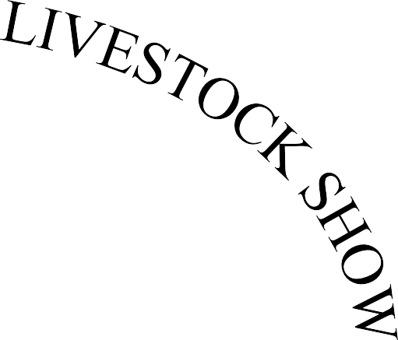

JANUARY 4-5, 2019
ARCHER COUNTY ACTIVITY CENTER
ARCHER CITY, TEXAS

LIVESTOCK AND
HOME ECONOMICS
SHOW CATALOG

TABLE OF CONTENTS

GENERAL RULES | 3 – 4
SHOWMANSHIP RULES | 5
ACJLS PREMIUM SALE RULES | 6
JUNIOR MARKET STEERS | 7
JUNIOR BEEF HEIFERS | 7
JUNIOR DAIRY | 8
JUNIOR MARKET SWINE | 9
JUNIOR MARKET LAMBS | 10
JUNIOR MARKET GOATS | 10
JUNIOR POULTRY | 11
JUNIOR MEAT RABBITS | 11
AG MECHANICS DIVISION | 12 – 14
HOME ECONOMICS GENERAL RULES | 15
JUNIOR FOOD | 16 – 17
JUNIOR CRAFT | 18
JUNIOR PHOTOGRAPHY | 19
HOME ECONOMICS SCHEDULE | 20
ETHICS POLICY | 21 – 22
ACJLS 2019 SHOW SCHEDULE | 23
SAMPLE PREMIUM AUCTION CARD | 24
BUCKLE DONORS | 25
2018 ACJLS AUCTION BUYERS/SUPPORTORS | 26

IMPORTANT – PLEASE READ ALL GENERAL RULES AND GUIDELINES PRIOR TO THE SHOW.

GENERAL RULES

- Entry fees will be $20 per entry (i.e. steer, pen of rabbits, etc.), with entry fees due by December 4, 2018. Any entries made between December 4-17, 2018, will impose a $25 late fee per entry. EXCEPTION: Rabbit deadline will be December 17, 2018. No late entries will be accepted after this date for rabbits. NO entries will be taken after December 17, 2018.
- ELIGIBILITY: Only Archer County members of the FFA and 4-H Clubs are eligible to compete in the Archer County Jr. Livestock show. Each FFA member must be certified by their Ag Science Teacher and must be eligible under FFA rules, and each 4-H member must be certified by their County Extension Agent – Ag and in the 3rd grade by date of the show. All exhibitors must be enrolled in Archer County schools at the time of the County Show or reside within the Archer County Line. Exhibitors must be full-time county residents or be enrolled students during the complete duration of the project (validation to show day) to be eligible to participate. Exhibitors are prohibited from showing in any other county livestock show.
- All Exhibitors must adhere to the “No Pass, No Play Rule” in accordance with all school districts.
- All beef and dairy animals must be halter broke and in show condition. Sick, diseased or apparently unhealthy animals will be strictly prohibited and promptly removed.
- All entries must be in the Show Barn and weighed according to the weigh-in schedule. EXCEPTION: Dairy cattle must be at the Barn by 8:00 AM Saturday.
- The exhibitor is responsible for feeding, caring for and showing his/her animals during the entire show. His/her stall area must be kept neat and clean at all times during the show.
- All breeding animals will show together unless there are five animals of one breed to form another class.
- OWNERSHIP:

Steers must be owned approximately 180 days before Show Date and validated by June 30, 2018.

Beef heifers must be owned and cared for by the owner 60 days before Show Date and will be validated by November 1, 2018.
    - All sheep and goats must be owned approximately 60 days before Show Date and validated by October 31, 2018.
    - All swine must be owned approximately 45 days before Show Date and validated by November 30, 2018.
    - Dairy cattle exhibited at the show must have been owned and cared for by the owner on or before November 1, 2018.
  - Turkeys must be owned and fed by hatch date set by poultry committee.
  - Broilers must be owned and fed 40 days prior to the Show Date.
  - Rabbits must be owned and cared for not less than 21 days prior to Show Date.
- The Grand Champion will be selected from the first-place winners of each class. The Reserve Champion will be selected from the remaining class winners and the second-place winner from the class of the Grand Champion.

- LIABILITY: The Archer County Jr. Livestock Show Association, FFA Chapters and 4-H Clubs concerned, or any person connected with the Show, will not be held liable or responsible for any bodily injury or any other damages or losses sustained to livestock, persons or property while at the Show.
- Only shavings will be used in all barns for bedding. No hay will be allowed in barns for bedding.

Each exhibitor MUST provide their own animal for the sale or make their own arrangements as to an animal for the sale. ACJLS WILL NOT be providing these animals for the auction sale.
- Interpretation of the rules and the making of additional rules may be made by the show management as they deem necessary.
- Registration or ownership papers must show the exhibitor’s name as the owner of the animal concerned. It is further required that all market animals or birds be tagged, tattooed or banded on the dates established by the Association.
- In compliance with State regulations, all poultry must originate from a Pullorum-typhoid free hatchery or farm as certified by the Texas Animal Health Department.
- It is the responsibility of the youth to turn in Premium Auction Exhibitor’s card by 12 Noon on Saturday. If auction cards are not turned in by deadline, the Auction Show Committee reserves the right to move exhibitor to the bottom of the Sale Order in fairness to all participating. Premium Auction Exhibitor’s cards will be given out at weigh-in of animals. No Exhibitor is allowed more than one entry in the Premium Auction.
- A committee will be appointed by the Board of Directors before the show to receive and resolve complaints. Any protest must be filed in writing, accompanied by a $50 non- refundable cash fee, during or immediately upon conclusion of the show.
- Any youth or any member of their family who has been disqualified from, refused entrance to or withheld prizes from any competition on the local/county level will not be eligible to participate in the ACJL Show.
- Only products labeled for animal use are allowed.
- No Exhibitor is allowed more than one entry in the Premium Auction (Craft, Food, or Animal) EXCEPTION: Ag Mechanics — members of a qualifying team of 2 or more individuals may still sell an animal or craft project through the premium sale.
- Animals must enter the show ring under their own power to be eligible to receive Premium Auction money.
- No exhibitor shall receive add-on monies unless that exhibitor passes through the premium sale.
- All add-on monies NOT paid by January 30th will not be added onto exhibitor checks. Any monies received after this date shall be paid directly to the exhibitor and not handled by the show board.
- SUBSTITUTION RULE: An exhibitor must exhibit their own animal in the show -EXCEPTION: a youth has more than 1 entry in a class. Other special cases can be made but must first be approved in writing with a $50 substitution fee no later than one (1) hour before the show. Substitute exhibitors MUST be a member of Archer County 4-H, Archer City FFA, Holliday FFA or Windthorst FFA.
- There will be NO Floor Price for animals. It will be the responsibility of the exhibitor to take care of their animal(s) after the show.

SHOWMANSHIP RULES

HOW TO BE ELIGIBLE FOR THE SHOWMANSHIP AWARD

Must be FFA or 4-H member and show his/her own animal in each class. The award will be based on the following:
  - General appearance of animal
  - Training of the animal
  - General appearance of exhibitor
  - How well the exhibitor and animal conduct themselves in the Show Ring
  - Exhibitor CAN win Showmanship and Grand Championship in the same division
  - In Swine there will be 3 divisions: Junior (3rd– 5th grade), Intermediate (6th-8th grades) and Senior (9th-12th grades)
  - In Sheep, Goat, Beef & Dairy there will be 2 divisions: Junior (3rd-7th Grade) and Senior (8th-12th Grade)

Clarification on Showmanship Rule
*Each exhibitor who wishes to enter the showmanship class MUST bring back/show the animal that they exhibited in the judged class. *

NO EXHIBITOR/ANIMAL SUBSTITUTIONS WILL BE ALLOWED

ACJLS PREMIUM SALE RULES

- The exhibitor and only the exhibitor may take an animal through the show sale run. Substitutions will not be allowed except in special cases that must first be approved by the Show Board at least 1 hour before the sale. A $50 cash fee must be paid for the exception to be heard by the Board and, if granted, the $50 fee will be returned.
- Every exhibitor will be allowed to sell one (1) project through the Premium Auction. If the exhibitor is also on a team that wins grand champion Ag Mechanics Project, then the exhibitor can sell their animal/craft project in addition to Ag Mechanics Project.
- Every exhibitor in the sale will walk through the sale ring.
- Exhibitor MUST provide their own animal for the sale. The Show Board will not be providing animals for exhibitors.
- If an exhibitor misses his/her sale spot, (you are not at the sale door ready to go in) you will be rolled to the bottom of the sale. If the exhibitor does not present themselves at that time, they will not be allowed to sell a project.
- The sale will start at 7:00 PM — Don’t be late!
- No protest of sale order will be heard after 6:00 PM. A $50 nonrefundable cash fee is required for the Show Board to hear your protest before 6:00 PM sale night.
- It is the responsibility of the youth to turn in Premium Auction Exhibitor’s card on or before 12:00 NOON on Saturday. If auction cards are not turned in by the deadline, the auction show committee reserves the right to move exhibitor to the bottom of the sale order in fairness to all participating. Premium Auction Exhibitor cards will be available throughout the entire show.
- All exhibitors receiving auction premiums will be required to write thank-you letters to all buyers and add-on premiums. Checks will then be released to the exhibitor’s supervisor who may have other obligations which must be met before exhibitors receive their check.
- There will be NO sale floor for animals. It will be up to the exhibitor to take care of their own animals after the show/sale.
- The Archer County Junior Livestock Show is NOT liable for non-payment of premiums or add-ons. All add-on monies NOT paid by January 30th will not be added onto exhibitor checks. Any monies received after this date shall be paid directly to the exhibitor and not handled by the show board.
- Entry payments returned as insufficient funds will be deducted from premium checks.

JUNIOR MARKET STEERS

Judge: TBA
Committee: Doug Dunkel (Chairman), Greg Carnes, Nathan Munchrath, Rusty Downs

- Rules requirement: Entries that are made in the Market Steer classes must meet the requirements of the General Rules.
- Number of entries: Each exhibitor will be permitted to enter as many as 3 animals in this division. The steers may be pure-bred, grade or cross-bred, but only steers may be entered.
- Date of Ownership: June 30, 2018.
- Weighing: Saturday at 7:00 AM
- Market steers must weigh at least 800 lbs. to be allowed to show. Steers will be shown by weight and not breed. There will be no preset weight breaks. Steers will be weighed in at their respective times, and classes will be subdivided into the appropriate number as seen fit by that division’s chairmen.
- This is a “Blow & Show” Show. Wash and dry cattle only. No clippers allowed in the barn.

JUNIOR BEEF HEIFERS

Judge: TBA
Committee: Doug Dunkel (Chairman), Greg Carnes, Nathan Munchrath, Rusty Downs

- Rules requirement: Entries in the Beef Heifer classes must meet the requirements of the rules under the General Rules.
- Number of entries: Each exhibitor will be permitted to enter 3 animals in this division.
- Certificates of Registration or Ownership on each animal entered must be available. Registered or commercial animals may be shown.
- Date of Ownership: Beef heifers must be owned on or before November 1 and validated by the date in November set by the validation committee. The validation can be a registration paper validation or actual animal validation process.
- Age limit: Heifers shown in this Division must be born after September 1, 2016.
- All breeds and ages will show together unless numbers entered warrant class breakdown as deemed necessary by the Board of Directors.
- Grand Champion: The Grand Champion Breeding Beef Heifer will be selected from the first-place winner of each class. The Reserve Champion will be selected from the remaining first-place winners and the second-place heifer from the class from which the Champion was selected.
- “Blow & Show” only. Wash and dry cattle only. No clippers allowed in the barn area.
- Heifers will be allowed in the Premium Sale.

BEEF SHOWMANSHIP: Heifer and steer showmanship will be a combined class with (2) two showmanship divisions: Junior (3rd-7th grade) and Senior (8th-12th grade).

JUNIOR DAIRY CATTLE

Judge: Danny Huddleston
Committee Co-Chairmen: Bradley Veitenheimer, John Veitenheimer, Blake Hoegger

- Rules Requirement: Entries in the Dairy Cattle classes must meet the requirements of the rules under the General Rules.
- Entries may be one of any of the dairy breeds. Each exhibitor is limited to no more than one animal per class and no more than 3 in the Junior Dairy Show. Commercial (grade) and/or registered animals may be shown.
- Certification of age and ownership must be available.
- Date of Ownership: Dairy cattle exhibited at the show must have been owned and cared for by the owner on or before November 1, 2018. They will be validated at a time and place set by the Show Board. Validation can be registration papers or actual animal validation process.
- Exhibitor can sell “PASS THRU” only in the Premium Auction.
- Junior and Senior Showmanship awards will be presented. Junior Champion Heifer and Senior Champion Cow buckles will be awarded.

There will be 8 classes of dairy cattle:

Junior Heifer Calf born September 1, 2018 to November 1, 2018
Senior Heifer Calf born March 1, 2018 to August 31, 2018
Junior Yearling born September 1, 2017 to February 28, 2018
Summer Yearling (not in milk) born June 1, 2017 to August 31, 2017
Senior Yearling (not in milk) born December 1, 2016 to May 31, 2017

Junior Champion Heifer

2-Year-Old Cow born September 1, 2016 to November 30, 2016
3- & 4-Year-Old Cow born September 1, 2014 to August 31, 2016
5-Year-Old and Older Cow born before September 1, 2014

Senior Champion Cow

JUNIOR MARKET HOGS
Judge: Dan Reid
Committee: Dan York (Chairman), Greg Carnes, Keith McCall, Will Myers, Michael Frazier

- Rules Requirement: Entries in the Market Hog classes must meet the requirements of the rules under the General Rules.
- Number of entries: Each exhibitor will be permitted to enter no more than 3 animals in the Junior Market Hog Show. All swine must be owned by the date in November set by the validation committee.
- No Market Hog will be allowed to show that weighs more than 270 pounds. There is no bottom weight limit. There will be a 5-pound tolerance allowed at weigh-in. There will be no pre-set weight breaks. Hogs will be weighed in at their respective times, and classes will be subdivided into the appropriate number as seen fit by that division’s chairmen.
- Entries may be barrow or gilt.
- Market hogs will be shown in a 6-breed format:

HAMPS WHITE OPBs
DUROCS BLACK OPBs
YORKS CROSSES
- Five (5) head will be REQUIRED to make a Breed. Chairmen can combine White OPBs and Black OPBs if necessary to make one breed. All other breeds not meeting the 5-head requirement will be shown in the cross classes.
- If there are not enough animals to make a breed class, then class will be broken by weight only.
- Five (5) head will be required to make a weight break within a breed. (CLASSES BROKEN AT THE DISCRETION OF THE CHAIRMEN).
- Decision of the classifier will be final. Any Exhibitor or parent exhibiting unsportsmanlike behavior will result in the entry being disqualified from the show.
- Market hogs may be clipped or sheared but no clipping will be permitted on the show grounds.
- There will be three (3) Showmanship Divisions: Junior (3rd-5th grade), Intermediate (6th-8th grade) and Senior (9th-12th grades).

JUNIOR MARKET LAMBS
Judge: Robbie Blakely
Committee: Rusty Looper (Chairman), Todd Herring, Ryan Looper

- Rules Requirement: Entries in the Market Lamb classes must meet the requirements of the rules under the General Rules.
- Entries: each exhibitor may enter and exhibit no more than three (3) animals in the Junior Lamb Show. Entries may be pure-bred, grade, or cross-bred. All sheep must be owned and validated by the date in October set by the validation committee.
- Market Lambs must weigh at least 75 pounds with no upper limit required to show. Lambs will be shown by weight and not breed. There will be no preset weight breaks. Lambs will be weighed in at their respective times and classes will be subdivided into the appropriate number as seen fit by that division’s chairmen.
- Either wether and/or ewe lambs can be shown.
- There will be (2) two Showmanship Divisions: Junior (3rd-7th grade) and Senior (8th- 12th grades).

JUNIOR MARKET GOATS
Judge: Robbie Blakely
Committee: Rusty Looper (Chairman), Todd Herring, Ryan Looper

- Rules requirement: Entries in the Market Goat classes must meet the requirements of the rules under the General Rules.
- Entries: Each exhibitor may enter and exhibit no more than three (3) animals. Entries may be purebred or grade. All goats must be owned and validated by the date in October set by the validation committee.
- Market meat goats must weigh 50 pounds with no upper limit required. Goats will be shown by weight and not breed. There will no preset weight breaks. Goats will be weighed in at their respective times and classes will be subdivided into the appropriate number as seen fit by that division’s chairmen.
- Wether or doe kids may be entered. Horns must be tipped or dehorned.
- There will be two (2) Showmanship Divisions: Junior (3rd-7th grade) and Senior (8th- 12th grades).

JUNIOR POULTRY
Judge: Michael Schoppa, Wilbarger County, Texas
Committee (Broilers): Brad Mitchell, James Mitchell, Amanda Necessary
Committee (Turkeys): Travis Vaughn, Amanda Necessary

- Rules requirement: Entries in the Poultry classes must meet the requirements of the rules under the General Rules.
- Classes: There may be up to three classes of poultry.
  - Market Broilers
  - Turkey Hens
  - Turkey Toms
- Entries: An exhibitor can enter three (3) Toms and three (3) Hens. A pen of three broilers will constitute a broiler entry. An exhibitor may enter only three (3) entries per class. All Turkey and Broiler orders will be placed through the Extension Office at one time.
- All broilers will be from the same hatch and delivered at the same time. All turkeys will be from the same hatch and ordered in a county order format.
- The judge will select one Champion Pen of Broilers and a Champion Turkey Hen and a Champion Turkey Tom.

JUNIOR RABBITS

Judge: Michael Schoppa, Wilbarger County, Texas

Committee: James Mitchell (Chairman), Clifton Russell

- Rules requirement: Entries in the Rabbit classes must meet the requirements of the rules under the General Rules.
- There will only be a meat pen class. The breeding classes have been deleted.
- Each exhibitor is allowed only 3 entries. Rabbits must be owned and cared for a period of not less than 21 days prior to the show.
- All breeds will be judged together.
- Meat pens will consist of (3) three rabbits weighing no less than 10½ pounds nor more than 15½ pounds per pen.
- Entry deadline for the Rabbit Division will be no later than the date and time stated on the entry form.

AGRICULTURE MECHANICS

Judge: TBA
Committee: Ryan Looper (Chairman), Brad Mitchell, Jeff Miller, Travis Vaughn

The purpose of this show is to provide an opportunity for Archer County 4-H and FFA members to display projects constructed in agricultural mechanics classes; to promote the development of skills in agricultural mechanics through competition; to recognize individual and group accomplishments in the area of agricultural mechanics; and to provide an opportunity for public appreciation of this important phase of 4-H and FFA Youth Programs.

SPECIAL RULES
- ELIGIBILITY: Entries in this division are limited to Archer County FFA and 4-H members. Projects exhibited must have been constructed by FFA and 4-H members under direct supervision of the CEA or AST, either as a part of their agricultural mechanics instruction in agricultural science or as a part of their supervised work experience program.

- OWNERSHIP: Projects may have been individually, or group constructed and may be individually or chapter owned.

- CLUB ENTRIES: Entries made in the name of FFA Chapters or 4-H Clubs are not eligible. All projects must be entered in the names of the exhibitors who participated in planning and construction of the project.

- ENTRY LIMITATION: Each exhibitor may enter two individual projects and no more than one per class. Each group of students may enter no more than two group constructed projects and may have no more than one entry in any project class. No individual exhibitor may enter more than four projects total.

- CONSTRUCTION DATE: A project can be exhibited only one time at the Archer County Jr. Livestock Show.

- PROJECT PRESENTATION: All projects must be painted or properly treated and must be clean and in a presentable condition, even though they may have been used. Due to limited exhibit space, trailers and other equipment are to be displayed in transport position. Operation of ramps, extensions, and other special features may be demonstrated only as directed by the official judges and as space permits. No additional floor space will be provided for podiums, chairs, tables, show boxes, etc. No electricity will be available for computers, other electronics, etc. Electricity will be available for projects requiring it for operation during judging only. No touch up painting of any type will be allowed.

- EXHIBITOR PRESENTATION/SHOWMANSHIP: Exhibitors should be dressed appropriately and be with their project when it is judged. Exhibitors should be courteous and helpful to those viewing their project, including those exhibiting next to them. Exhibitors should not interfere with or shield those who are exhibiting next to them. Exhibitors should be available to answer questions when their project is being judged. Knowledge of the project will be evaluated at this time. Exhibitors should be well informed of the project they are representing but should not be boisterous or argumentative. Exhibitors should provide any equipment that may be necessary to judge their project (flashlights, mat or creeper for judging projects that the judge would need to get underneath such as trailers). Exhibitors may be requested to hold measuring tape and assist the judge in making measurements on projects. An anonymous judge will award showmanship.

- DOCUMENTATION: An original (exhibitor drawn) plan or drawing, a bill of materials and photographs showing all phases of construction are to be provided with projects. TxDOT and/or ASAE regulations and specifications are to be provided as they apply to individual projects. Display of plans, photos, etc. must be done in such a manner that no additional floor space is required. Stands, podiums, etc. will be permitted only when they can be positioned on or under the project.

- PROJECT SAFETY: Appropriate and safe display stands must be provided for gates, panels, and other projects that need support. Sharp edges and points, such as found on self-feeder roofs, bale movers, etc., are to be padded or covered as necessary to prevent injury. All trailers and other equipment that is to be operated and/or transported on public roads are to be equipped with safety equipment specified in Title 7, Vehicles and Traffic Transportation Code of Texas Statutes. Specific chapters regarding width (621.201), lights and reflectors (545.106, 547.324 and 547.331), brakes (547.401), length (621.201) and inspection (621.204) are to be adhered to. Any trailer that exceeds 102 inches in width must have a signed permit. All towed equipment, regardless of standards, is to be equipped with safety chains. All three-point hitch and P.T.O. operated equipment is to meet current ASAE standards. The IMS WEB page will provide information on how to access or acquire TxDOT Equipment and Vehicle Registrations, and ASABE Standards. (www-ims.tamu.edu)

- ELECTRICAL SAFETY: All 120 VAC and higher electrical plugs and receptacles are to be the equipment grounding type. All metal components are to be grounded. Ground fault circuit interrupters (GFCI) shall be provided for all 120 VAC receptacles. All 50 VAC and higher connections are to be protected in appropriate indoor or outdoor rated enclosures.

- GENERAL SAFETY: Flammable and/or combustible liquids shall not be used, stored or sprayed inside any Archer County building or show grounds at any time. This shall include, but is not limited to, enamel paints, thinners, reducers, gasoline or any other petroleum-based liquids. All liquids must be in properly labeled original containers. All compressed gas cylinders shall be properly secured in place. Hand wheels are to be removed. Protective caps installed and taped. No regulators or hoses are to be installed at any time. No extension cords allowed.

NO OFFLOADING ASSISTANCE WILL BE PROVIDED.

- PROJECTS WITH ENGINES: There is to be no more than two gallons of fuel in any fuel tank. The fuel tank cap is to be in place and sealed with tape. The battery is to be disconnected. This applies to all engines in the exhibit area.

- VEHICLES: Tractors, truck or other vehicles (including non-entered trailers) are not allowed in the exhibit area as part of the display.

- PROJECT COMPLETENESS: All projects should be complete including finish. Any item necessary for use of the project must be a part of it (example: hinges and latches on gates and panels) including documentation.

- SIGNS: All projects are to be identified with standard club exhibitor cards. Additional signs, banners, etc. are encouraged, but are subject to approval by the Committee.

- LOSS OR DAMAGE: Every precaution will be taken to protect the projects entered; however, neither the Archer County Jr. Livestock Show, its management, superintendents nor judges of this Division will be responsible for any loss or damage to projects.

- AUCTION: Overall Grand Champion Ag Mechanics Project is eligible for the Premium Auction. Buyer will not receive possession unless youth decides so. If the project is a team project, all monies will be split among that team.

- JUDGING CRITERIA for projects:
Criteria Points
Workmanship (including finish) 30
Design and Materials Used (including practical) 20
Documentation 20
Knowledge of Project (response to questions) 20
Degree of Difficulty 10

Total 100

Blue Ribbon 90-100 Points / Red Ribbon 80-90 Points / White Ribbon 70-80 Points

Failure to provide all required documentation and information will result in projects being lowered one classification.

DIVISIONS

AGRICULTURAL MACHINERY AND EQUIPMENT, ELECTRICAL, LIVESTOCK AND TRAILER CLASSES:
Examples to this class: Hay handling, Spraying, Tractor, Hydraulic, Shop, Truck, Tractor and Agriculture related Equipment, Gates and Livestock Equipment, Shop Tools, Trim Tables, Squeeze Chutes, Livestock feeders, and all types of Trailer bumper pull and gooseneck.

RECREATIONAL PROJECT CLASSES:
Examples to this class: Barbecue Pits and Smokers, Hunting equipment, Tables, Chairs, Hat Rack, Home Décor and etc.

HOME ECONOMICS PROJECT SHOW

GENERAL RULES AND GUIDELINES
- The Archer County Home Economics Show is a division of the Archer County Jr. Livestock Show and under general supervision of the Archer County Jr. Livestock Show Board. As in past years, the County Extension Agent-FCH and Family and Consumer Science Teachers /FCCLA advisors serve in an advisory role giving direction to the volunteers from 4-H, schools and local community that assist with the annual competition and exhibit.

- The Archer County Home Economics Show will be open to all active 4-H, FFA and FCCLA members in Archer County.

- Entry deadline will be Monday, December 3, 2018 with entry fees being $5.00 per entry, payable when submitting entry forms. Entry forms can be returned to:
-FFA advisors,
-FCCLA advisors, or
-Texas A&M AgriLIFE Extension Service at 512 W. Cottonwood, Archer City.
-Mail to: Archer County Jr. Livestock Show Association, Box 580, Archer City, TX 76351

- Entry limit: Youth can enter up to:
-3 Craft Division
-3 Food Division and,
-15 Photography Division

- The Archer Co. Jr. Livestock Show Association, the local 4-H clubs, FFA and FCCLA chapters or any person connected with the Show, exhibit and judging competition will not be held liable or responsible for any bodily injury or other damages or loss sustained to persons or property while at the Show.

- Interpretation of the rules and making of additional rules may be made by the Show Management as they deem necessary.

CHECK IN AND JUDGING OF ALL DIVISIONS
- All Entries need to be checked in between 9:00-11:00 a.m. on Friday, January 4, 2019, at the Archer County Activity Building in Archer City.

- Judging will begin at 12 noon and will be closed to the general public.

- Public viewing will occur after all judging is complete, ribbons attached, and awards determined. (Approximately around 4 p.m.) Pickup of entries will occur from 4:30 to 5:30 p.m. on Friday, January 4, 2019. Judging times are tentative due to the number of entries submitted.

FOOD DIVISION

1. The age divisions for the Food Division will be:

- Junior 3rd-8th grade
- Senior 9th -12th grade

2. All food entries must be on disposable plates or containers. (Paper, foam, cardboard, disposable aluminum). NO GLASS OR HEAVY METAL PIE PLATES. In placing cakes on covered cardboard, please keep a margin of about 2 inches around the cake due to space limitations.

3. All food entered must be covered with clear wrap (clear plastic wrap or zip top bags).

4. All food entries should have a simple label and a copy of the recipe.
  - On the label, name the product (Example: Texas Pecan Pie, Mint Truffle Brownies).
  - The recipe can be a copy taped to the container.
  - Please do not write your name on the recipe or label.
  - An exhibitor tag will be placed on entry at check-in.

5. Food entries in cookies, candy, rolls, muffins must have 12 pieces per plate.

6. Cakes, breads, and pies must have a small sample sliced, but not removed.

7. Special Food instructions:
a. No cake mixes are to be entered unless it is only part of the recipe.
b. No ingredient should be used unless the exhibitor can legally purchase.
(Example: Rum cake - ¼ cup rum cannot be purchased by minor, but rum extract or flavoring can be)
c. Please consider food safety concerns as you prepare your recipe. No raw, uncooked egg products in finished product. If food entry needs to be refrigerated or frozen at serving, then it should not be entered.
d. Lattice top will be accepted as part of a 2-crust fruit pie, but no whipped cream or meringue will be accepted with pie entry.
  - Yeast breads are made with yeast. Quick breads are leavened with baking powder, baking soda, air or a combination of both.

8. Classes available:

  - Cake
  - Candy
  - Pie
  - Cookie
  - Yeast Bread
  - Quick
  - Bread

JUDGING OF FOOD DIVISION
- General Awards – Only 3 ribbons will be given in each class; 1st, 2nd, and 3rd places with green participation ribbons for all other entries. All ties will be broken by the judges.

- Prize money is awarded as follows: 1st place, $3; 2nd place, $2, and 3rd place, $1.

- Additional Awards - To determine rosettes and trophy awards, a special round of judging will occur after general class winners are determined.
  - Each 1st place class winner will be judged a second time (Junior class winner versus Senior class winner) to determine the division winner of each class; cake, pie, cookie, yeast bread, quick bread, and candy.
  - Only the one division champion will be eligible for the Premium Auction selected by the head table judges.
    - If the exhibitor of the outstanding entry in each of these divisions wishes not to sell their entry or is selling an animal, the alternate in that category will be eligible to sell their entry.
    - If an exhibitor happens to qualify in two outstanding food categories, they will have to choose and determine the one that they will take to the Premium Auction and the alternate in the remaining category will then advance.
c. All division champions will be judged a third time to determine Grand Champion Food.

PRIZES FOR FOOD DIVISION
- Rosettes will be given to these winners and will be determined by head table judges:
  - Cake Division Champion
  - Candy Division Champion
  - Pie Division Champion
  - Cookie Division Champion
  - Yeast Bread Division Champion
  - Quick Bread Division Champion

- Trophies will be given to these winners and will be determined by head table judges:

  - Grand Champion Craft
  - Grand Champion Food

Food winners will need to bake a fresh, uncut product for the Premium Auction (Saturday, January 5, 2019). All exhibitors that qualify for the Premium Auction with an “Division Champion” food entry will have only until 6 p.m. of the show day to accept or decline entry so alternates can be notified, and proper time can be allowed to prepare new products for the Saturday auction sale.

CRAFT DIVISION

- All craft entries should be complete and ready to use.
- No entry should be entered consecutive years or after the first time.
- Kits may be used.
- All craft entries must be the work of the exhibitor.
- No team or groups can enter an item, only individuals.
- One overall Outstanding Craft will be eligible for the Premium Auction. This will be determined by the judges and alternates will be selected in ranking order.
- Classes Available:

  - Leathercraft
  - Metal Work
  - Embroidery/Sewing
  - Woodworking
  - Holiday Decorations

JUDGING OF CRAFT DIVISION
1. General Awards – Only 3 ribbons will be given in each class; 1st, 2nd, and 3rd places with green participation ribbons for all other entries. All ties will be broken by the judges.
2. Prize money is awarded as follows: 1st place, $3; 2nd place, $2, and 3rd place, $1.
3. Additional Awards - To determine rosettes and trophy awards, a special round of judging will occur after general class winners are determined.
a. Each 1st place class winner will be judged a second time (Junior class winner versus Senior class winner) to determine the division winner of each class; leathercraft, metal work, embroidery/sewing, woodworking, and holiday decorations.
b. Only the one division champion will be eligible for the Premium Auction selected by the head table judges.
- If the exhibitor of the outstanding entry in each of these divisions wishes not to sell their entry or is selling an animal, the alternate in that category will be eligible to sell their entry.
- If an exhibitor happens to qualify in two outstanding craft categories, they will have to choose and determine the one that they will take to the Premium Auction and the alternate in the remaining category will then advance.
c. All division champions will be judged a third time to determine Grand Champion Craft.

PRIZES FOR CRAFT DIVISION
- Rosettes will be given to these winners and will be determined by head table judges:

- Leathercraft Division Champion
- Metal Work Division Champion
- Embroider/Sewing Division Champion
- Woodworking Division Champion

- Holiday Decoration Division Champion

- Trophies will be given to these winners and will be determined by head table judges:

- Grand Champion Craft
- Grand Champion Food

All exhibitors that qualify for the Premium Auction with an “Division Champion” craft entry will have only until 6 p.m. of the show day to accept or decline entry so alternates can be notified, and proper time can be allowed to prepare new products for the Saturday auction sale.
PHOTOGRAPHY DIVISION

- The age divisions for the Photography Division will be:
  - Clover Kids (K-2nd grade) ***Participation Only***
  - Junior (3rd-5th grades)
  - Intermediates (6th-8th grades)
  - Seniors (9th-12th grades)

- Basic guidelines of the Texas 4-H photography project will be followed but adapted for county competition. True photographs will be exhibited as either black and white or colored prints, 8x10 in size, for county judging and placed on exhibit boards. This competition will be used as a county qualifying event for any 4-H youth that wishes to enter in district and state 4-H photography events.

- Only pictures taken between January 5, 2018 and January 4, 2019 can be entered.

- Each photograph must be a true 8x10 photograph.
  - No mounting.
  - Pictures should be placed in a plastic page protector for display
  - Velcro attachments will be added for display purposes.

- Classes Available:
Animal-Domestic Animal-Wildlife
Catch-All Details & Macro
Dominant Color Elements of Design
Enhanced Food
Landscape and Nature Motion/Action
People Plant/Flora
Sports Travel and Place

JUDGING OF PHOTOGRAPHY DIVISION
- General Awards: Only 3 ribbons will be given in each class; 1st, 2nd, and 3rd places with green participation ribbons for all other entries. All ties will be broken by the judges.

- Prize money is awarded as follows: 1st place, $3; 2nd place, $2; 3rd place, $1.

- One overall best of show rosette will be awarded to the outstanding picture selected by the judges, regardless of age category.

2019 Home Economics Schedule

ENTRY DEADLINE: Monday, December 3, 2018
SHOW DAY: Friday, January 4, 2019
ARCHER COUNTY ACTIVITY BUILDING
512 WEST COTTONWOOD, ARCHER CITY

SCHEDULE

9:00 to 11:00 a.m. Check in Entries (photography, food, and craft)

9:00 to 11:00 a.m. Public Viewing of Entries (General public, exhibitors and families are encouraged to come and show support as entries are being accepted)

12:00 noon Judging begins of food, craft, and photography entries
CLOSED TO THE PUBLIC

12:00 to 3:00 p.m. Judging of Entries, ribbons placed on entries
CLOSED TO THE PUBLIC

3:00 to 4:00 p.m. AWARDS PRESENTED

4:00 p.m. Open for Public Viewing

4:30 to 5:30 p.m. Pick up Entries and Prize Money

6:00 p.m. CLOSED AND CLEAN UP

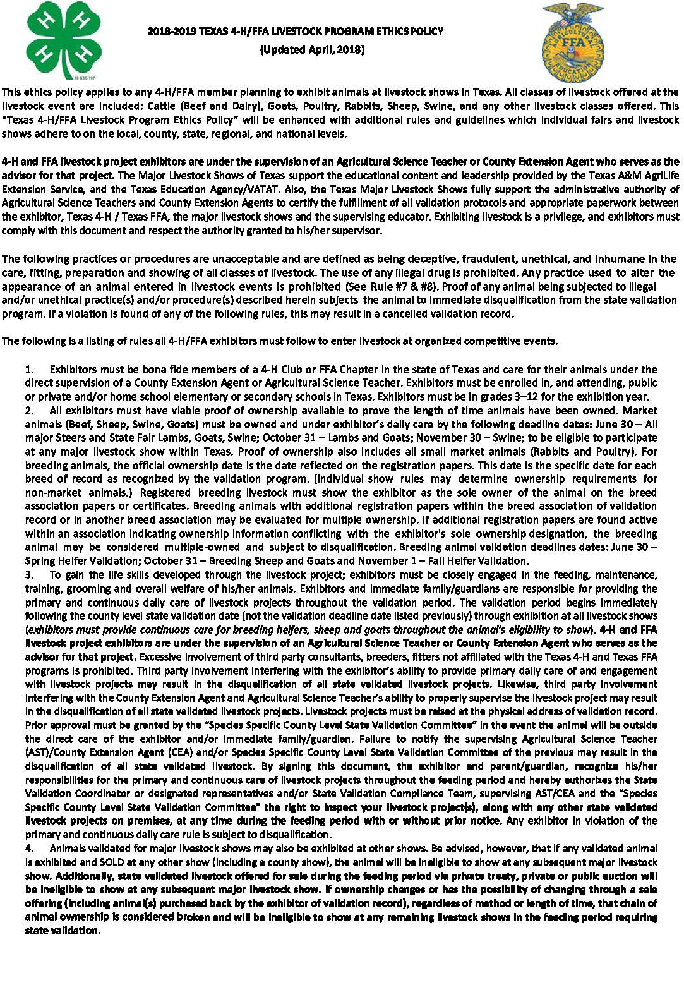
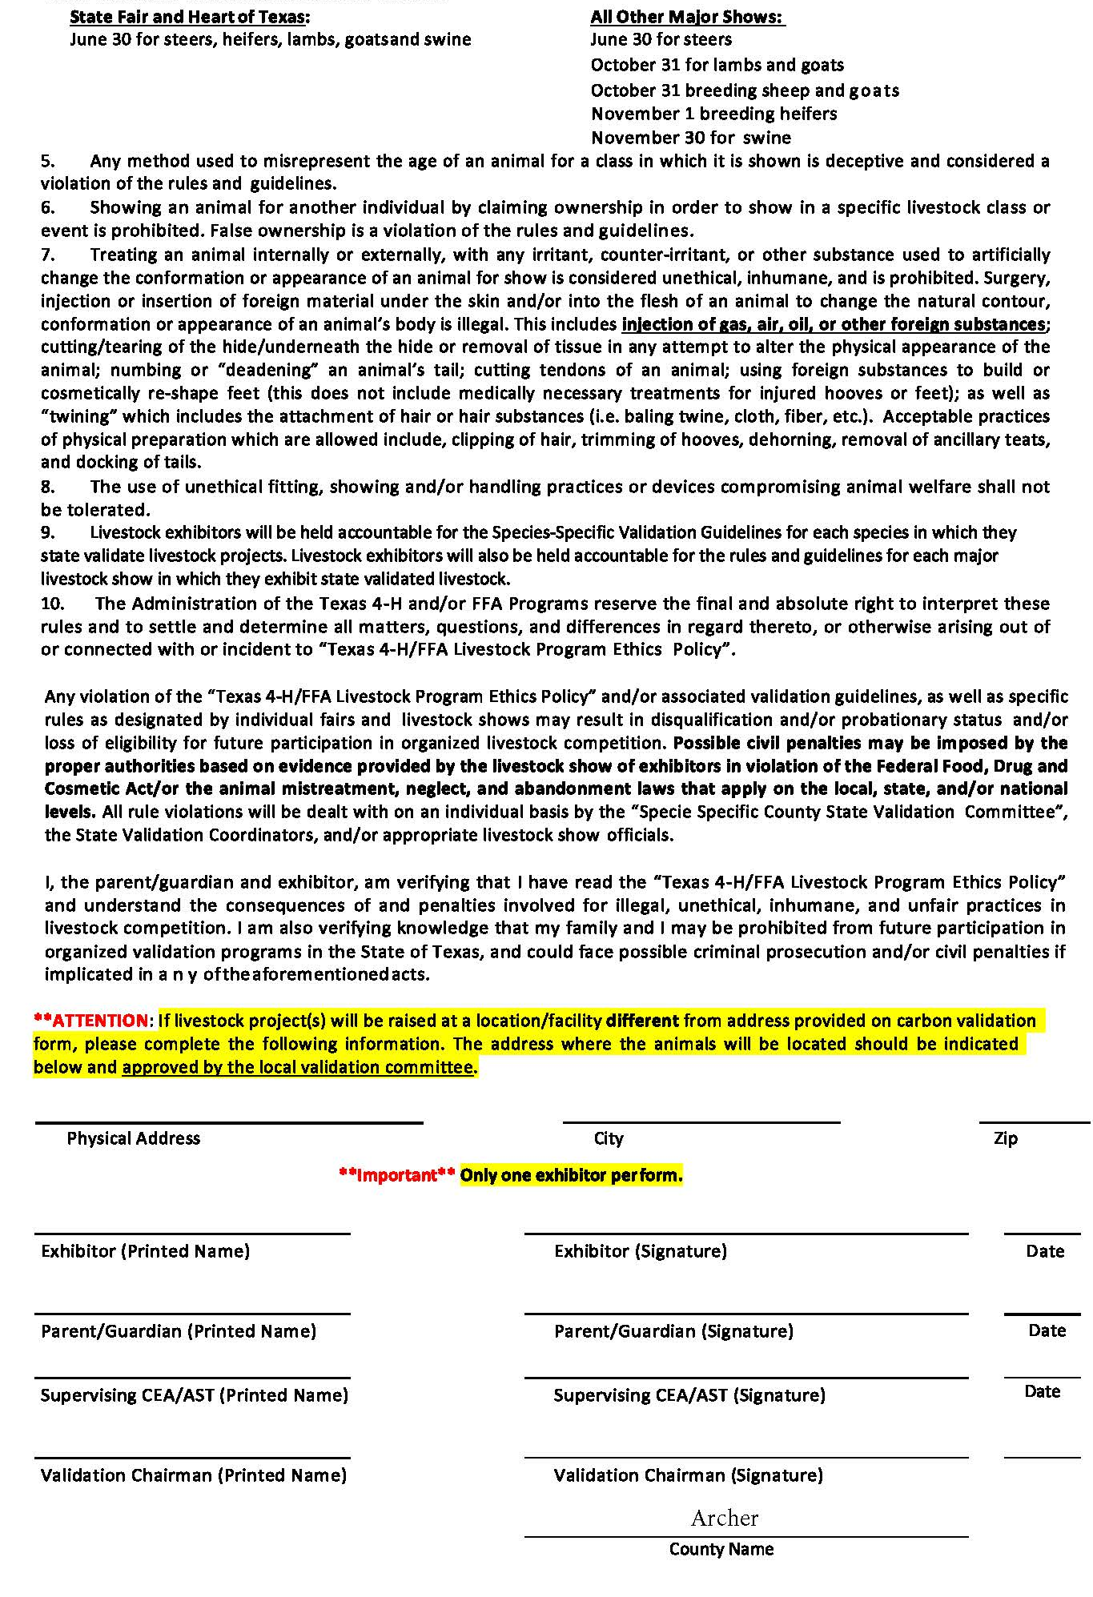

OFFICIAL SHOW SCHEDULE
Archer County Activity Building & Show Barn
Archer City, Texas

Thursday, January 3, 2019

5:00 pm Show Grounds Open

Friday, January 4, 2019

7:00 am-9:00 am Weigh-in swine, sheep, goats, rabbits
9:00 am-11:00 am Check-in Home Economics Entries (Open for Public Viewing)
10:00 am-11:00 am Judge Poultry
11:30 am-12 noon Judge Home Economics Entries
(Closed for Public Viewing)
11:00 am-1:00 pm Judge Rabbits
1:00 pm-2:00 pm Judge Lambs
–Goat Show to follow Lamb Show
4:00 pm-5:30 pm Public Viewing of Home Ec. Entries
4:30 pm-5:30 pm Pickup Home Ec. Entries
6:00 pm-8:00 pm Judge Swine

Saturday, January 5, 2019

7:30 am Dairy Cattle Check-In
7:00 am-8:00 am Weigh-in Beef Steers and Beef Heifers
8:00 am-9:00 am Ag Mechanics Show Projects in Place
8:00 am-9:30 am Judge Dairy
9:30 am-12 noon Judge Beef Heifers and Steers
–Ag Mechanics Show to follow Beef Show
12 noon Turn in Premium Auction Exhibitor Cards
5:30 pm-7:00 pm Buyer’s Appreciation Dinner – Activity Building
7:00 pm Premium Auction – Show Barn

GOOD LUCK TO ALL EXHIBITORS

SAMPLE

PREMIUM AUCTION CARD

Please circle your species:
Steer - Heifer - Dairy Cow - Dairy Heifer - Swine - Lamb - Goat - Chicken - Turkey - Rabbit
Exhibitor Name: Phone Number: FFA Chapter/4-H Club:
Weight: Tag Number: Placing: Division/Breed:
Circle your Class Number
1 2 3 4 5 6 7 8 9 10 11 12 13 14 15
16 17 18 19 20 21 22 23 24 25

This Card MUST be filled out completely and turned in by 12 NOON on Saturday January 5, 2019. Leaving any section blank will cause your entry to be placed last in the sale order.

2019 BUCKLE DONORS

Grand Champion Broiler Mitchell Insurance
Grand Champion Turkey Reliable Well Service – Pete Owens
Grand Champion Meat Goat Archer County Soil & Water Conservation District
Grand Champion Lamb Stone Services – Greg Stone
Grand Champion Beef Heifer Greg Carnes & Mike Gilmore
Grand Champion Beef Steer Ann Parkey
Grand Champion Dairy Heifer Dr. Andy Bloom
Grand Champion Dairy Cow Livestock Nutrition Center, LLC
Grand Champion Swine Clifton Russell & Greg Carnes
Grand Champion Rabbit American National Bank – Archer City
Junior Showmanship – Lamb The Feed and Garden Store
Senior Showmanship – Lamb Holli-Tex Supply
Junior Showmanship – Goat Kelly Propane
Senior Showmanship – Goat Mr. & Mrs. Rusty Looper
Junior Showmanship – Beef Hash Show Supply
Senior Showmanship – Beef Charlie & Patricia Hall
Junior Showmanship – Swine Tonya & Boucher Mooney
Intermediate Showmanship – Swine Double T Cattle Co. and D & S Cattle Co.
Senior Showmanship – Swine Willy Cuba Family
Junior Showmanship – Dairy Farmers Insurance – Brian Anderle
Senior Showmanship – Dairy Dairy Farmers of America – Jeff Hoegger

Reserve Champion Buckle Sponsors:
Todd & Jennifer Herring Capital Farm Credit
Warren Reid Chuck & Barbara Calvin
OK Concrete Mitchell Grain
Running R Bits & Spurs Ryan & Sylvia Looper

Auctioneer: Allen Heugatter
Scales donated by River Star Farms

2018 AUCTION BUYERS

17 Bar Ranch
Ann Parkey
Atmos Energy
Bailey Bros. Ag
Barnett Bit - Neal Reynolds
Berend Bros.
Bert Williamson
Big State Welding
Bill Jennings
Bill Jentsch, Jr.
Capital Farm Credit
Clifton Russell
Community Telephone
D&S Cattle Company
Dickey McGann & Rowe Ins
Dirty Mike & the Boys
Four Stars
Freddy Compton
Gillespie’s Paint and Body
Haigood & Campbell
Haile Brothers
Herb Easley
Holliday ISD
Jacksboro National Bank
Jay Manasco
Jerry & Margie Vieth
Jim Bob Wallace
Joe Aulds
John Hawley, Jr.
Kevin Dyes
Kelly Propane
Lipscomb Chevrolet
Lucky Dollar - Windthorst
Mickey Mayo
Mitchell Insurance
Oodles Supermarket
Patterson Welding & Supply
Patterson Auto Group
Pinpoint Accuracy
Robert Veitenheimer Dozer Srvc.
RT’s Food Store
Running R Bits & Spurs
Rusty Looper
Steven and Jenny Schroeder
Shayne Owen
Swenson Backhoe Srvc.
Sincerely Yours Florist
State Farm Insurance
Steve Stephens
Stevens Farm & Ranch
Superior Pipeline Services
Switch House Ranch
Taco Casa - Craig Martindale
The Feed and Garden Store
Todd Herring
Tommy Berend
Tubing Testers
Vernon Auto Group
Windthorst Federal Credit Union

